Defuse the Bomb – Fraction of a Number 1
The Mathematician, a notorious terrorist has planted a bomb. You must defuse that bomb using the mathematical clues he’s left.
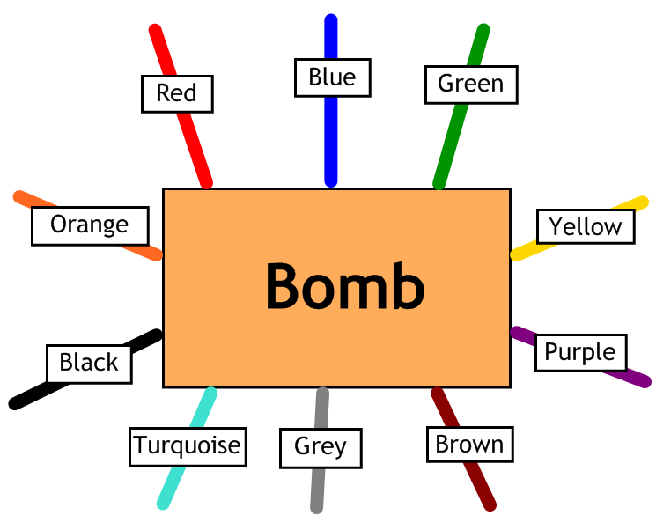
Answer the questions, then cut the coloured wires in the order that the answers appear, using the table below:
Red | Blue | Green | Yellow | Purple | Brown | Grey | Turquoise | Black | Orange
12 | 9 | 8.5 | 5 | 8 | 4 | 6 | 16 | 7 | 13

Here are the clues that show which order to cut the wires:
1 | What is $\frac{1}{2}$ of 32?
2 | What is $\frac{1}{3}$ of 24?
3 | What is $\frac{1}{5}$ of 45?
4 | What is $\frac{1}{8}$ of 32?
5 | What is $\frac{1}{2}$ of 17?
6 | What is $\frac{1}{4}$ of 28?
7 | What is $\frac{1}{5}$ of 60?
8 | What is $\frac{1}{9}$ of 45?

