Defuse the Bomb – Fraction of a Number 1 - Answers
The Mathematician, a notorious terrorist has planted a bomb. You must defuse that bomb using the mathematical clues he’s left.
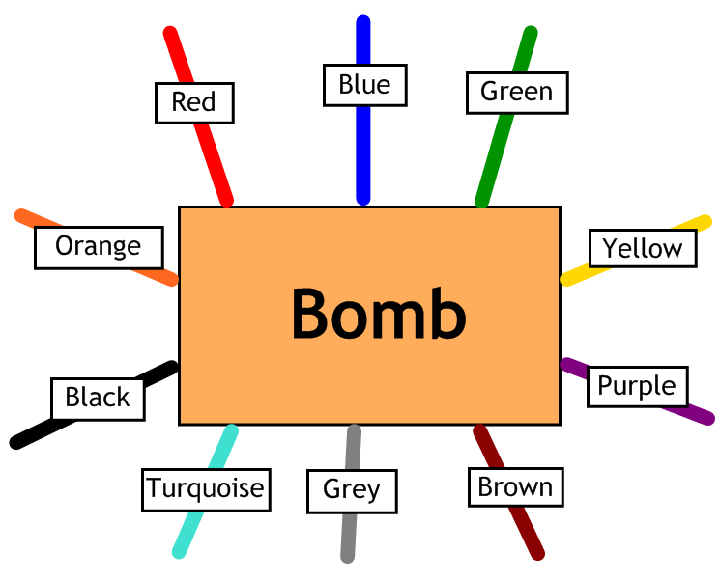
Answer the questions, then cut the coloured wires in the order that the answers appear, using the table below:
Red | Blue | Green | Yellow | Purple | Brown | Grey | Turquoise | Black | Orange
12 | 9 | 8.5 | 5 | 8 | 4 | 6 | 16 | 7 | 13

Here are the clues that show which order to cut the wires:
1 | What is $\frac{1}{2}$ of 32? 16 - Turquoise
2 | What is $\frac{1}{3}$ of 24? 8 – Purple
3 | What is $\frac{1}{5}$ of 45? 9 – Blue
4 | What is $\frac{1}{8}$ of 32? 4 – Brown
5 | What is $\frac{1}{2}$ of 17? 8.5 – Green
6 | What is $\frac{1}{4}$ of 28? 7 – Black
7 | What is $\frac{1}{5}$ of 60? 12 – Red
8 | What is $\frac{1}{9}$ of 45? 5 - Yellow

