Defuse the Bomb – Adding and Subtracting Fractions 2 - Answers
The Mathematician, a notorious terrorist has planted a bomb. You must defuse that bomb using the mathematical clues he’s left.
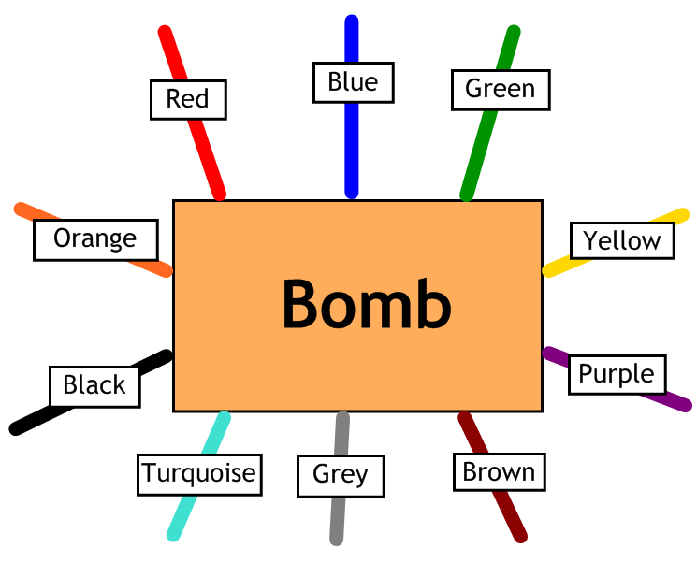
Answer the questions, then cut the coloured wires in the order that the answers appear, using the table below:
Red | Blue | Green | Yellow | Purple | Brown | Grey | Turquoise | Black | Orange
$$1\frac{21}{30}$$ | $$1\frac{19}{30}$$ | $$2\frac{11}{12}$$ | $$5\frac{1}{6}$$ | $$2\frac{7}{15}$$ | $$2\frac{1}{15}$$ | $$2\frac{5}{12}$$ | $$4\frac{7}{8}$$ | $$5\frac{1}{3}$$ | $$4\frac{3}{8}$$

Here are the clues that show which order to cut the wires – you may have to simplify your answers, so look carefully:

1 | Calculate $3\frac{1}{4}+1\frac{5}{8}$ Answer: $4\frac{7}{8}$ - Turquoise
2 | Calculate $2\frac{7}{15}-\frac{2}{5}$ Answer: $2\frac{1}{15}$ - Brown
3 | Calculate $3\frac{1}{4}+1\frac{11}{12}$ Answer: $5\frac{1}{6}$ - Yellow
4 | Calculate $3\frac{3}{10}-1\frac{2}{3}$ Answer: $1\frac{19}{30}$ - Blue
5 | Calculate $1\frac{3}{4}+\frac{2}{3}$ Answer: $2\frac{5}{12}$ - Grey
6 | Calculate $4\frac{1}{6}-1\frac{7}{10}$ Answer: $2\frac{7}{15}$ - Purple

