Defuse the Bomb – Adding and Subtracting Fractions 1
The Mathematician, a notorious terrorist has planted a bomb. You must defuse that bomb using the mathematical clues he’s left.
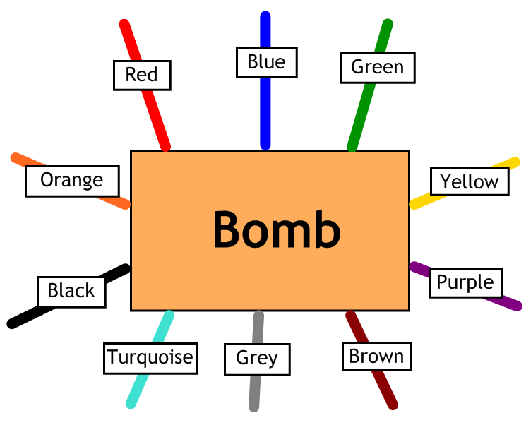
Answer the questions, then cut the coloured wires in the order that the answers appear, using the table below:
Red | Blue | Green | Yellow | Purple | Brown | Grey | Turquoise | Black | Orange
$$1\frac{8}{63}$$ | $$\frac{3}{20}$$ | $$\frac{7}{8}$$ | $$\frac{19}{40}$$ | $$\frac{11}{12}$$ | $$\frac{11}{15}$$ | $$1\frac{5}{63}$$ | $$\frac{3}{5}$$ | $$1\frac{1}{12}$$ | $$\frac{3}{10}$$

Here are the clues that show which order to cut the wires – you may have to simplify your answers, so look carefully:
1 | Calculate $\frac{3}{4}+\frac{1}{8}$
2 | Calculate $\frac{7}{10}-\frac{2}{5}$
3 | Calculate $\frac{1}{3}+\frac{7}{12}$
4 | Calculate $\frac{9}{10}-\frac{3}{4}$
5 | Calculate $\frac{3}{4}+\frac{1}{3}$
6 | Calculate $\frac{5}{6}-\frac{1}{10}$
7 | Calculate $\frac{5}{9}+\frac{4}{7}$
8 | Calculate $\frac{17}{20}-\frac{3}{8}$

