Defuse the Bomb – Adding and Subtracting Fractions 1 - Answers
The Mathematician, a notorious terrorist has planted a bomb. You must defuse that bomb using the mathematical clues he’s left.
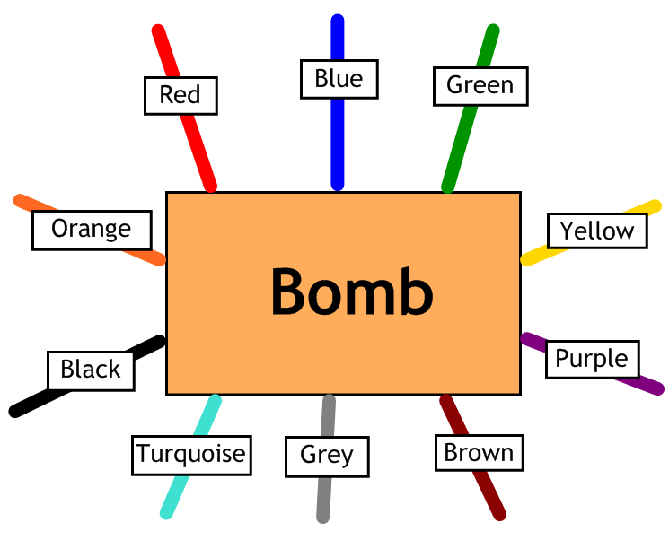
Answer the questions, then cut the coloured wires in the order that the answers appear, using the table below:
Red | Blue | Green | Yellow | Purple | Brown | Grey | Turquoise | Black | Orange
$$1\frac{8}{63}$$ | $$\frac{3}{20}$$ | $$\frac{7}{8}$$ | $$\frac{19}{40}$$ | $$\frac{11}{12}$$ | $$\frac{11}{15}$$ | $$1\frac{5}{63}$$ | $$\frac{3}{5}$$ | $$1\frac{1}{12}$$ | $$\frac{3}{10}$$

Here are the clues that show which order to cut the wires – you may have to simplify your answers, so look carefully:
1 | Calculate $\frac{3}{4}+\frac{1}{8}$ Answer: $\frac{7}{8}$ - Green
2 | Calculate $\frac{7}{10}-\frac{2}{5}$ Answer: $\frac{3}{10}$ - Orange
3 | Calculate $\frac{1}{3}+\frac{7}{12}$ Answer: $\frac{11}{12}$ - Purple
4 | Calculate $\frac{9}{10}-\frac{3}{4}$ Answer: $\frac{3}{20}$ - Blue
5 | Calculate $\frac{3}{4}+\frac{1}{3}$ Answer: $1\frac{1}{12}$ - Black
6 | Calculate $\frac{5}{6}-\frac{1}{10}$ Answer: $\frac{11}{15}$ - Brown
7 | Calculate $\frac{5}{9}+\frac{4}{7}$ Answer: $1\frac{8}{63}$ - Red
8 | Calculate $\frac{17}{20}-\frac{3}{8}$ Answer: $\frac{19}{40}$ - Yellow

