Crack The Safe – Multiplying and Dividing Fractions – Answers
The antidote to a potentially fatal and contagious virus is being kept in a safe but the code to open it has been lost.
The owner of the safe has been struck down by the virus but left themselves some clues to the code in case of this eventuality; however, we need your expertise to solve them.
In order to help you out, the owner of the safe has left a list of possible numbers in the code that opens the safe, but the order is a mystery and as an extra layer of security, there are more possible answers than you require.
All answers should be in their simplest form.
Code #1 | Code #2 | Code #3 | Code #4 | Code #5 | Code #6
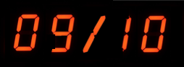 | 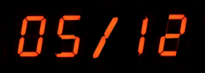 | 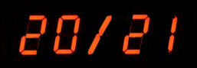 | 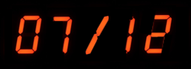 | 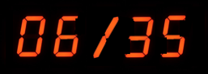 | 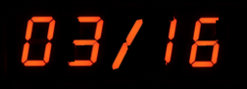
Calculate:  $$\frac{3}{5}÷\frac{2}{3}$$ | Calculate:  $$\frac{5}{6}×\frac{3}{4}$$ | Calculate:  $$\frac{4}{7}÷\frac{3}{5}$$ | Calculate:  $$\frac{2}{3}×\frac{7}{8}$$ | Sophie has $\frac{3}{5}$ of a bag of sweets. She eats $\frac{2}{7}$ of the sweets she has. What fraction of a full bag of sweets does Sophie eat? | Four friends win a cash prize. They donate $\frac{1}{4}$ to charity then share the remainder equally between them. What fraction of the prize do they each receive?
$$\frac{9}{10}$$ | $$\frac{5}{8}$$ | $$\frac{20}{21}$$ | $$\frac{7}{12}$$ | $$\frac{6}{35}$$ | $$\frac{3}{16}$$

Possible Code Values
$$\frac{7}{12}$$ | $$\frac{10}{9}$$ | $$\frac{3}{16}$$ | $$\frac{5}{8}$$ | $$\frac{6}{35}$$ | $$\frac{1}{4}$$ | $$\frac{21}{10}$$ | $$\frac{3}{4}$$ | $$\frac{9}{10}$$ | $$\frac{20}{21}$$

