Crack The Safe – Mixed Numbers – Answers
The antidote to a potentially fatal and contagious virus is being kept in a safe but the code to open it has been lost.
The owner of the safe has been struck down by the virus but left themselves some clues to the code in case of this eventuality; however, we need your expertise to solve them.
In order to help you out, the owner of the safe has left a list of possible numbers in the code that opens the safe, but the order is a mystery and as an extra layer of security, there are more possible answers than you require.
All answers must be given as improper fractions where necessary so they can be typed into the safe.
Code #1 | Code #2 | Code #3 | Code #4 | Code #5 | Code #6
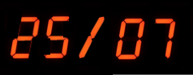 | 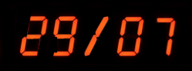 | 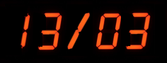 | 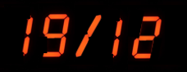 | 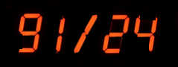 | 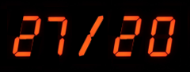
Write this mixed number as an improper fraction:  $$3\frac{5}{7}$$ | Write this mixed number as an improper fraction:  $$4\frac{1}{7}$$ | Calculate:  $$1\frac{1}{2}+2\frac{5}{6}$$ | Calculate:  $$4\frac{1}{3}-2\frac{3}{4}$$ | Calculate:  $$1\frac{5}{8}×2\frac{1}{3}$$ | Calculate:  $$2\frac{1}{4}÷1\frac{2}{3}$$
$$\frac{25}{7}$$ | $$\frac{29}{7}$$ | $$\frac{13}{3}$$ | $$\frac{19}{12}$$ | $$\frac{91}{24}$$ | $$\frac{27}{20}$$

Possible Code Values
$$\frac{13}{3}$$ | $$\frac{15}{3}$$ | $$\frac{27}{7}$$ | $$\frac{25}{7}$$ | $$\frac{29}{7}$$ | $$\frac{91}{24}$$ | $$\frac{27}{20}$$ | $$\frac{25}{12}$$ | $$\frac{19}{12}$$ | $$\frac{23}{20}$$

