Crack The Safe – Fraction of an Amount
The antidote to a potentially fatal and contagious virus is being kept in a safe but the code to open it has been lost.
The owner of the safe has been struck down by the virus but left themselves some clues to the code in case of this eventuality; however, we need your expertise to solve them.
In order to help you out, the owner of the safe has left a list of possible numbers in the code that opens the safe, but the order is a mystery and as an extra layer of security, there are more possible answers than you require.
Code #1 | Code #2 | Code #3 | Code #4 | Code #5 | Code #6
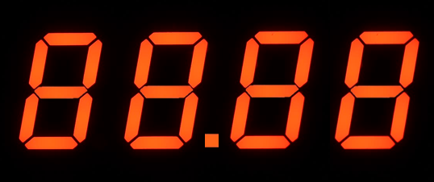
Find $\frac{5}{8}$ of $72$. | Louise has a bag of $45$ marbles. She gives away $\frac{1}{3}$ of them. How many marbles does Louise give away? | A sale has $\frac{2}{5}$ off all items. A pair of shoes normally cost $£64$. How much do you save in the sale? | Eight friends share a competition prize of $£150$ equally. How much does each receive? | $\frac{3}{8}$ of a number is $15$. What is the number? | A sale offers a quarter off all items. A shirt usually costs $£38$. How much is the shirt in the sale?

Possible Code Values
$$19.25$$ | $$25.6$$ | $$40$$ | $$45$$ | $$28.5$$ | $$24.8$$ | $$18.75$$ | $$48$$ | $$15$$ | $$9.5$$

