Crack The Safe – Adding and Subtracting Fractions
The antidote to a potentially fatal and contagious virus is being kept in a safe but the code to open it has been lost.
The owner of the safe has been struck down by the virus but left themselves some clues to the code in case of this eventuality; however, we need your expertise to solve them.
In order to help you out, the owner of the safe has left a list of possible numbers in the code that opens the safe, but the order is a mystery and as an extra layer of security, there are more possible answers than you require.
All answers should be in their simplest form.
Code #1 | Code #2 | Code #3 | Code #4 | Code #5 | Code #6
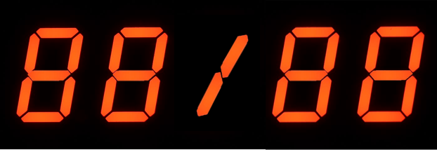 |  |  |  |  | 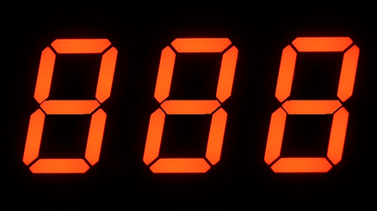
Calculate:  $$\frac{5}{8}+\frac{1}{6}$$ | Calculate:  $$\frac{1}{2}-\frac{5}{12}$$ | Calculate:  $$\frac{7}{8}-\frac{5}{6}$$ | Calculate:  $$\frac{1}{3}+\frac{3}{8}$$ | Katie has $\frac{1}{4}$ of a bag of sweets. Sam has $\frac{2}{5}$ of a bag of sweets. If Katie and Sam combined their sweets, what fraction of a whole bag would they have? | $\frac{7}{8}$ of a bag of marbles are left on a table. I take $\frac{1}{5}$ of a full bag of marbles from the bag on the table. What is the smallest possible number of marbles in a full bag?

Possible Code Values
$$\frac{1}{12}$$ | $$\frac{1}{24}$$ | $$\frac{11}{20}$$ | $$\frac{13}{20}$$ | $$40$$ | $$20$$ | $$\frac{19}{24}$$ | $$\frac{7}{12}$$ | $$24$$ | $$\frac{17}{24}$$

