Candidates may use any calculator allowed by the regulations of the
Joint Council for Qualifications. Calculators must not have the facility
for symbolic algebra manipulation, differentiation and integration, or
have retrievable mathematical formulae stored in them.
Instructions
- Use black ink or ball-point pen.
- If pencil is used for diagrams / sketches / graphs it must be dark (HB or B).
  - Fill in the boxes at the top of this page with your name,
centre number and candidate number.
- Answer all questions and ensure that your answers to parts of questions are clearly labelled.
- Answer the questions in the spaces provided
– there may be more space than you need.
- You should show sufficient working to make your methods clear.
Answers without working may not gain full credit.
- Answers should be given to three significant figures unless otherwise stated.
Information
- A booklet ‘Mathematical Formulae and Statistical Tables’ is provided.
- There are 16 questions in this question paper. The total mark for this paper is 100.
- The marks for each question are shown in brackets
– use this as a guide as to how much time to spend on each question.
Advice
- Read each question carefully before you start to answer it.
- Try to answer every question.
- Check your answers if you have time at the end.
1. The line l₁ has equation 2x + 4y – 3 = 0
The line l₂ has equation y = mx + 7, where m is a constant.
Given that l₁ and l₂ are perpendicular,
(a) find the value of m.
(2)

The lines l₁ and l₂ meet at the point P.
(b) Find the x coordinate of P.
(2)
(Total for Question 1 is 4 marks)
___________________________________________________________________________

2. Find, using algebra, all real solutions to the equation
(i) 16a² = 2
(4)
(ii) b⁴ + 7b² – 18 = 0
(4)
(Total for Question 2 is 8 marks)
___________________________________________________________________________

3. (a) Given that k is a constant, find
simplifying your answer.
(3)
(b) Hence find the value of k such that
= 8
(3)
(Total for Question 3 is 6 marks)
___________________________________________________________________________

4. A tree was planted in the ground.
Its height, H metres, was measured t years after planting.
Exactly 3 years after planting, the height of the tree was 2.35 metres.
Exactly 6 years after planting, the height of the tree was 3.28 metres.
Using a linear model,
(a) find an equation linking H with t.
(3)

The height of the tree was approximately 140 cm when it was planted.
(b) Explain whether or not this fact supports the use of the linear model in part (a).
(2)
(Total for Question 4 is 5 marks)
___________________________________________________________________________

5. A curve has equation
y = 3x² + + 2 x > 0
(a) Find, in simplest form,
(3)
(b) Hence find the exact range of values of x for which the curve is increasing.
(2)
(Total for Question 5 is 5 marks)
___________________________________________________________________________

6.
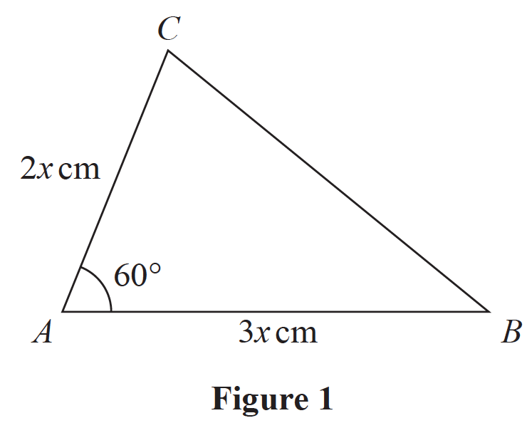

Figure 1 shows a sketch of a triangle ABC with AB = 3x cm, AC = 2x cm and
angle CAB = 60°
Given that the area of triangle ABC is 18 cm²
(a) show that x = 2
(3)
(b) Hence find the exact length of BC, giving your answer as a simplified surd.
(3)
(Total for Question 6 is 6 marks)
___________________________________________________________________________

7. The curve C has equation
y = + 1 x ∈ ℝ, x ≠ 0
where k is a constant.
(a) Sketch C stating the equation of the horizontal asymptote.
(3)

The line l has equation y = –2x + 5
(b) Show that the x coordinate of any point of intersection of l with C is given by a
solution of the equation
2x² – 4x + k² = 0
(2)
(c) Hence find the exact values of k for which l is a tangent to C.
(3)
(Total for Question 7 is 8 marks)
___________________________________________________________________________

8. (a) Find the first 3 terms, in ascending powers of x, of the binomial expansion of
giving each term in its simplest form.
(4)
(b) Explain how you could use your expansion to estimate the value of 1.925⁶
You do not need to perform the calculation.
(1)
(Total for Question 8 is 5 marks)
___________________________________________________________________________

9. A company started mining tin in Riverdale on 1st January 2019.
A model to find the total mass of tin that will be mined by the company in Riverdale is
given by the equation
T = 1200 – 3(n – 20)²
where T tonnes is the total mass of tin mined in the n years after the start of mining.
Using this model,
(a) calculate the mass of tin that will be mined up to 1st January 2020,
(1)
(b) deduce the maximum total mass of tin that could be mined,
(1)
(c) calculate the mass of tin that will be mined in 2023.
(2)
(d) State, giving reasons, the limitation on the values of n.
(2)
(Total for Question 9 is 6 marks)
___________________________________________________________________________

10. A circle C has equation
x² + y² – 4x + 8y – 8 = 0
(a) Find
(i) the coordinates of the centre of C,
(ii) the exact radius of C.
(3)

The straight line with equation x = k, where k is a constant, is a tangent to C.
(b) Find the possible values for k.
(2)
(Total for Question 10 is 5 marks)
___________________________________________________________________________

11. f (x) = 2x³ – 13x² + 8x + 48

(a) Prove that (x – 4) is a factor of f (x).
(2)
(b) Hence, using algebra, show that the equation f (x) = 0 has only two distinct roots.
(4)

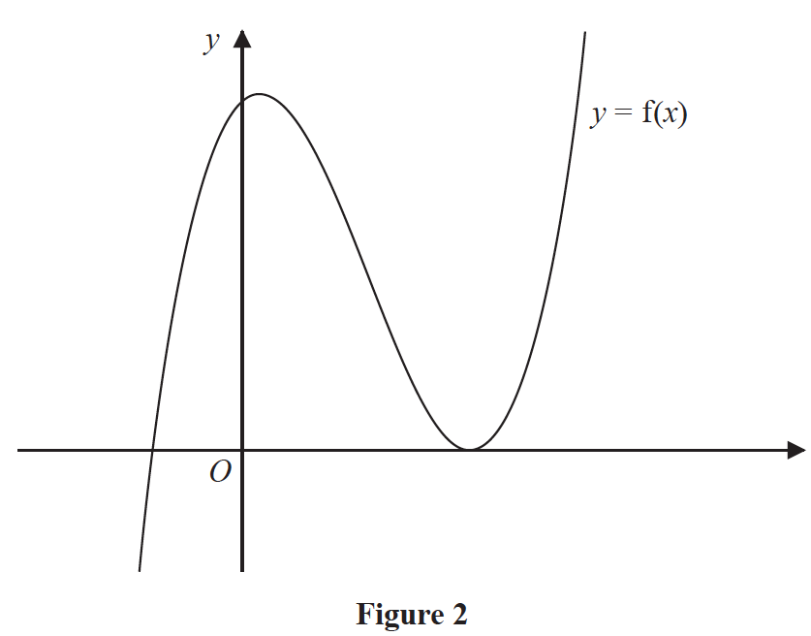
Figure 2 shows a sketch of part of the curve with equation y = f (x).
(c) Deduce, giving reasons for your answer, the number of real roots of the equation
2x³ – 13x² + 8x + 46 = 0
(2)

Given that k is a constant and the curve with equation y = f(x + k) passes through the origin,
(d) find the two possible values of k.
(2)
(Total for Question 11 is 10 marks)
___________________________________________________________________________

12. (a) Show that
≡ 4 – 5cos 𝜃
(4)
(b) Hence, or otherwise, solve, for 0 ⩽ x < 360°, the equation
= 4 + 3sin x
(3)
(Total for Question 12 is 7 marks)
___________________________________________________________________________

13.
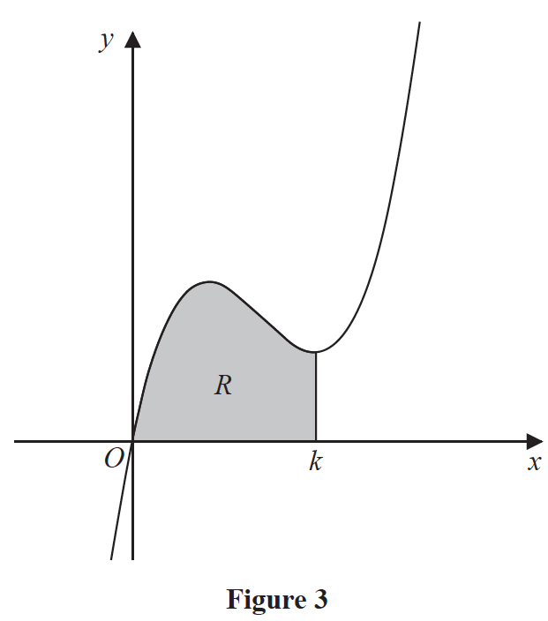

Figure 3 shows a sketch of part of the curve with equation
y = 2x³ – 17x² + 40x
The curve has a minimum turning point at x = k.
The region R, shown shaded in Figure 3, is bounded by the curve, the x-axis and the line
with equation x = k.
Show that the area of R is
(Solutions based entirely on graphical or numerical methods are not acceptable.)
(7)
(Total for Question 13 is 7 marks)
___________________________________________________________________________

14. The value of a car, £V, can be modelled by the equation
V = 15 700e^{–0.25t} + 2300 t ∈ ℝ, t ⩾ 0
where the age of the car is t years.
Using the model,
(a) find the initial value of the car.
(1)

Given the model predicts that the value of the car is decreasing at a rate of £500 per year
at the instant when t = T,
(b) (i) show that
3925e^{–0.25T} = 500
(ii) Hence find the age of the car at this instant, giving your answer in years and
months to the nearest month.
(Solutions based entirely on graphical or numerical methods are not acceptable.)
(6)

The model predicts that the value of the car approaches, but does not fall below, £A.
(c) State the value of A.
(1)
(d) State a limitation of this model.
(1)
(Total for Question 14 is 9 marks)
___________________________________________________________________________

15. Given n ∈ ℕ, prove that n³ + 2 is not divisible by 8
(4)
(Total for Question 15 is 4 marks)
___________________________________________________________________________

16. (i) Two non-zero vectors, a and b, are such that
| a + b | = | a | + | b |
Explain, geometrically, the significance of this statement.
(1)
(ii) Two different vectors, m and n, are such that | m | = 3 and | m – n | = 6
The angle between vector m and vector n is 30°
Find the angle between vector m and vector m – n, giving your answer, in degrees,
to one decimal place.
(4)
(Total for Question 16 is 5 marks)
___________________________________________________________________________

TOTAL FOR PAPER IS 100 MARKS

