1 A curve has equation
y = 2x³ – 4x + 5
Find the equation of the tangent to the curve at the point P(2, 13).
Write your answer in the form y = mx + c, where m and c are integers to be found.
Solutions relying on calculator technology are not acceptable.
(5)
(Total for Question 1 is 5 marks)
___________________________________________________________________________

2 [In this question the unit vectors i and j are due east and due north respectively.]
A coastguard station O monitors the movements of a small boat.
At 10:00 the boat is at the point (4i – 2j) km relative to O.
At 12:45 the boat is at the point (–3i – 5j) km relative to O.
The motion of the boat is modelled as that of a particle moving in a straight line at
constant speed.
(a) Calculate the bearing on which the boat is moving, giving your answer in degrees to
one decimal place.
(3)
(b) Calculate the speed of the boat, giving your answer in km h^{–1}
(3)
(Total for Question 2 is 6 marks)
___________________________________________________________________________

3
In this question you must show all stages of your working.
Solutions relying on calculator technology are not acceptable.
(i) Solve the equation
= x
writing the answer as a surd in simplest form.
(3)
(ii) Solve the equation
4^{3x – 2} =
(3)
(Total for Question 3 is 6 marks)
___________________________________________________________________________

4 In 1997 the average CO₂ emissions of new cars in the UK was 190 g/km.
In 2005 the average CO₂ emissions of new cars in the UK had fallen to 169 g/km.
Given A g/km is the average CO₂ emissions of new cars in the UK n years after 1997 and
using a linear model,
(a) form an equation linking A with n.
(3)

In 2016 the average CO₂ emissions of new cars in the UK was 120 g/km.
(b) Comment on the suitability of your model in light of this information.
(3)
(Total for Question 4 is 6 marks)
___________________________________________________________________________

5
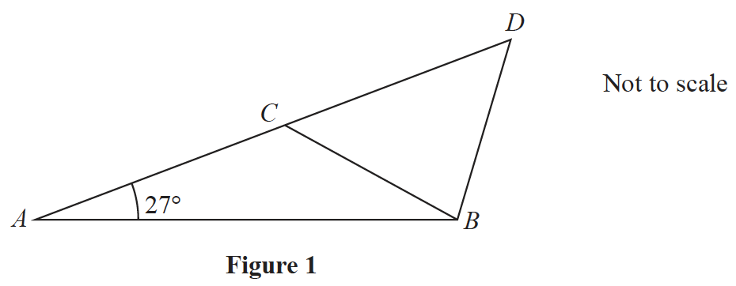
Figure 1 shows the design for a structure used to support a roof.
The structure consists of four steel beams, AB, BD, BC and AD.
Given AB = 12 m, BC = BD = 7m and angle BAC = 27°
(a) find, to one decimal place, the size of angle ACB.
(3)

The steel beams can only be bought in whole metre lengths.
(b) Find the minimum length of steel that needs to be bought to make the complete
structure.
(3)
(Total for Question 5 is 6 marks)
___________________________________________________________________________

6 (a) Find the first 4 terms, in ascending powers of x, in the binomial expansion of
(1 + kx)¹⁰
where k is a non-zero constant. Write each coefficient as simply as possible.
(3)

Given that in the expansion of (1 + kx)¹⁰ the coefficient x³ is 3 times the coefficient of x,
(b) find the possible values of k.
(3)
(Total for Question 6 is 6 marks)
___________________________________________________________________________

7 Given that k is a positive constant and = 4
(a) show that 3k + – 12 = 0
(4)
(b) Hence, using algebra, find any values of k such that
= 4
(4)
(Total for Question 7 is 8 marks)
___________________________________________________________________________

8 The temperature, θ °C, of a cup of tea t minutes after it was placed on a table in a room,
is modelled by the equation
θ = 18 + t ⩾ 0
Find, according to the model,
(a) the temperature of the cup of tea when it was placed on the table,
(1)
(b) the value of t, to one decimal place, when the temperature of the cup of tea was 35 °C.
(3)
(c) Explain why, according to this model, the temperature of the cup of tea could not fall
to 15 °C.
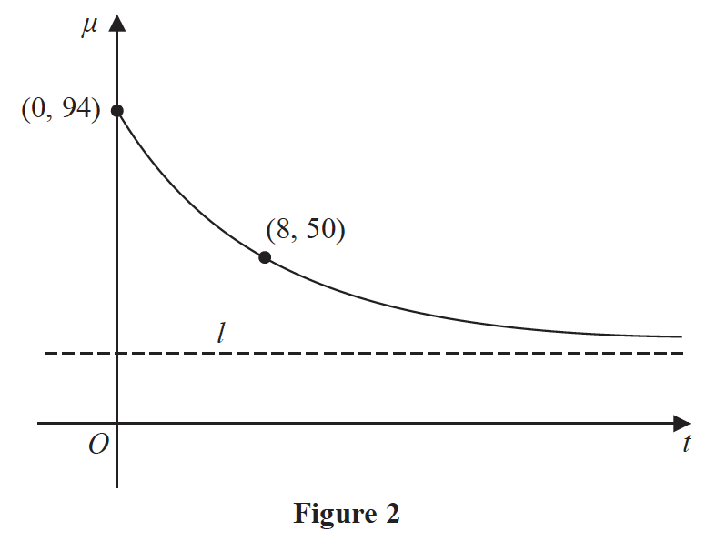
(1)

The temperature, μ °C, of a second cup of tea t minutes after it was placed on a table in a
different room, is modelled by the equation
μ = A + t ⩾ 0
where A and B are constants.
Figure 2 shows a sketch of μ against t with two data points that lie on the curve.
The line l, also shown on Figure 2, is the asymptote to the curve.
Using the equation of this model and the information given in Figure 2
(d) find an equation for the asymptote l.
(4)
(Total for Question 8 is 9 marks)
___________________________________________________________________________

9
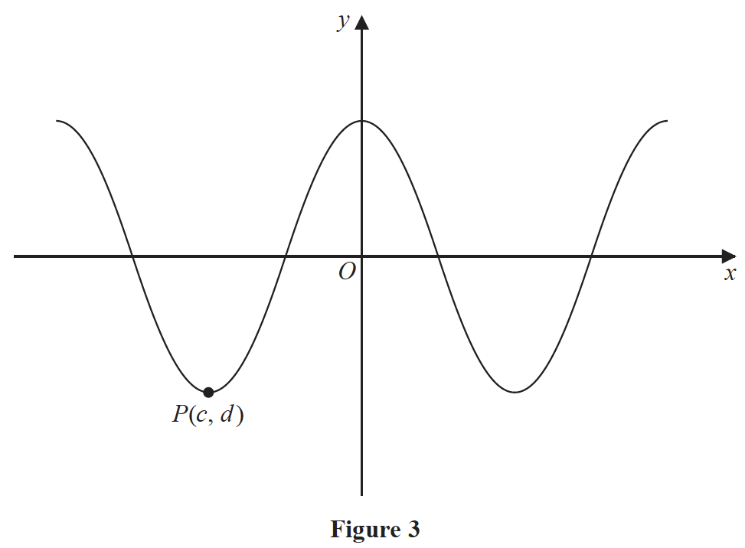
Figure 3 shows part of the curve with equation y = 3 cos x°.
The point P(c, d) is a minimum point on the curve with c being the smallest negative
value of x at which a minimum occurs.
(a) State the value of c and the value of d.
(1)
(b) State the coordinates of the point to which P is mapped by the transformation which
transforms the curve with equation y = 3 cos x° to the curve with equation
(i) 3 cos
(ii) y = 3 cos (x – 36)°
(2)
(c) Solve, for 450° ⩽ θ < 720°,
3 cos θ = 8 tan θ
giving your solution to one decimal place.

In part (c) you must show all stages of your working.
Solutions relying entirely on calculator technology are not acceptable.
(5)
(Total for Question 9 is 8 marks)
___________________________________________________________________________

10
g(x) = 2x³ + x² – 41x – 70
(a) Use the factor theorem to show that g(x) is divisible by (x – 5).
(2)
(b) Hence, showing all your working, write g(x) as a product of three linear factors.
(4)

The finite region R is bounded by the curve with equation y = g(x) and the x-axis, and
lies below the x-axis.
(c) Find, using algebraic integration, the exact value of the area of R.
(4)
(Total for Question 10 is 10 marks)
___________________________________________________________________________

11 (i) A circle C₁ has equation
x² + y² + 18x – 2y + 30 = 0
The line l is the tangent to C₁ at the point P(–5, 7).
Find an equation of l in the form ax + by + c = 0, where a, b and c are integers to
be found.
(5)
(ii) A different circle C₂ has equation
x² + y² – 8x + 12y + k = 0
where k is a constant.
Given that C₂ lies entirely in the 4th quadrant, find the range of possible values for k.
(4)
(Total for Question 11 is 9 marks)
___________________________________________________________________________

12 An advertising agency is monitoring the number of views of an online advert.
The equation
log₁₀ V = 0.072t + 2.379 1 ⩽ t ⩽ 30, t ∈ ℕ
is used to model the total number of views of the advert, V, in the first t days after the
advert went live.
(a) Show that V = ab^{t} where a and b are constants to be found.
Give the value of a to the nearest whole number and give the value of b to
3 significant figures.
(4)
(b) Interpret, with reference to the model, the value of ab.
(1)

Using this model, calculate
(c) the total number of views of the advert in the first 20 days after the advert went live.
Give your answer to 2 significant figures.
(2)
(Total for Question 12 is 7 marks)
___________________________________________________________________________

13 (a) Prove that for all positive values of a and b
⩾ 4
(4)
(b) Prove, by counter example, that this is not true for all values of a and b.
(1)
(Total for Question 13 is 5 marks)
___________________________________________________________________________

14 A curve has equation y = g(x).
Given that
● g(x) is a cubic expression in which the coefficient of x³ is equal to the coefficient of x
● the curve with equation y = g(x) passes through the origin
● the curve with equation y = g(x) has a stationary point at (2, 9)
(a) find g(x),
(7)
(b) prove that the stationary point at (2, 9) is a maximum.
(2)
(Total for Question 14 is 9 marks)
___________________________________________________________________________

TOTAL FOR PAPER IS 100 MARKS

