
1 A system of three equations is defined by
kx + 3y – z = 3
3x – y + z = –k
–16x – ky – kz = k
where k is a positive constant.
Given that there is no unique solution to all three equations,
(a) show that k = 2
(2)

Using k = 2
(b) determine whether the three equations are consistent, justifying your answer.
(3)
(c) Interpret the answer to part (b) geometrically.
(1)
(Total for Question 1 is 6 marks)
___________________________________________________________________________

2 Given that
z₁ = 2 + 3i
|z₁z₂| =
arg(z₁z₂) =
where z₁ and z₂ are complex numbers,
(a) write z₁ in the form r(cos θ + i sin θ)
Give the exact value of r and give the value of θ in radians to 4 significant figures.
(2)
(b) Find z₂ giving your answer in the form a + ib where a and b are integers.
(6)
(Total for Question 2 is 8 marks)
___________________________________________________________________________

3
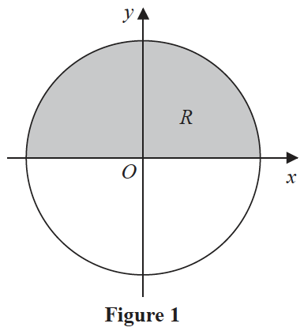
Figure 1 shows a circle with radius r and centre at the origin.
The region R, shown shaded in Figure 1, is bounded by the x-axis and the part of the
circle for which y > 0
The region R is rotated through 360° about the x-axis to create a sphere with volume V
Use integration to show that V =
(5)
(Total for Question 3 is 5 marks)
___________________________________________________________________________

4
All units in this question are in metres.
A lawn is modelled as a plane that contains the points L (–2, –3, –1), M (6, –2, 0) and
N (2, 0, 0), relative to a fixed origin O.
(a) Determine a vector equation of the plane that models the lawn, giving your answer in
the form r = a + λb + μc
(3)

(b) (i) Show that, according to the model, the lawn is perpendicular to the vector

(ii) Hence determine a Cartesian equation of the plane that models the lawn.
(4)

There are two posts set in the lawn.
There is a washing line between the two posts.
The washing line is modelled as a straight line through points at the top of each post with
coordinates P (–10, 8, 2) and Q (6, 4, 3).
(c) Determine a vector equation of the line that models the washing line.
(2)
(d) State a limitation of one of the models.
(1)

The point R (2, 5, 2.75) lies on the washing line.
(e) Determine, according to the model, the shortest distance from the point R to the lawn,
giving your answer to the nearest cm.
(2)

Given that the shortest distance from the point R to the lawn is actually 1.5 m,
(f) use your answer to part (e) to evaluate the model, explaining your reasoning.
(1)
(Total for Question 4 is 13 marks)
___________________________________________________________________________

5
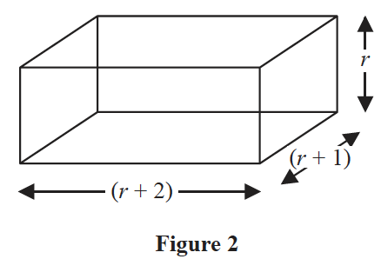
A block has length (r + 2) cm, width (r + 1) cm and height r cm, as shown in Figure 2.
In a set of n such blocks, the first block has a height of 1 cm, the second block has a
height of 2 cm, the third block has a height of 3 cm and so on.
(a) Use the standard results for and to show that the total volume, V, of
all n blocks in the set is given by
V = (n + 1)(n + 2)(n + 3) n ⩾ 1
(5)

Given that the total volume of all n blocks is
(n⁴ + 6n³ – 11 710) cm³
(b) determine how many blocks make up the set.
(2)
(Total for Question 5 is 7 marks)
___________________________________________________________________________

6 (i)
where a and b are non-zero constants.
Given that the matrix A is self-inverse,
(a) determine the value of b and the possible values for a.
(5)

The matrix A represents a linear transformation M.
Using the smaller value of a from part (a),
(b) show that the invariant points of the linear transformation M form a line, stating
the equation of this line.
(3)
(ii)
where p is a positive constant.
The matrix P represents a linear transformation U.
The triangle T has vertices at the points with coordinates (1, 2), (3, 2) and (2, 5).
The area of the image of T under the linear transformation U is 15
(a) Determine the value of p.
(4)

The transformation V consists of a stretch scale factor 3 parallel to the x-axis with the
y-axis invariant followed by a stretch scale factor –2 parallel to the y-axis with the x-axis
invariant. The transformation V is represented by the matrix Q.
(b) Write down the matrix Q.
(2)

Given that U followed by V is the transformation W, which is represented by the matrix R,
(c) find the matrix R.
(2)
(Total for Question 6 is 16 marks)
___________________________________________________________________________

7
f(z) = z⁴ + az³ + bz² + cz + d
where a, b, c and d are real constants.
The equation f(z) = 0 has complex roots z₁, z₂, z₃ and z₄
When plotted on an Argand diagram, the points representing z₁, z₂, z₃ and z₄ form the
vertices of a square, with one vertex in each quadrant.
Given that z₁ = 2 + 3i, determine the values of a, b, c and d.
(6)
(Total for Question 7 is 6 marks)
___________________________________________________________________________

8 Prove by induction that, for n ∈ ℤ⁺
f(n) = 2^{n + 2} + 3^{2n + 1}
is divisible by 7
(6)
(Total for Question 8 is 6 marks)
___________________________________________________________________________

9 The cubic equation
3x³ + x² – 4x + 1 = 0
has roots α, β, and γ.
Without solving the cubic equation,
(a) determine the value of
(3)
(b) find a cubic equation that has roots , and giving your answer in the form
x³ + ax² + bx + c = 0, where a, b and c are integers to be determined.
(3)
(Total for Question 9 is 6 marks)
___________________________________________________________________________

10 Given that there are two distinct complex numbers z that satisfy
{z : |z – 3 – 5i| = 2r}
determine the exact range of values for the real constant r.
(7)
(Total for Question 10 is 7 marks)
___________________________________________________________________________

TOTAL FOR CORE PURE MATHEMATICS IS 80 MARKS

