4A Inequalities with Variables as Denominators
Consider $\frac{1}{x}<x$

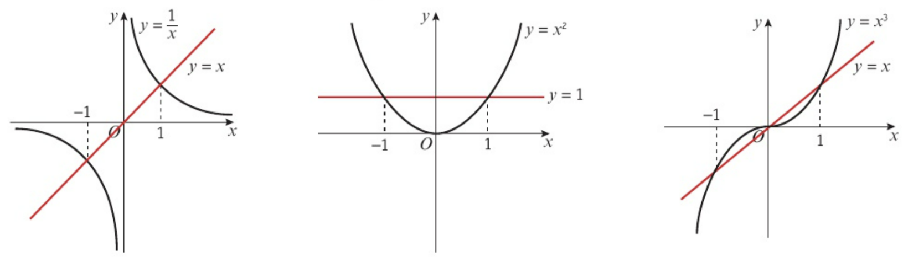

- Solve $\frac{x^{2}}{x-2}<x+1, x≠2$

- Solve $\frac{x}{x+1}≤\frac{2}{x+3}, x≠-1, x≠-3$

