1A Populations & Samples
Population

Census

Sample

Sampling Frame

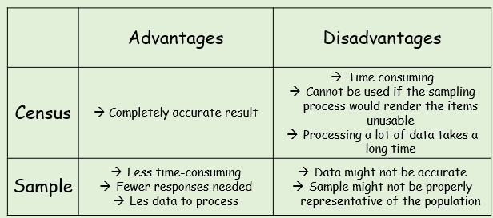
- A supermarket wants to test a delivery of avocados for ripeness by cutting them in half.
- Suggest a reason why the supermarket should choose a sample rather than a census

The supermarket tests a sample of 5 avocados and find that 4 of them are ripe. They estimate that 80% of the total are ripe.
- Suggest a way this estimate could be improved

