11A Standard Integrals

- Find the value of $\int_{-3}^{-2}{\left(\frac{1}{x}\right) dx}$

- Find the following integral:
$$\int{\left(2cosx+\frac{3}{x}-\sqrt{x}\right) dx}$$

- Find the following integral:
$$\int{\left(\frac{cosx}{\sin^{2}x}-2e^{x}\right) dx}$$

- Given that $a$ is a positive constant and:
$$\int_{a}^{3a}{\left(\frac{2x+1}{x}\right)} dx=ln12$$
Find the exact value of $a$.

11B Basic Reverse Chain Rule

- Find the following integral:
$$\int{\cos\left(2x+3\right)} dx$$

- Find the following integral:
$$\int{\left(e^{4x+1}\right)} dx$$

- Find the following integral:
$$\int{\left(\sec^{2}3x\right)} dx$$

- Find:
$$\int{\left(\frac{1}{3x+2}\right)} dx$$

- Find:
$$\int{{\left(2x+3\right)}^{4}} dx$$

11D Spotting Derivatives

- Find:
$$\int{\left(\frac{2x}{x^{2}+1}\right)} dx$$

- Find:
$$\int{\left(\frac{cosx}{3+2sinx}\right)} dx$$

- Find:
$$\int{\left(3sin⁡(x)cos(x)\right)} dx$$

- Find:
$$\int{(3\cos^{2}\left(x\right)sin\left(x\right))} dx$$

- Find:
$$\int{{{x(x}^{2}+5)}^{3}} dx$$

- Find:
$$\int{{5\tan\left(x\right)sec}^{4}(x)} dx$$

- Find $\int{\frac{\sin{2x}}{{\left(3+\cos{2x}\right)}^{3}}} dx$ (1f from textbook exercise)

11C Using Trigonometric Identities

- Find the following integral:
$$\int{\left(\tan^{2}x\right)} dx$$

- Find:
$$\int{\left(sin3xcos3x\right)} dx$$

- Find:
$$\int{{\left(secx+tanx\right)}^{2}} dx$$

- Show that:
$$\int_{\frac{π}{12}}^{\frac{π}{8}}{\left(\sin^{2}x\right)}dx=\frac{π}{48}+\frac{1-\sqrt{2}}{8}$$

11G Integration by Partial Fractions

- Find:
$$\int{\frac{x-5}{(x+1)(x-2)}dx}$$

- Find:
$$\int{\frac{9x^{2}-3x+2}{9x^{2}-4}}dx$$

11F Integration by Parts

- Find:
$$\int{\left(xcosx\right) dx}$$

- Find:
$$\int{\left(x^{2}lnx\right) dx}$$

- Find:
$$\int{\left(x^{2}e^{x}\right) dx}$$

- Evaluate:
$$\int_{1}^{2}{lnx} dx$$

11E Integration by Substitution

- Find $\int{\left(x\sqrt{2x+5}\right)}dx$ using the following substitution:
$$u=2x+5$$

- Find $\int{\left(x\sqrt{2x+5}\right)}dx$ using the following substitution:
$$u^{2}=2x+5$$

- Use the substitution $u=sinx+1$ to find:
$$\int{cosxsinx{\left(1+sinx\right)}^{3} dx}$$

- Prove that:
$$\int{\left(\frac{1}{\sqrt{1-x^{2}}}\right)} dx=arcsinx+c$$

- Use integration by substitution to evaluate:
$$\int_{0}^{2}{x{(x+1)}^{3} dx}$$

- Use integration by substitution to evaluate:
$$\int_{0}^{\frac{π}{2}}{cosx\sqrt{1+sinx} dx}$$

11H part 2 Integrating Parametric Equations
Note that this was initially left out of the textbook, so depending on your edition, you may not have practise questions. I will be using the old C4 notes and examples to talk through the theory.

- The cure has parametric equations
$$x=t(1+t) y=\frac{t}{1+t}$$
Find the exact area of the region R, bounded by the curve C, the x-axis and the lines x=0 and x=2

- A curve has Parametric equations:
$$x=5t^{2} y=t^{3}$$
Work out:
$\int_{5}^{20}{y}dx$

- The diagram shows a sketch of the curve with Parametric equations:
The curve meets the x-axis at x = 0 and x = 9. The shaded region is bounded by the curve and the x-axis.
$$x=t^{2} y=2t\left(3-t\right) t≥0$$
- Find the value of t when:
- x = 0
- x = 9

b) Find the Area of R

- The diagram shows a sketch of the curve with Parametric equations:
$$x=2t^{2} y=t(4-t^{2})$$
Calculate the finite area inside the loop…

11H Part 1 Integrating to Find Areas
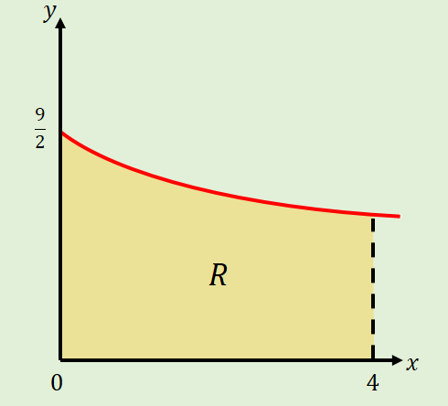
- The diagram shows part of the curve:
$$y=\frac{9}{\sqrt{4+3x}}$$
The region $R$ is bounded by the curve, the x-axis, and the lines $x=0$ and $x=4$, and shown. Use integration to find the area of $R$.

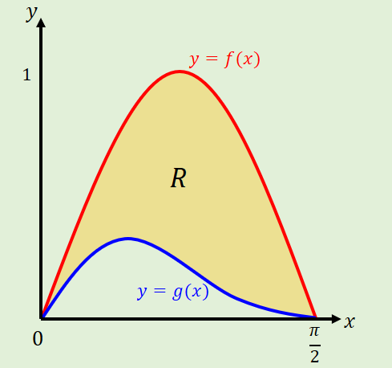
- The diagram shows part of the curves $y=f(x)$ and $y=g(x)$, where:
$$f\left(x\right)=sin2x$$
$$g\left(x\right)=sinx\cos^{2}x$$
$$0≤x≤\frac{π}{2}$$
The region $R$ is bounded by the two curves. Use integration to find the area of $R$.

11I The Trapezium Rule

- Using 4 strips, estimate the area under the curve:
$$y=\sqrt{2x+3}$$
Between the lines x = 0 and x = 2

- Using 8 strips, estimate the area under the curve:
$$y=\sqrt{2x+3}$$
Between the lines x = 0 and x = 2

- Complete the table of values and use it to find an estimate for:
$$\int_{0}^{\frac{π}{3}}{secx dx}$$
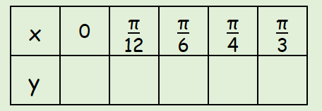

- Use the trapezium rule with 4 strips to find an approximation for:
$$\int_{0}^{2}{xsinx dx}$$

11L Integration as the Limit of a Sum

- The diagram shows a sketch of the curve with equation $y=\sin{x}$.
The area under the curve between $x=1$ and $x=2$ can be thought of as a thin series of strips of height $y$ and width $δx.$
Calculate$\lim_{δx→0}{\sum_{x=1}^{2}{\sin{x} δx}}$, giving your answer correct to 4 significant figures.
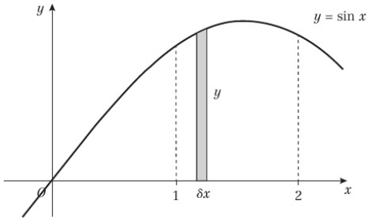

11J Separating the Variables

- Find a general solution to the differential equation:
$$\left(1+x^{2}\right)\frac{dy}{dx}=xtany$$

- Find the particular solution of the differential equation:
$$\frac{dy}{dx}=\frac{-3(y-2)}{(2x+1)(x+2)}$$
given that x = 1 when y = 4

11K Modelling with Integration

- The rate of increase of a population P of micro organisms at time t, in hours, is given by:
$\frac{dP}{dt}=3P,$ $t>0$
Initially, the population was of size 8.
- Find a model for $P$ in the form $P=Ae^{3t}$, stating the value of $A$

- Find, to the nearest hundred, the size of the population at the time $t=2$

- Find the time at which the population will be 1000 times its starting value.

- State one limitation of this model for large values of $t$

- Water in a manufacturing plant is held in a large cylindrical tank of diameter 20m. Water flows out of the bottom of the tank through a tap at a rate proportional to the cube root of the volume (of the water).
- Show that after $t$ minutes after the tap is opened, $\frac{dh}{dt}=-k\sqrt[3]{h}$ for some constant $k$.

- Show that the general solution to this differential equation may be written as $h={\left(P-Qt\right)}^{\frac{3}{2}}$, where $P$ and $Q$ are constants

Initially, the height of the water is 27m. 10 minutes later, the height is 8m.
- Find the values of the constants $P$ and $Q$

- Find the time in minutes when the water is at a depth of 1m

