1A Populations & Samples
Population

Census

Sample

Sampling Frame

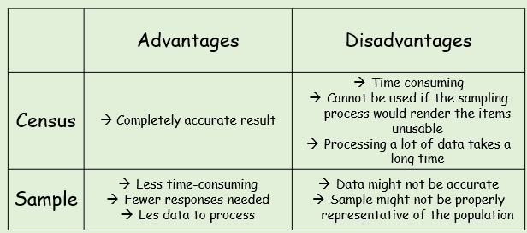
- A supermarket wants to test a delivery of avocados for ripeness by cutting them in half.
- Suggest a reason why the supermarket should choose a sample rather than a census

The supermarket tests a sample of 5 avocados and find that 4 of them are ripe. They estimate that 80% of the total are ripe.
- Suggest a way this estimate could be improved

1B Random Sampling (Simple Random, Systematic & Statified)

Simple Random

Systematic

Stratified

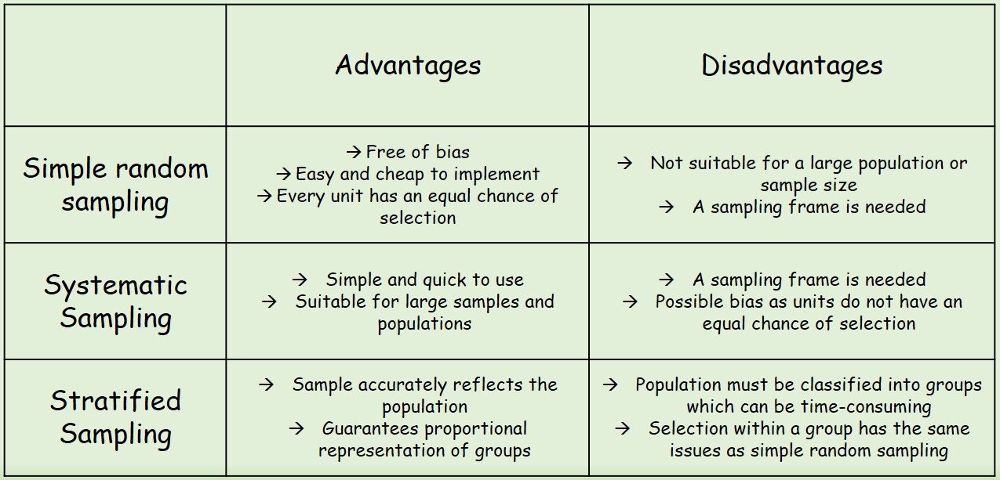
- A yacht club with 100 members are listed alphabetically in the club’s membership book. The committee wants to take a sample of 12 members to fill in a questionnaire.
- Explain how they could use a random number generator to generate the sample

- Explain how they could use a lottery system to generate the sample

- A factory manager wants to find out what his workers think of the canteen facilities. He decides to give a questionnaire to a sample of 80 workers. It is believed that different age groups will have different opinions.
The table to the right shows the number of workers in each age bracket.
- What sampling method should be used?
Age | Quantity
18-32 | 75
33-47 | 140
48-62 | 85

- How many workers should be selected from each age bracket?

1C Non-Random Sampling (Quota & Opportunity)

Quota Sampling

Opportunity Sampling

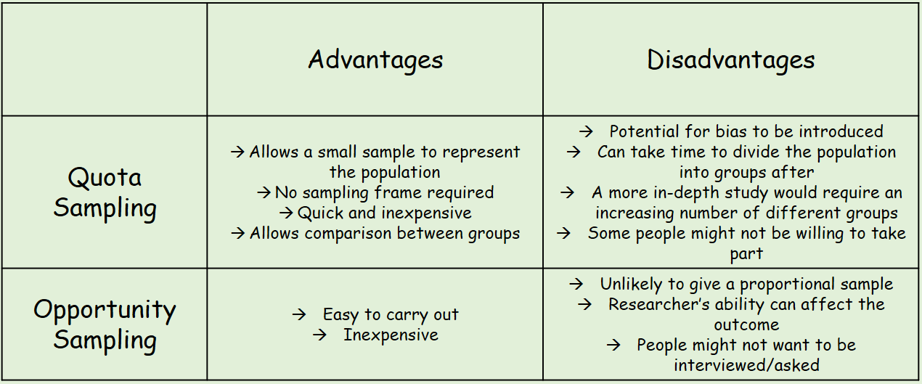
1D Types of Data
Quantitative Data

Qualitative Data

Discrete Data

Continuous Data

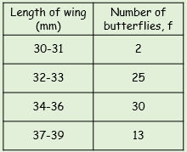
Class Boundaries

Midpoint

Class Width

- Is the length Qualitative or Quantitative?

- Is the length Discrete or Continuous?

- Write down the class boundaries, midpoint and class width for the class 34-36

