QQQ – Statistics Yr2 - Chapter 1 – Correlation & Regression
Total Marks: 21
(21 = Platinum, 19 = Gold, 17 = Silver, 15 = Bronze)

1.
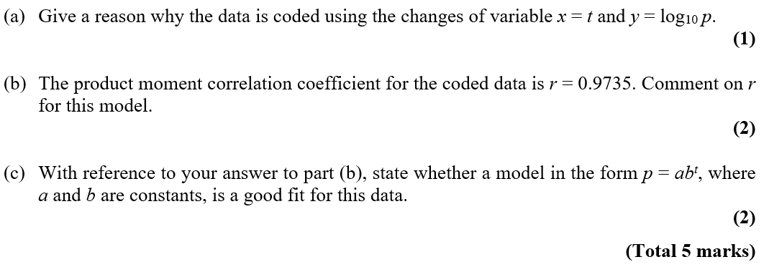
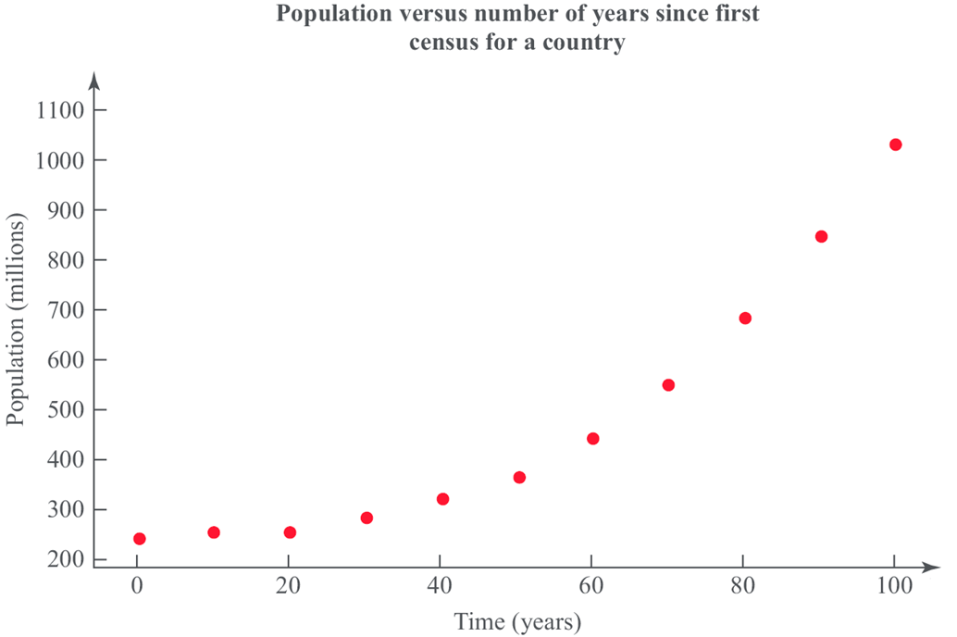
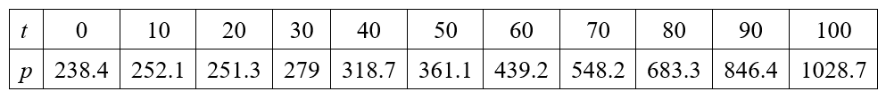

2.

To investigate if there is a correlation between daily mean pressure (hPa) and daily mean wind speed (kn) the location Hurn 2015 was randomly selected from:

Camborne 2015 Camborne 1987
Hurn 2015 Hurn 1987
Leuchars 2015 Leuchars 1987
Leeming 2015 Leeming 1987
Heathrow 2015 Heathrow 1987.

(Source: Pearson Edexcel GCE AS and A Level Mathematics data set.)

The statistical software output for these data is shown in Figure 3 below.

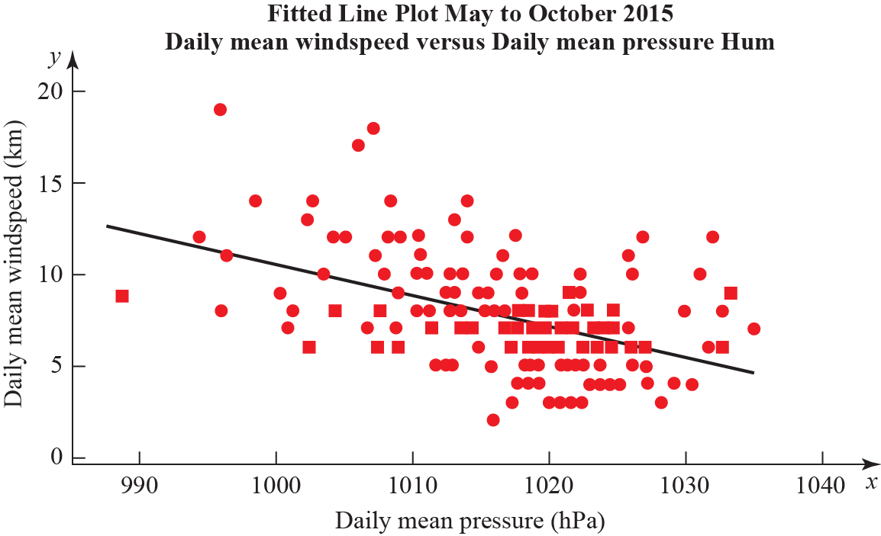

Figure 3

Correlation coefficient.
Daily mean winds and Daily mean pressure = −0.477 p-value < 0.001.
Regression summary output for daily mean wind speed versus daily mean pressure.

 | Coefficients | Lower 95% | Upper 95%
Intercept | 180.00 | 133.5424 | 226.4128
Daily Mean Pressure (hPa)  Gradient | −0.1694 | −0.21512 | −0.12377

(a) State what is measured by the product moment correlation coefficient.
(1)

(b) Comment on the correlation between the two variables.
(1)

(c) Give an interpretation of the correlation between the two variables.
(1)

(d) Test at 5% significance level whether or not the product moment correlation coefficient for the population is less than zero. State your hypotheses clearly.
(3)

(e) Write down the regression model for daily mean wind speed versus daily mean pressure.
(2)

(f) Interpret the gradient of the line of regression stated in part e.
(1)

(g) The regression model (equation of regression) was used to predict the daily mean wind speed of 11.15 knots for a daily mean pressure of 995 hPa. Comment on the accuracy of this prediction.
(1)

3.
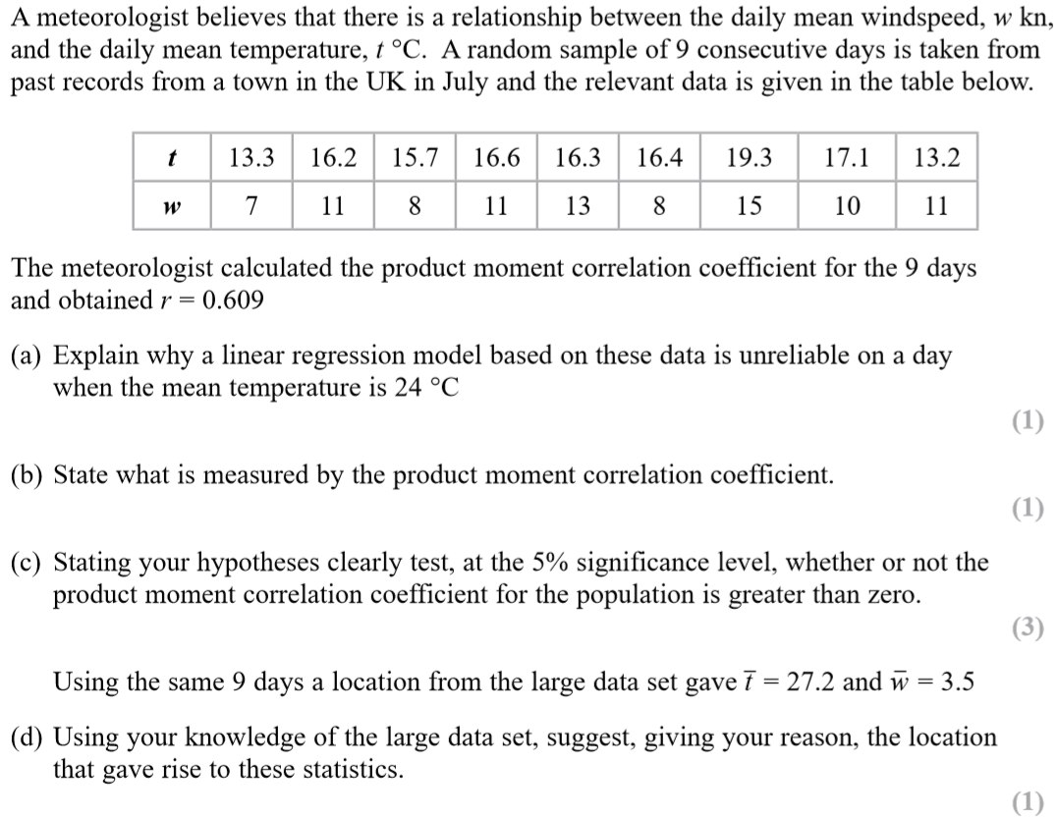

Solutions (
1.
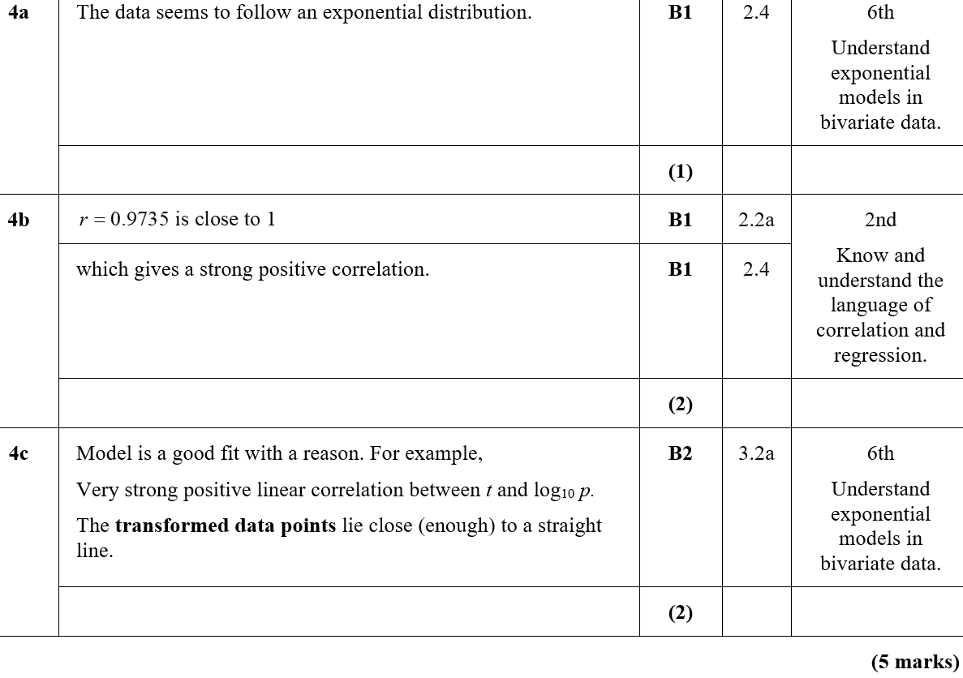 2.
G4 | Scheme | Marks | AOs | Pearson Progression Step and Progress descriptor
a | Linear association between two variables. | B1 | 1.2 | 2nd  Know and understand the language of correlation and regression.
 |  | (1)
b | Negative correlation. | B1 | 1.2 | 2nd  Know and understand the language of correlation and regression.
 |  | (1)
c | As daily mean pressure increases (rises) daily mean wind speed decreases (falls) in Hurn May to October in 2015.  or  As daily mean pressure decreases (falls) daily mean wind speed increases (rises) in Hurn May to October in 2015. | B1 | 3.2 | 5th  Interpret the PPMC as a measure of correlation.
 |  | (1)
d | H₀ : $ρ$ = 0, H₁ : $ρ$ < 0  p-value < 0.05  There is evidence to reject H_{0.}  There is (strong) evidence of negative correlation between the daily mean wind speed and daily mean pressure. | B1  M1  A1 | 2.5  1.1b  2.2b | 6th  Carry out a hypothesis test for zero correlation.
 |  | (3)
e | Daily mean wind speed = 180 − 0.170 × daily mean pressure. | B2 | 1.1b | 4th  Use the principles of bivariate data analysis in the context of the large data set.
 |  | (2)
f | The regression model suggests for every hPa increase in daily mean pressure the daily mean wind speed decreases by 0.1694 knots.  or  The regression model suggests for every hPa decrease in daily mean pressure the daily mean wind speed increases by 0.1694 knots. | B1 | 3.2 | 4th  Use the principles of bivariate data analysis in the context of the large data set.
 |  | (1)
g | Sensible comment. For example,  Not very accurate as very few or no points  Not very accurate as near the bottom range for the data. | B1 | 3.5b | 4th  Make predictions using the regression line within the range of the data.
 |  | (1)
(10 marks)
Notes
e
B1 y = 180.0 − 0.1694x unless x and y are defined.
3.
