QQQ – Statistics Yr2 - Chapter 1 – More complex numbers
Total Marks: 24
(24 = Platinum, 22 = Gold, 19 = Silver, 17 = Bronze)

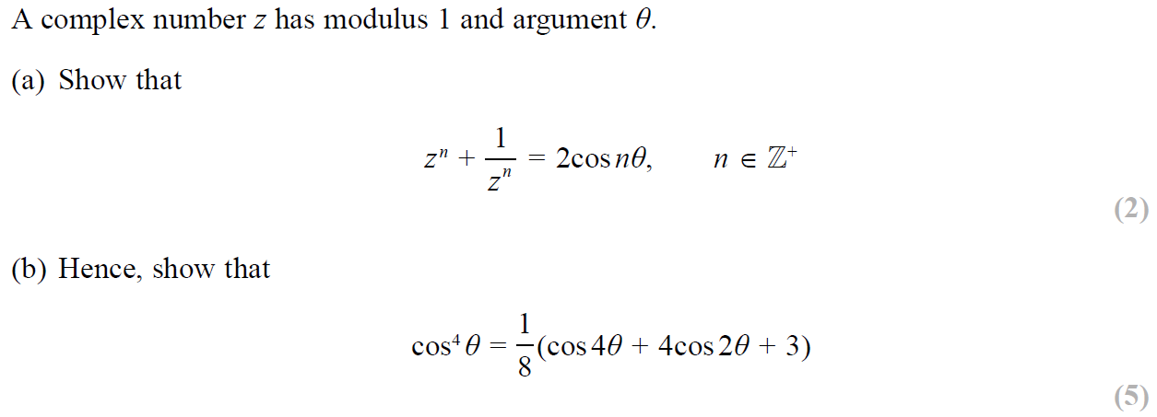
1.

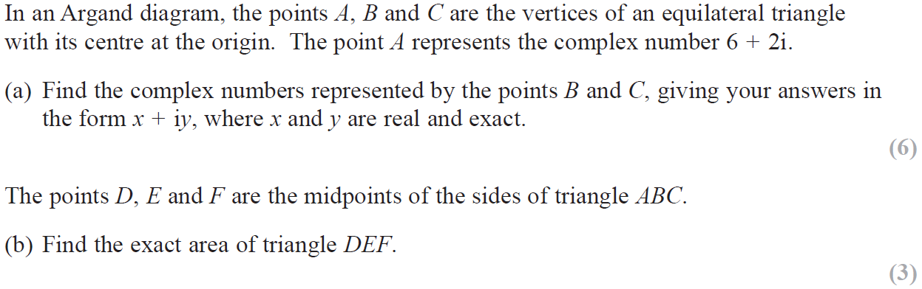
2.

3.
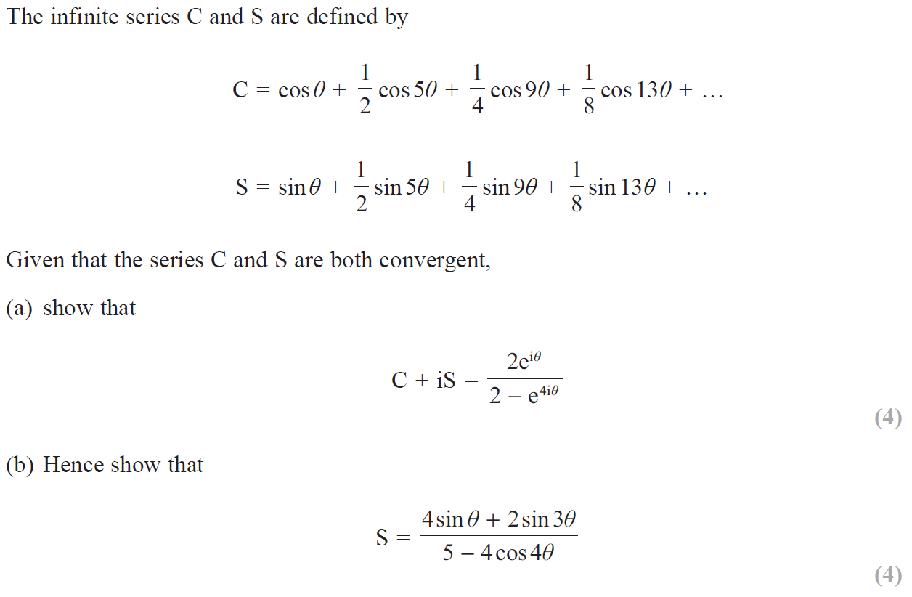

Solutions
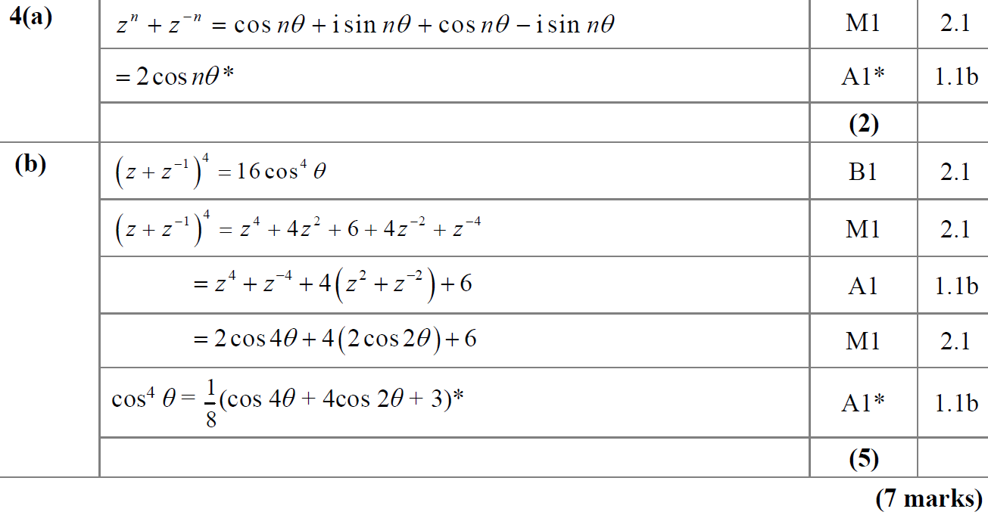

2.
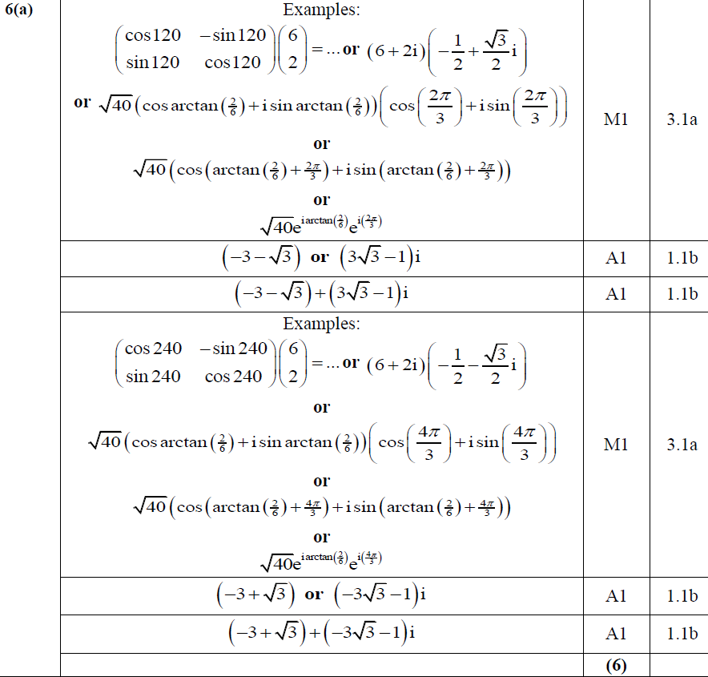
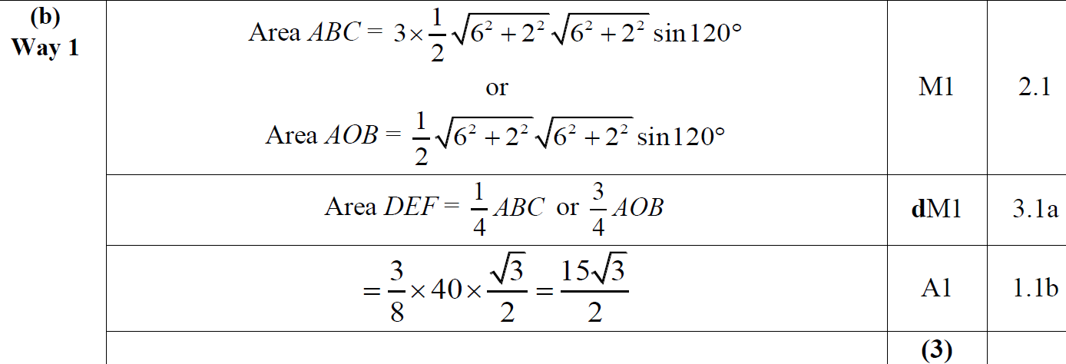

Many other ways possible. See full ms from 2019 for additional solutions

3.
