Candidates may use any calculator allowed by Pearson regulations.
Calculators must not have the facility for symbolic algebra
manipulation, differentiation and integration, or have retrievable
mathematical formulae stored in them.
Instructions
- Use black ink or ball-point pen.
- If pencil is used for diagrams / sketches / graphs it must be dark (HB or B).
- Answer all questions and ensure that your answers to parts of questions are clearly labelled.
- Answer the questions in the spaces provided
– there may be more space than you need.
- You should show sufficient working to make your methods clear. Answers without working may not gain full credit.
- Answers should be given to three significant figures unless otherwise stated.
Information
- A booklet ‘Mathematical Formulae and Statistical Tables’ is provided.
- There are 14 questions in this question paper. The total mark for this paper is 100.
- The marks for each question are shown in brackets
– use this as a guide as to how much time to spend on each question.
Advice
- Read each question carefully before you start to answer it.
- Try to answer every question.
- Check your answers if you have time at the end.
Answer ALL questions. Write your answers in the spaces provided.

1. Given
2^{x} × 4^{y} =
express y as a function of x.
(3)
(Total for Question 1 is 3 marks)
___________________________________________________________________________

2. The speed of a small jet aircraft was measured every 5 seconds, starting from the time it
turned onto a runway, until the time when it left the ground.
The results are given in the table below with the time in seconds and the speed in m s⁻¹.

Time (s) | 0 | 5 | 10 | 15 | 20 | 25
Speed (m s⁻¹) | 2 | 5 | 10 | 18 | 28 | 42

Using all of this information,
(a) estimate the length of runway used by the jet to take off.
(3)

Given that the jet accelerated smoothly in these 25 seconds,
(b) explain whether your answer to part (a) is an underestimate or an overestimate of the
length of runway used by the jet to take off.
(1)
(Total for Question 2 is 4 marks)
___________________________________________________________________________

3.
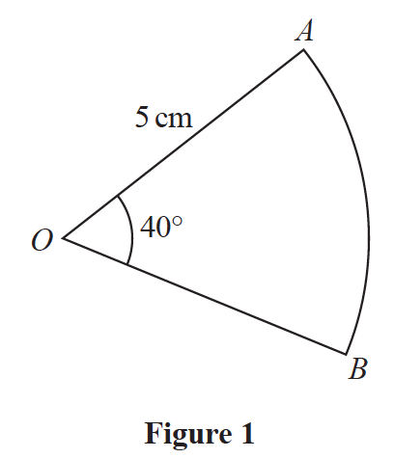
Figure 1 shows a sector AOB of a circle with centre O, radius 5 cm and angle AOB = 40°
The attempt of a student to find the area of the sector is shown below.

Area of sector | = r²𝜃
 | = × 5² × 40
 | = 500 cm²

(a) Explain the error made by this student.
(1)
(b) Write out a correct solution.
(2)
(Total for Question 3 is 3 marks)
___________________________________________________________________________

4.
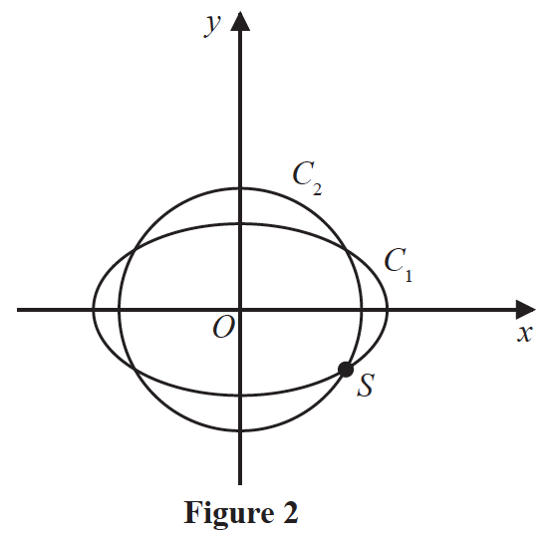
The curve C₁ with parametric equations
x = 10 cos t, y = 4sin t, 0 ⩽ t < 2π
meets the circle C₂ with equation
x² + y² = 66
at four distinct points as shown in Figure 2.
Given that one of these points, S, lies in the 4th quadrant, find the Cartesian coordinates of S.
(6)
(Total for Question 4 is 6 marks)
___________________________________________________________________________

5.
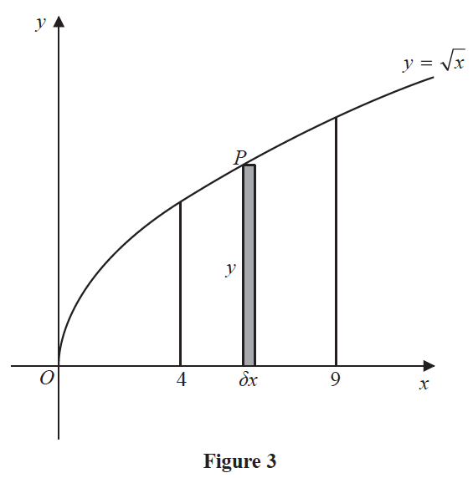
Figure 3 shows a sketch of the curve with equation y =
The point P(x, y) lies on the curve.
The rectangle, shown shaded on Figure 3, has height y and width δx.
Calculate
(3)
(Total for Question 5 is 3 marks)
___________________________________________________________________________

6.
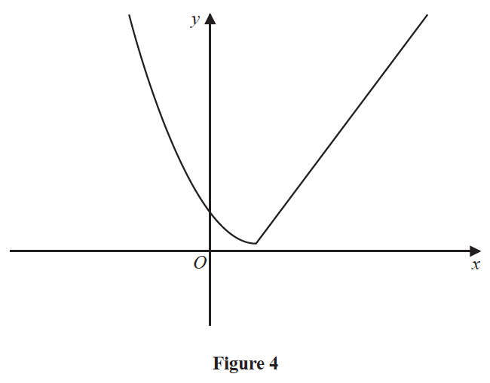
Figure 4 shows a sketch of the graph of y = g (x), where
g (x) = |  | x ⩽ 2
g (x) = |  | x > 2

(a) Find the value of gg(0).
(2)
(b) Find all values of x for which
g(x) > 28
(4)

The function h is defined by
h(x) = (x – 2)² + 1 x ⩽ 2
(c) Explain why h has an inverse but g does not.
(1)
(d) Solve the equation
h⁻¹ (x) =
(3)
(Total for Question 6 is 10 marks)
___________________________________________________________________________

7. A small factory makes bars of soap.
On any day, the total cost to the factory, £y, of making x bars of soap is modelled to be
the sum of two separate elements:
- a fixed cost,
- a cost that is proportional to the number of bars of soap that are made that day.
(a) Write down a general equation linking y with x, for this model.
(1)

The bars of soap are sold for £2 each.
On a day when 800 bars of soap are made and sold, the factory makes a profit of £500.
On a day when 300 bars of soap are made and sold, the factory makes a loss of £80.
Using the above information,
(b) show that y = 0.84x + 428
(3)
(c) With reference to the model, interpret the significance of the value 0.84 in the equation.
(1)

Assuming that each bar of soap is sold on the day it is made,
(d) find the least number of bars of soap that must be made on any given day for the
factory to make a profit that day.
(2)
(Total for Question 7 is 7 marks)
___________________________________________________________________________

8. (i) Find the value of
(3)
(ii) Show that
(3)
(Total for Question 8 is 6 marks)
___________________________________________________________________________

9. A research engineer is testing the effectiveness of the braking system of a car when it is
driven in wet conditions.
The engineer measures and records the braking distance, d metres, when the brakes are
applied from a speed of V km h⁻¹.
Graphs of d against V and log₁₀ d against log₁₀ V were plotted.
The results are shown below together with a data point from each graph.

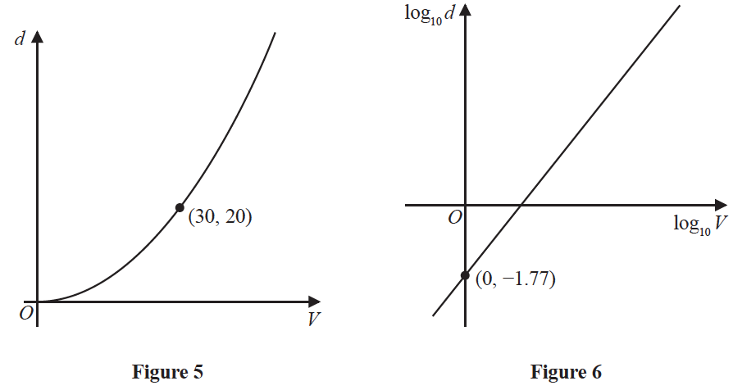

(a) Explain how Figure 6 would lead the engineer to believe that the braking distance
should be modelled by the formula
d = kV^{n} where k and n are constants
with k 0.017
(3)

Using the information given in Figure 5, with k = 0.017
(b) find a complete equation for the model giving the value of n to 3 significant figures.
(3)

Sean is driving this car at 60 km h⁻¹ in wet conditions when he notices a large puddle in
the road 100 m ahead. It takes him 0.8 seconds to react before applying the brakes.
(c) Use your formula to find out if Sean will be able to stop before reaching the puddle.
(3)
(Total for Question 9 is 9 marks)
___________________________________________________________________________

10.

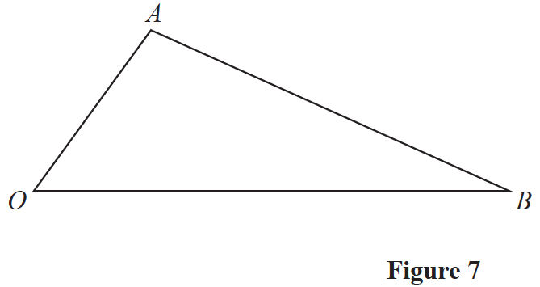

Figure 7 shows a sketch of triangle OAB.
The point C is such that = 2.
The point M is the midpoint of AB.
The straight line through C and M cuts OB at the point N.
Given = a and = b
(a) Find in terms of a and b.
(2)
(b) Show that = a + 𝜆b, where 𝜆 is a scalar constant.
(2)
(c) Hence prove that ON : NB = 2 : 1
(2)
(Total for Question 10 is 6 marks)
___________________________________________________________________________

11.
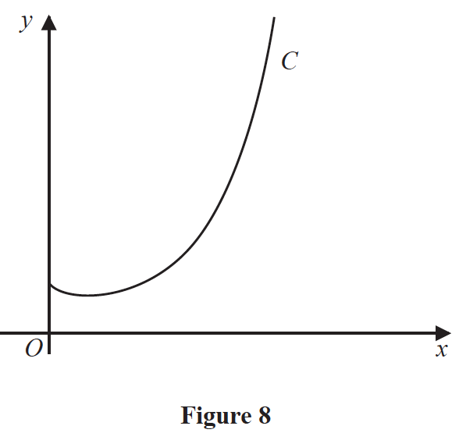

Figure 8 shows a sketch of the curve C with equation y = x ^{x}, x > 0.
(a) Find, by firstly taking logarithms, the x coordinate of the turning point of C.
(Solutions based entirely on graphical or numerical methods are not acceptable.)
(5)

The point P(α, 2) lies on C.
(b) Show that 1.5 < α < 1.6
(2)

A possible iteration formula that could be used in an attempt to find α is
x_{n+1} =
Using this formula with x₁ = 1.5
(c) find x₄ to 3 decimal places,
(2)
(d) describe the long-term behaviour of x_{n}
(2)
(Total for Question 11 is 11 marks)
___________________________________________________________________________

12. (a) Prove
𝜃 ≠ (90n)°, n ∈ ℤ
(4)
(b) Hence solve, for 90° < 𝜃 < 180°, the equation
giving any solutions to one decimal place.
(3)
(Total for Question 12 is 7 marks)
___________________________________________________________________________

13.
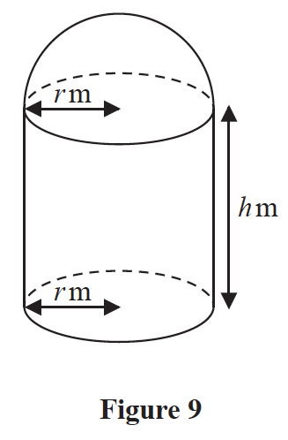
[A sphere of radius r has volume πr³ and surface area 4πr²]
A manufacturer produces a storage tank.
The tank is modelled in the shape of a hollow circular cylinder closed at one end with a
hemispherical shell at the other end as shown in Figure 9.
The walls of the tank are assumed to have negligible thickness.
The cylinder has radius r metres and height h metres and the hemisphere has radius r metres.
The volume of the tank is 6 m³.
(a) Show that, according to the model, the surface area of the tank, in m², is given by
πr²
(4)

The manufacturer needs to minimise the surface area of the tank.
(b) Use calculus to find the radius of the tank for which the surface area is a minimum.
(4)
(c) Calculate the minimum surface area of the tank, giving your answer to the nearest integer.
(2)
(Total for Question 13 is 10 marks)
___________________________________________________________________________

14. (a) Use the substitution u = 4 − to show that
= −8 ln |4 − | − 2 + k
where k is a constant
(6)

A team of scientists is studying a species of slow growing tree.
The rate of change in height of a tree in this species is modelled by the differential equation
where h is the height in metres and t is the time, measured in years, after the tree is planted.
(b) Find, according to the model, the range in heights of trees in this species.
(2)

One of these trees is one metre high when it is first planted.
According to the model,
(c) calculate the time this tree would take to reach a height of 12 metres, giving your
answer to 3 significant figures.
(7)
(Total for Question 14 is 15 marks)
___________________________________________________________________________

TOTAL FOR PAPER IS 100 MARKS

