Candidates may use any calculator allowed by Pearson regulations.
Calculators must not have the facility for symbolic algebra
manipulation, differentiation and integration, or have retrievable
mathematical formulae stored in them.
Instructions
- Use black ink or ball-point pen.
- If pencil is used for diagrams / sketches / graphs it must be dark (HB or B).
- Answer all questions and ensure that your answers to parts of questions are clearly labelled.
- Answer the questions in the spaces provided
– there may be more space than you need.
- You should show sufficient working to make your methods clear.
Answers without working may not gain full credit.
- Answers should be given to three significant figures unless otherwise stated.
Information
- A booklet ‘Mathematical Formulae and Statistical Tables’ is provided.
- There are 14 questions in this question paper. The total mark for this paper is 100.
- The marks for each question are shown in brackets
– use this as a guide as to how much time to spend on each question.
Advice
- Read each question carefully before you start to answer it.
- Try to answer every question.
- Check your answers if you have time at the end.
Answer ALL questions. Write your answers in the spaces provided.

1. f (x) = 3x³ + 2ax² – 4x + 5a

Given that (x + 3) is a factor of f (x), find the value of the constant a.
(3)
(Total for Question 1 is 3 marks)
_____________________________________________________________________________

2.
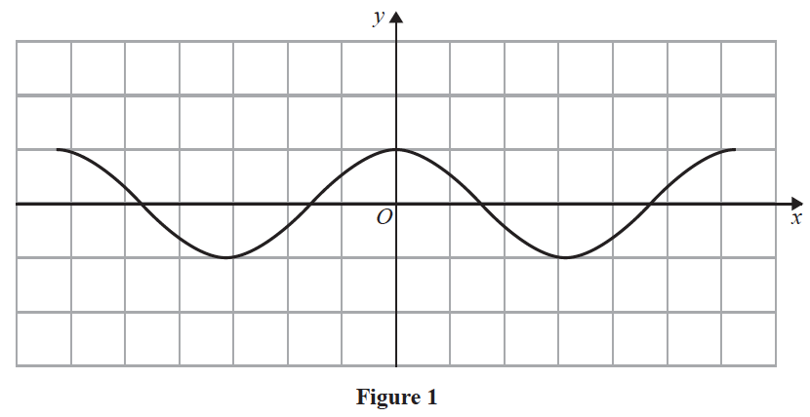
Figure 1 shows a plot of part of the curve with equation y = cos x where x is measured in radians.
Diagram 1, on the opposite page, is a copy of Figure 1.
(a) Copy and use Diagram 1 to show why the equation
cos x − 2x − = 0
has only one real root, giving a reason for your answer.
(2)

Given that the root of the equation is α, and that α is small,
(b) use the small angle approximation for cos x to estimate the value of α to 3 decimal places.
(3)
(Total for Question 2 is 5 marks)
_____________________________________________________________________________

3.
y = x ≠ −1
(a) Show that where A and n are constants to be found.
(4)
(b) Hence deduce the range of values for x for which < 0
(1)
(Total for Question 3 is 5 marks)
_____________________________________________________________________________

4. (a) Find the first three terms, in ascending powers of x, of the binomial expansion of
giving each coefficient in its simplest form.
(4)

The expansion can be used to find an approximation to

Possible values of x that could be substituted into this expansion are:
- x = –14 because
- x = 2 because
- x = because

(b) Without evaluating your expansion,
(i) state, giving a reason, which of the three values of x should not be used
(1)
(ii) state, giving a reason, which of the three values of x would lead to the most accurate approximation to
(1)
(Total for Question 4 is 6 marks)
_____________________________________________________________________________

5. f (x) = 2x² + 4x + 9 x ∈ ℝ

(a) Write f (x) in the form a(x + b)² + c, where a, b and c are integers to be found.
(3)
(b) Sketch the curve with equation y = f (x) showing any points of intersection with the
coordinate axes and the coordinates of any turning point.
(3)
(c) (i) Describe fully the transformation that maps the curve with equation y = f (x) onto
the curve with equation y = g (x) where
g (x) = 2(x – 2)² + 4x – 3 x ∈ ℝ

(ii) Find the range of the function
h(x) = x ∈ ℝ
(4)
(Total for Question 5 is 10 marks)
_____________________________________________________________________________

6. (a) Solve, for –180° ≤ θ ≤ 180°, the equation

5 sin 2θ = 9 tan θ
giving your answers, where necessary, to one decimal place.
[Solutions based entirely on graphical or numerical methods are not acceptable.]
(6)
(b) Deduce the smallest positive solution to the equation
5 sin (2x – 50°) = 9 tan (x – 25°)
(2)
(Total for Question 6 is 8 marks)
___________________________________________________________________________

7. In a simple model, the value, £V, of a car depends on its age, t, in years.
The following information is available for car A
- its value when new is £20 000
- its value after one year is £16 000
(a) Use an exponential model to form, for car A, a possible equation linking V with t.
(4)

The value of car A is monitored over a 10-year period.
Its value after 10 years is £2 000
(b) Evaluate the reliability of your model in light of this information.
(2)

The following information is available for car B
- it has the same value, when new, as car A
- its value depreciates more slowly than that of car A
(c) Explain how you would adapt the equation found in (a) so that it could be used to
model the value of car B.
(1)
(Total for Question 7 is 7 marks)
___________________________________________________________________________

8.
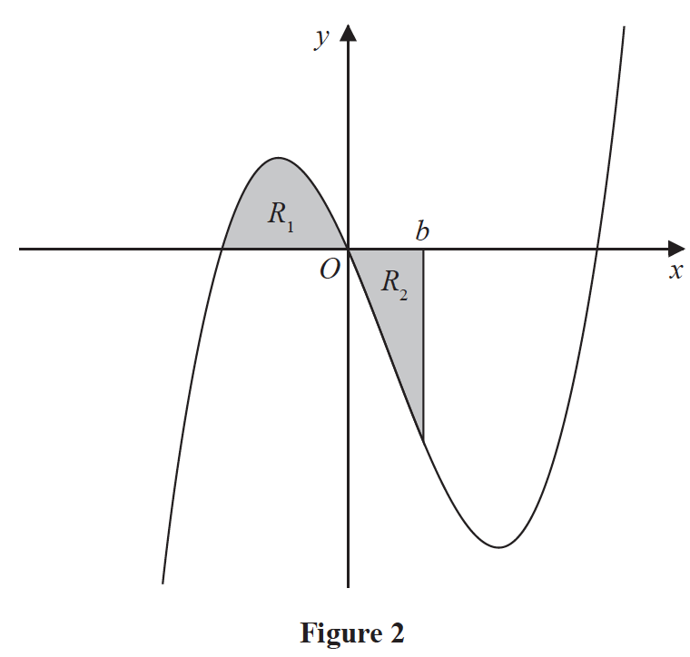
Figure 2 shows a sketch of part of the curve with equation y = x(x + 2)(x – 4).
The region R₁ shown shaded in Figure 2 is bounded by the curve and the negative x-axis.
(a) Show that the exact area of R₁ is
(4)

The region R₂ also shown shaded in Figure 2 is bounded by the curve, the positive x-axis
and the line with equation x = b, where b is a positive constant and 0 < b < 4
Given that the area of R₁ is equal to the area of R₂
(b) verify that b satisfies the equation
(b + 2)² (3b² – 20b + 20) = 0
(4)

The roots of the equation 3b² – 20b + 20 = 0 are 1.225 and 5.442 to 3 decimal places.
The value of b is therefore 1.225 to 3 decimal places.
(c) Explain, with the aid of a diagram, the significance of the root 5.442
(2)
(Total for Question 8 is 10 marks)
___________________________________________________________________________

9. Given that a > b > 0 and that a and b satisfy the equation
log a – log b = log(a – b)
(a) show that
(3)
(b) Write down the full restriction on the value of b, explaining the reason for this restriction.
(2)
(Total for Question 9 is 5 marks)
___________________________________________________________________________

10. (i) Prove that for all n ∈ ℕ, n² + 2 is not divisible by 4
(4)
(ii) “Given x ∈ ℝ, the value of |3x – 28| is greater than or equal to the value of (x – 9).”

State, giving a reason, if the above statement is always true, sometimes true or never true.
(2)
(Total for Question 10 is 6 marks)
___________________________________________________________________________

11. A competitor is running a 20 kilometre race.
She runs each of the first 4 kilometres at a steady pace of 6 minutes per kilometre.
After the first 4 kilometres, she begins to slow down.
In order to estimate her finishing time, the time that she will take to complete each subsequent kilometre is modelled to be 5% greater than the time that she took to complete the previous kilometre.

Using the model,
(a) show that her time to run the first 6 kilometres is estimated to be 36 minutes 55 seconds,
(2)
(b) show that her estimated time, in minutes, to run the rth kilometre, for 5 ≤ r ≤ 20, is
6 × 1.05^{r − 4}
(1)
(c) estimate the total time, in minutes and seconds, that she will take to complete the race.
(4)
(Total for Question 11 is 7 marks)
___________________________________________________________________________

12. f (x) = 10e^{−0.25x} sin x, x ≥ 0

(a) Show that the x coordinates of the turning points of the curve with equation y = f (x)
satisfy the equation tan x = 4
(4)

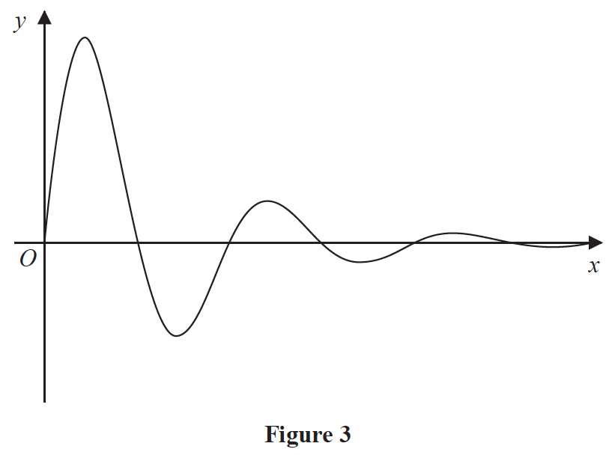
Figure 3 shows a sketch of part of the curve with equation y = f (x).
(b) Sketch the graph of H against t where
H(t) = |10e^{−0.25x} sin t | t ≥ 0
showing the long-term behaviour of this curve.
(2)

The function H(t) is used to model the height, in metres, of a ball above the ground t seconds after it has been kicked.

Using this model, find
(c) the maximum height of the ball above the ground between the first and second bounce.
(3)
(d) Explain why this model should not be used to predict the time of each bounce.
(1)
(Total for Question 12 is 10 marks)
___________________________________________________________________________

13. The curve C with equation
y = x ∈ ℝ, x ≠ −3, x ≠ 2
where p and q are constants, passes through the point and has two vertical asymptotes
with equations x = 2 and x = –3

(a) (i) Explain why you can deduce that q = 4
(ii) Show that p = 15
(3)

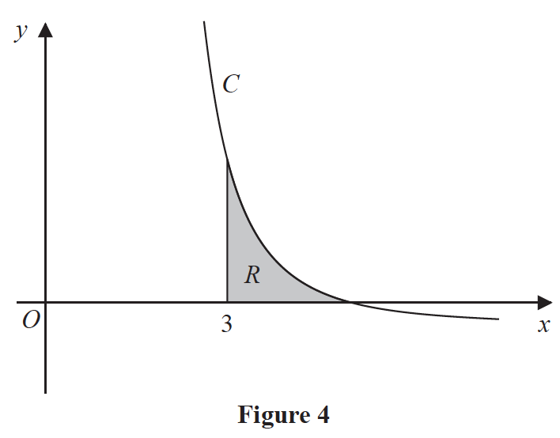
Figure 4 shows a sketch of part of the curve C. The region R, shown shaded in Figure 4,
is bounded by the curve C, the x-axis and the line with equation x = 3
(b) Show that the exact value of the area of R is a ln 2 + b ln 3, where a and b are rational
constants to be found.
(8)
(Total for Question 13 is 11 marks)
___________________________________________________________________________

14. The curve C, in the standard Cartesian plane, is defined by the equation
x = 4 sin 2y < y <
The curve C passes through the origin O
(a) Find the value of at the origin.
(2)
(b) (i) Use the small angle approximation for sin 2y to find an equation linking x and y
for points close to the origin.
(ii) Explain the relationship between the answers to (a) and (b)(i).
(2)
(c) Show that, for all points (x, y) lying on C,
where a and b are constants to be found.
(3)
(Total for Question 14 is 7 marks)
___________________________________________________________________________

TOTAL FOR PAPER IS 100 MARKS

