3C Eccentricity

Ellipse

Parabola

Hyperbola

- Show that for $0<e<1$, the ellipse with focus $S=(ae,0)$ and directrix $x=\frac{a}{e}$ has equation $\frac{x^{2}}{a^{2}}+\frac{y^{2}}{b^{2}}=1$.

- Find foci of the ellipse with equation $\frac{x^{2}}{9}+\frac{y^{2}}{4}=1$ and give the equation of the directrices. Hence sketch the ellipse.

- Find foci of the ellipse with equation $\frac{x^{2}}{16}+\frac{y^{2}}{25}=1$ and give the equation of the directrices. Hence sketch the ellipse.

- If $P$ is a point on an ellipse $\frac{x^{2}}{a^{2}}+\frac{y^{2}}{b^{2}}=1$, prove that $PS+PS^{'}=2a$

- Show that for $e>1$, the hyperbola with foci at $\left(±ae,0\right)$ and directrices at $x=±\frac{a}{e}$ has equation $\frac{x^{2}}{a^{2}}-\frac{y^{2}}{b^{2}}=1$

- Sketch the hyperbola with equation $\frac{x^{2}}{9}-\frac{y^{2}}{4}=1$, indicating the foci, directrices and equations of the asymptotes.

- Sketch the hyperbola with equation $\frac{x^{2}}{16}-\frac{y^{2}}{25}=1$, indicating the foci, directrices and equations of the asymptotes.

A quick note on hyperbolas and ellipses:
For hyperbolas, you don’t care which of $a$ and $b$ are bigger. For ellipses, swapping the $a$ and $b$ has the effect of rotating the ellipse $90°$ and hence the foci/directrices too. We don’t get this same rotation for hyperbolas.

Formula book p19
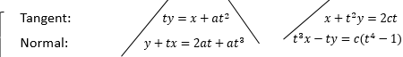
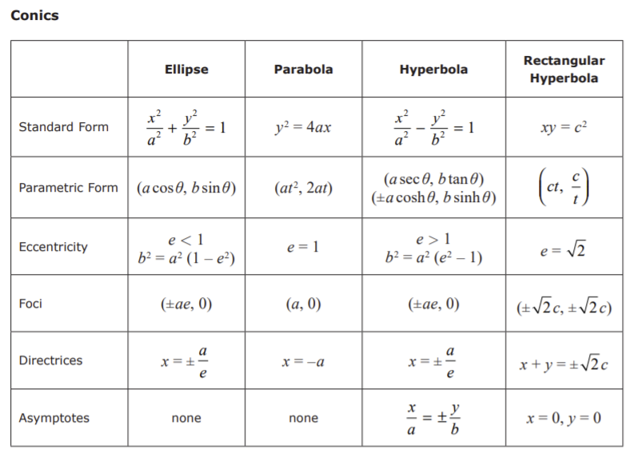
Note:

