3A Ellipses
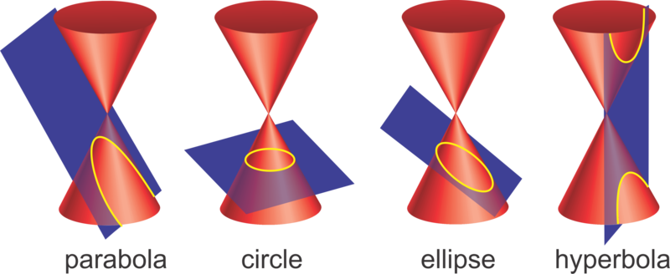

- The ellipse $E$ has equation
$4x^{2}+9y^{2}=36$.
- Sketch $E$.

- Write down its parametric equations.

- The ellipse $E$ has parameter equations:
$$x=3\cos{θ}y=5\sin{θ}$$
Determine its Cartesian equation.

