3A Ellipses
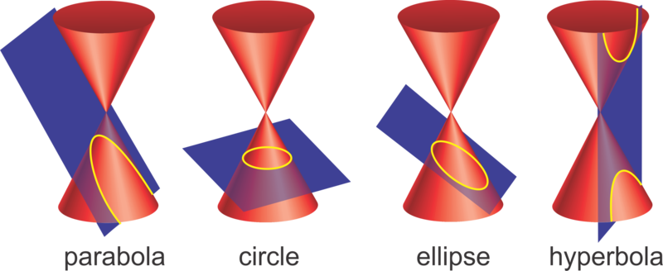

- The ellipse $E$ has equation
$4x^{2}+9y^{2}=36$.
- Sketch $E$.

- Write down its parametric equations.

- The ellipse $E$ has parameter equations:
$$x=3\cos{θ}y=5\sin{θ}$$
Determine its Cartesian equation.

3B Hyperbolas

- The hyperbola $H$ has equation
$4x^{2}-9y^{2}=36$.
- Sketch $H$.

- Write down the equations of the asymptotes of $H$.

- Find parametric Equations for $H$.

- A hyperbola H has parametric equations
$$x=4\sec{t}, y=\tan{t}, -π≤t<π, t≠±\frac{π}{2}$$
- Find a Cartesian equation for $H$.

- Sketch $H$.

- Write down the equations of the asymptotes of $H$.

3C Eccentricity

Ellipse

Parabola

Hyperbola

- Show that for $0<e<1$, the ellipse with focus $S=(ae,0)$ and directrix $x=\frac{a}{e}$ has equation $\frac{x^{2}}{a^{2}}+\frac{y^{2}}{b^{2}}=1$.

- Find foci of the ellipse with equation $\frac{x^{2}}{9}+\frac{y^{2}}{4}=1$ and give the equation of the directrices. Hence sketch the ellipse.

- Find foci of the ellipse with equation $\frac{x^{2}}{16}+\frac{y^{2}}{25}=1$ and give the equation of the directrices. Hence sketch the ellipse.

- If $P$ is a point on an ellipse $\frac{x^{2}}{a^{2}}+\frac{y^{2}}{b^{2}}=1$, prove that $PS+PS^{'}=2a$

- Show that for $e>1$, the hyperbola with foci at $\left(±ae,0\right)$ and directrices at $x=±\frac{a}{e}$ has equation $\frac{x^{2}}{a^{2}}-\frac{y^{2}}{b^{2}}=1$

- Sketch the hyperbola with equation $\frac{x^{2}}{9}-\frac{y^{2}}{4}=1$, indicating the foci, directrices and equations of the asymptotes.

- Sketch the hyperbola with equation $\frac{x^{2}}{16}-\frac{y^{2}}{25}=1$, indicating the foci, directrices and equations of the asymptotes.

A quick note on hyperbolas and ellipses:
For hyperbolas, you don’t care which of $a$ and $b$ are bigger. For ellipses, swapping the $a$ and $b$ has the effect of rotating the ellipse $90°$ and hence the foci/directrices too. We don’t get this same rotation for hyperbolas.

Formula book p19
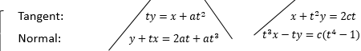
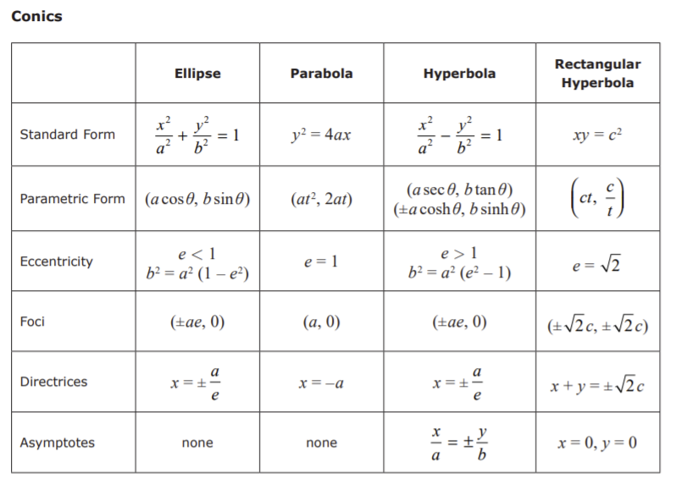
Note:
3D Gradients of an Ellipse

- Find the equation of the tangent to the ellipse with equation $\frac{x^{2}}{9}+\frac{y^{2}}{4}=1$ at the point $\left(3\cos{θ},2\sin{θ}\right)$

- Show that the equation of the normal to the ellipse with equation $\frac{x^{2}}{a^{2}}+\frac{y^{2}}{b^{2}}=1$ at the point $P\left(a\cos{θ},b\sin{θ}\right)$ is $by\cos{θ}=ax\sin{θ}+\left(b^{2}-a^{2}\right)\cos{θ}\sin{θ}$

Notes on tangents and normals to an ellipse

- The point $P\left(2,\frac{3\sqrt{3}}{2}\right)$ lies on the ellipse $E$ with parametric equations
$x=4\cos{θ}, y=3 sin θ$.
- Find the value of $θ$ at the point $P$.

- Find the equation of the normal to the ellipse at point $P$.

- Show that the condition for $y=mx+c$ to be a tangent to the ellipse $\frac{x^{2}}{a^{2}}+\frac{y^{2}}{b^{2}}=1$ is
$$a^{2}m^{2}+b^{2}=c^{2}$$

- The ellipse $C$ has the equation $\frac{x^{2}}{5^{2}}-\frac{y^{2}}{3^{2}}=1$. The line $l$ is normal to the ellipse at the point $P$ and passes through the point $Q$, where $C$ cuts the $y$-axis, as shown in the diagram.
Find the exact coordinates of the point $R$, where $l$ cuts the positive$x$-axis.
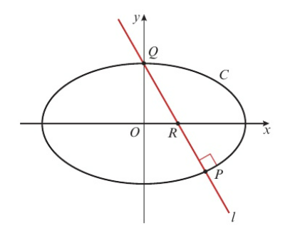

3E Gradients of a Hyperbola

- Find the equation of the tangent to the hyperbola with equation $\frac{x^{2}}{9}-\frac{y^{2}}{4}=1$ at the point $\left(6,2\sqrt{3}\right)$

- Prove that the equation of a tangent to the hyperbola $\frac{x^{2}}{a^{2}}-\frac{y^{2}}{b^{2}}=1$ at the point $\left(a\cosh{t}, b\sinh{t}\right)$ is $ay\sinh{t}+ab=bx\cosh{t}$

- Show that an equation of the normal to the hyperbola with equation $\frac{x^{2}}{a^{2}}-\frac{y^{2}}{b^{2}}=1$ at $(\operatorname{asec}{θ},b\tan{θ})$ is $by+ax\sin{θ}=\left(a^{2}+b^{2}\right)\tan{θ}$.

- Show that the condition for the line $y=mx+c$ to be a tangent to the hyperbola $\frac{x^{2}}{a^{2}}-\frac{y^{2}}{b^{2}}=1$ is that $m$ and $c$ satisfy $b^{2}+c^{2}=a^{2}m^{2}.$

- The tangent to the hyperbola with equation $\frac{x^{2}}{9}-\frac{y^{2}}{4}=1$ at the point $\left(3\cosh{t}, 2\sinh{t}\right)$ crosses the $y$-axis at the point $\left(0,-1\right)$. Find the value of $t$.

- The hyperbola $H$ has equation $\frac{x^{2}}{36}-\frac{y^{2}}{9}=1$.
The line $l_{1}$ is the tangent to $H$ at the point $P(6\cosh{t},3\sinh{t})$. The line $l_{2}$ passes through the origin and is perpendicular to $l_{1}.$ The lines $l_{1}$ and $l_{2}$ intersect at the point $Q$.
Show that the coordinates of the point $Q$ are $\left(\frac{6\cosh{t}}{4\sinh^{2}{t}+\cosh^{2}{t}}, -\frac{12\sinh{t}}{4\sinh^{2}{t}+\cosh^{2}{t}}\right)$.

3F More Loci

- The tangent to the ellipse with equation $\frac{x^{2}}{a^{2}}+\frac{y^{2}}{b^{2}}=1$ at the point $P\left(a\cos{t},b\sin{t}\right)$ crosses the $x$-axis at $A$ and the $y$-axis at $B$.
Find an equation for the locus of the mid-point of $AB$ as $P$ moves around the ellipse.

- The normal at $P\left(ap^{2}, 2ap\right)$ and the normal at $Q\left(aq^{2}, 2aq\right)$ to the parabola with equation $y^{2}=4ax$ meet at $R$.
- Find the coordinates of $R$.

The chord $PQ$ passes through the focus $\left(a,0\right)$ of the parabola.
- Show that $pq=-1$

- Show that the locus of $R$ is a parabola with equation $y^{2}=a\left(x-3a\right)$

