12B First Principles

- A point A with coordinates (4,16) lies on the curve with equation $y=x^{2}$. At point A the curve has gradient $g$.
- Show that $g=\lim_{δx→0}(8+δx)$

- Deduce the value of $g$

12C General Rules

- Find $f^{'}\left(x\right)$ for each of the expressions for $f(x)$ to the right.
- $f\left(x\right)=x^{6}$

- $f\left(x\right)=x^{\frac{1}{2}}$

- $f\left(x\right)=x^{-2}$

- $f\left(x\right)=x^{2}×x^{3}$

- $f\left(x\right)=\frac{x}{x^{5}}$

- $f\left(x\right)=7x^{3}$

- $f\left(x\right)=-4x^{\frac{1}{2}}$

- $f\left(x\right)=\sqrt{36x^{3}}$

12D Multiple terms

- Find $\frac{dy}{dx}$ when $y=x^{2}-6x-4$

- Find the gradient of the curve $y=x^{3}+x^{2}$ when $x=2$

- Find the gradient of the curve $y={\frac{1}{3}x}^{\frac{1}{2}}+4x^{2}$ at the point $\left(1,\frac{13}{3}\right)$

12E Preparing for Calculus

- Find $\frac{dy}{dx}$ when $y=\frac{1}{4\sqrt{x}}$

- Find the gradient of the curve $y=\frac{x-2}{x^{2}}$ at the point (2,0)

12F Tangents & Normals

- Find the equation of the tangent to the curve y = x³ – 3x² + 2x - 1, at the point (3,5).

- Find the equation of the normal to the curve y = 8 - 3√x at the point where x = 4.

12G Increasing & Decreasing Functions
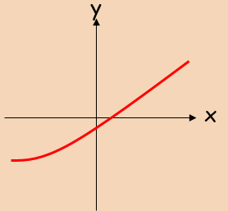
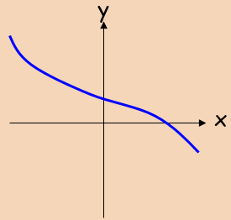
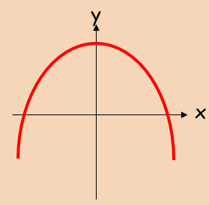
- Show that the function ;
$$f\left(x\right)=x^{3}+24x+3$$
is an increasing function.

- Find the range of values where:
$$f\left(x\right)=x^{3}+3x^{2}-9x$$
is a decreasing function.

12J Graphing the Gradient Function
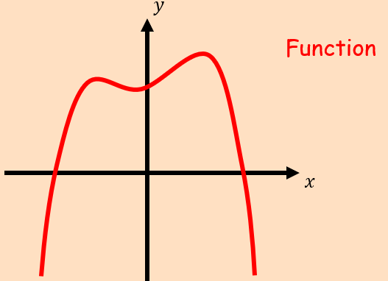
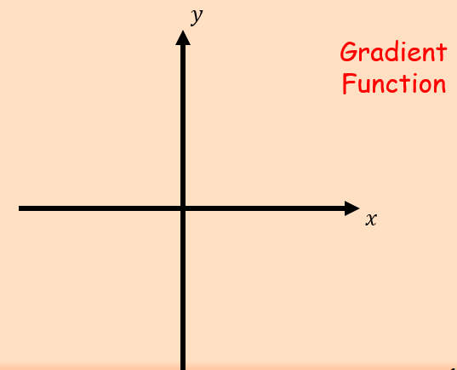
- The diagram shows the curve with equation $y=f(x)$. It has an asymptote at $y=-2$, a turning point at $(-3,-8)$and it cuts the x-axis at $(-10,0)$
- Sketch the graph of $y=f'(x)$
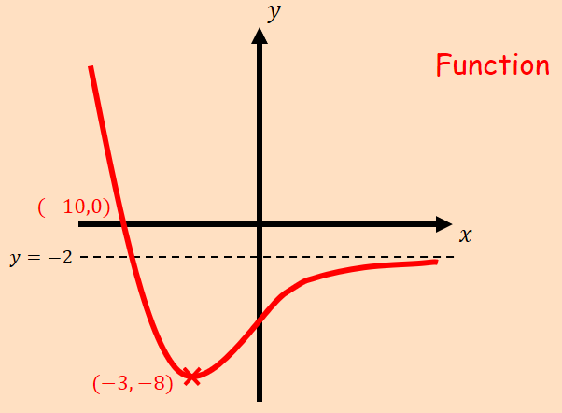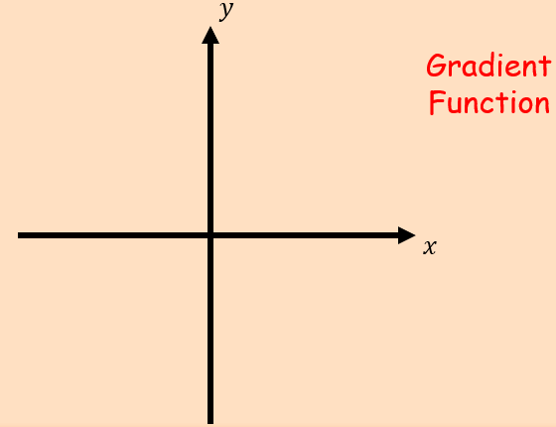

- State the equation of the asymptote of $y=f'(x)$

12H Second Derivatives

- Find $\frac{dy}{dx}$ and $\frac{d^{2}y}{dx^{2}}$ of the following:
$$y=3x^{5}+\frac{4}{x^{2}}$$

- Find $f^{'}(x)$ and $f^{''}(x)$ of the following:
$$f\left(x\right)=3\sqrt{x}+\frac{1}{2x}$$

12I Stationary Points
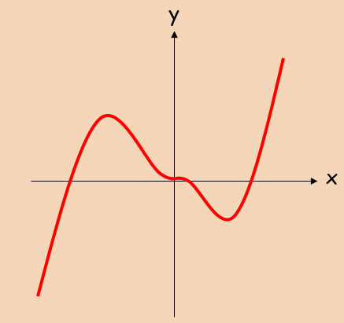
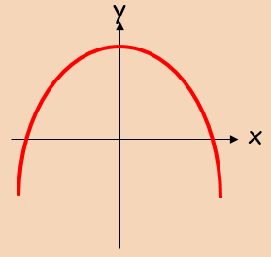
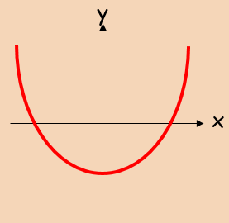

Note on f’’(x) = 0

- Find the coordinates of the turning point on the curve y = x⁴ – 32x, and state whether it is a minimum or maximum.

- Find the stationary points on the curve: y = 2x³ – 15x² + 24x + 6, and state whether they are minima, maxima or points of inflexion

12K Differentiation in Context

- Given that the volume, $V {cm}^{3}$, of an expanding sphere is related to its radius, $r cm$, by the formula $V=\frac{4}{3}πr^{3}$, find the rate of change of volume with respect to radius at the instant when the radius is 5cm.

- A large tank (shown) is to be made from 54m² of sheet metal. It has no top.
a) Show that the Volume of the tank will be given by:
$$V=18x-\frac{2}{3}x^{3}$$

b) Find the Maximum volume of the tank

