2D Rectangular Hyperbolas
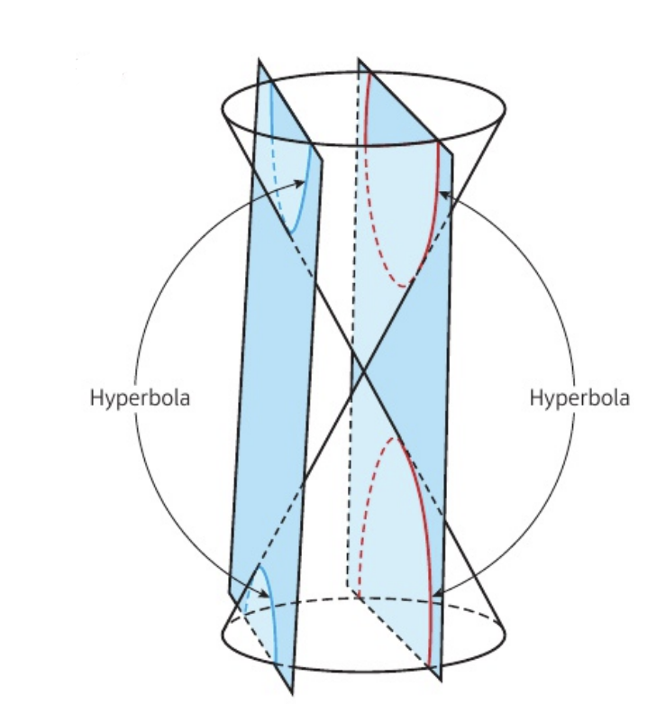
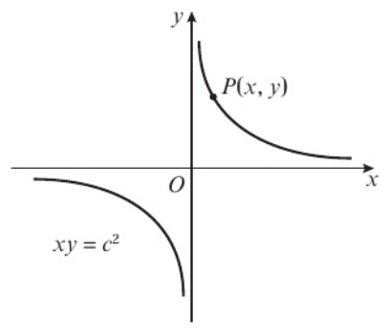
Eccentricity

What makes it rectangular?

- The rectangular hyperbola $H$ has Cartesian equation $xy=64$. The line $l$ with equation $x+2y-36=0$ intersects the curve at the points $P$ and $Q$.
- Find the coordinates of $P$ and $Q$.

- Find the equation of the perpendicular bisector of $PQ$ in the form $y=mx+c$.

