2B Parabolas
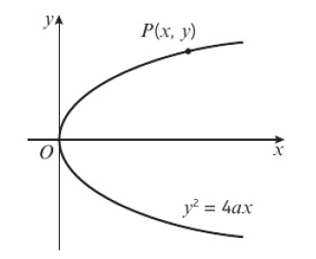
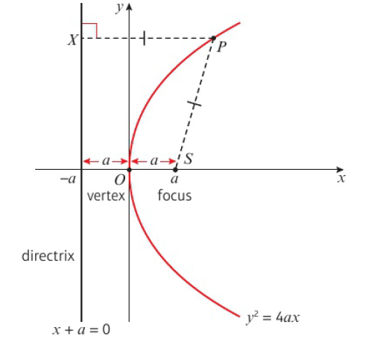
- Find the equation of the parabola with:
- focus: $(7,0)$ and directrix $x+7=0$

- focus $\left(\frac{\sqrt{3}}{4},0\right)$ and directrix $x=-\frac{\sqrt{3}}{4}$

- Find the coordinates of the focus and an equation of the directrix of a parabola with equation:
- $y^{2}=24x$

- $y^{2}=\sqrt{32}x$

