2A Parametrics Revisited
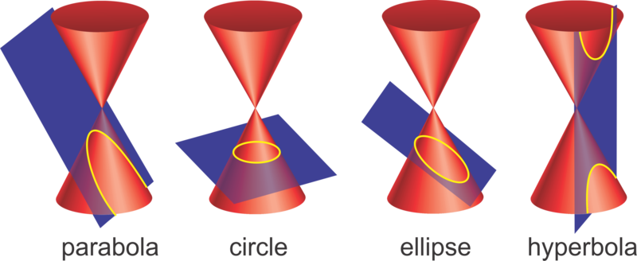

- A curve has parametic equations
$$x=at^{2}, y=2at, t∈R,$$
where$a$ is a positive constant. Find the Cartesian equation of the curve

A curve has parametric equations
$$x=ct, y=\frac{c}{t}, t≠0,$$
where $c$ is a positive constant.
- Find the Cartesian equation of the curve.

- Hence sketch the curve

Note: Alternative approach (multiplying to cancel t)

