2A Parametrics Revisited
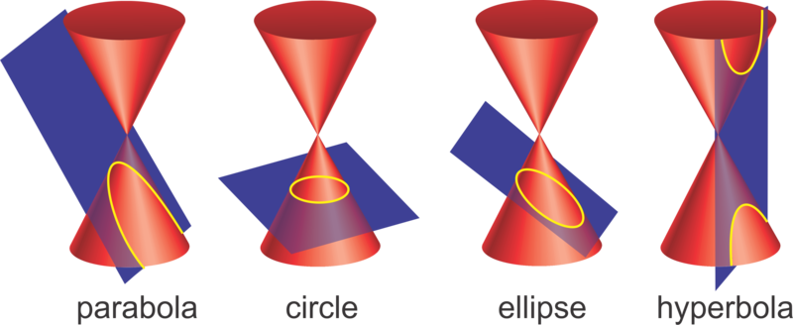

- A curve has parametic equations
$$x=at^{2}, y=2at, t∈R,$$
where$a$ is a positive constant. Find the Cartesian equation of the curve

A curve has parametric equations
$$x=ct, y=\frac{c}{t}, t≠0,$$
where $c$ is a positive constant.
- Find the Cartesian equation of the curve.

- Hence sketch the curve

Note: Alternative approach (multiplying to cancel t)

2B Parabolas
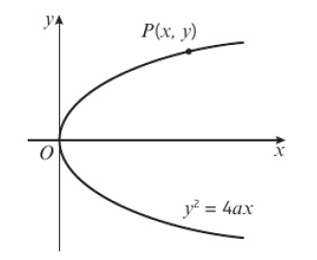
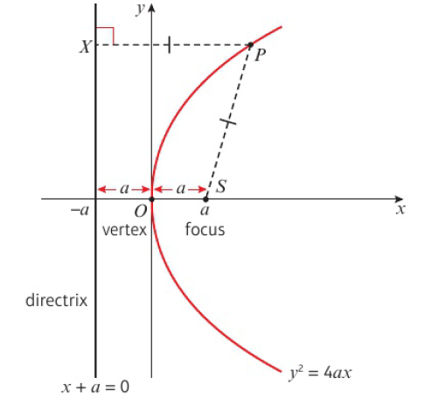
- Find the equation of the parabola with:
- focus: $(7,0)$ and directrix $x+7=0$

- focus $\left(\frac{\sqrt{3}}{4},0\right)$ and directrix $x=-\frac{\sqrt{3}}{4}$

- Find the coordinates of the focus and an equation of the directrix of a parabola with equation:
- $y^{2}=24x$

- $y^{2}=\sqrt{32}x$

2C Parabolas & Chords

- A point $P(8, -8)$ lies on the parabola C with equation $y^{2}=8x$. The point $S$ is the focus of the parabola. The line l passes through S and P.
- Find the coordinates of $S$.

- Find an equation for $l$, giving your answers in the form $ax+by+c=0$, where $a$, $b$, $c$ are integers.

- The line $l$ meets the parabola $C$ again at the point $Q$. The point $M$ is the mid-point of $PQ$. Find the coordinates of $Q$.

- Find the coordinates of $M$.

- Draw a sketch showing parabola $C$, the line $l$
and the points $P$, $Q$, $S$ and $M$.

- The parabola $C$ has general point $\left(at^{2},2at\right)$. The line $x=k$ intersects $C$ at the points $P$ and $Q$. Find, in terms of $a$ and $k$, the length of the chord $PQ$.

A quick note on integration:
2D Rectangular Hyperbolas
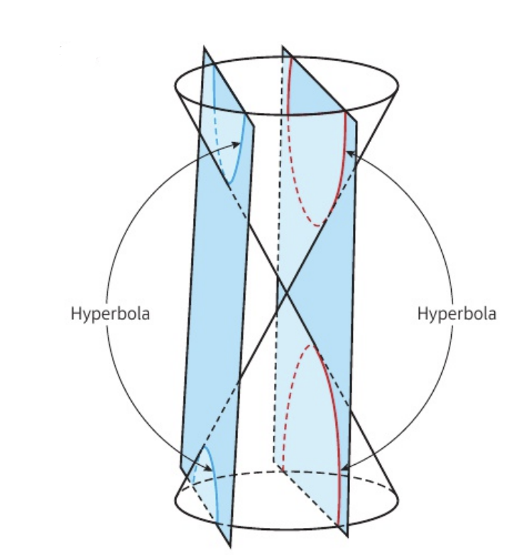
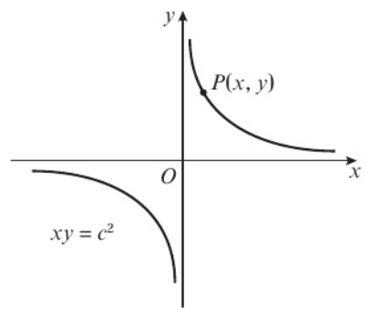
Eccentricity

What makes it rectangular?

- The rectangular hyperbola $H$ has Cartesian equation $xy=64$. The line $l$ with equation $x+2y-36=0$ intersects the curve at the points $P$ and $Q$.
- Find the coordinates of $P$ and $Q$.

- Find the equation of the perpendicular bisector of $PQ$ in the form $y=mx+c$.

2E Tangents & Normals

- The point $P$, where $x=2$, lies on the rectangular hyperbola $H$ with equation $xy=8$. Find:
- The equation of the tangent $T$.

- The equation of the normal $N$to $H$ at the point $P$, giving your answer in the form $ax+by+c=0$.

- The distinct points A and B, where $x=3$ lie on the parabola C with equation $y^{2}=27x$.
- The line $l_{1}$ is the tangent to C at A and the line $l_{2}$ is the tangent to C at B.
Given that at A, $y>0$, find the coordinates of A and B.

- Draw a sketch showing the parabola C. Indicate A, B, $l_{1}$ and $l_{2}$.

- Find equations for $l_{1}$ and $l_{2}$, giving your answer in the form $ax+by+c=0$.

- The point $P$ with coordinates $\left(75,30\right)$ lies on the parabola $C$ with equation $y^{2}=12x$.
Find the equation of the tangent to $C$ at $P$, giving your answer in the form $y=mx+c$

- The point $P(4,8)$ lies on the parabola $C$ with equation $y^{2}=4ax$. Find:
- The value of $a$

- An equation of the normal to $C$ at $P$

The normal to $C$ at $P$ cuts the parabola again at the point $Q$. Find:
- The coordinates of $Q$

- The length $PQ$, giving your answer as a simplified surd

2F Problem Solving with Tangents & Normals

- The point $P(at^{2},2at)$ lies on the parabola $C$ with equation $y^{2}=4ax$ where $a$ is a positive constant. Show that an equation of the normal to $C$ at $P$ is $y+tx=2at+at^{3}$

- The point $\left(ct,\frac{c}{t}\right), t≠0,$ lies on the rectangular hyperbola $H$ with equation $xy=c^{2}$ where $c$ is a positive constant.
- Show that an equation of the tangent to $H$ at $P$ is $x+t^{2}y=2ct.$

A rectangular hyperbola $G$ has equation $xy=9$. The tangent to $G$ at the point $A$ and the tangent to $G$ at the point $B$ meet at the point $\left(-1,7\right).$
- Find the coordinates of $A$ and $B$.

- The parabola $C$ has equation $y^{2}=20x$. The point $P\left(5p^{2},10p\right)$ is a general point on $C$. The line $l$ is normal to $C$ at the point $P$.
- Show that an equation for $l$ is $px+y=10p+5p^{3}$

The point $P$ lies on $C$. The normal to $C$ at $P$ passes through the point $\left(30,0\right)$ as shown on the diagram. The region $R$ is bounded by this line, the curve $C$ and the $x$-axis.
- Given that $P$ lies in the first quadrant, show that the area of the shaded region $R$ is $\frac{1100}{3}$

2G Loci
- The curve $C$ is the locus of points that are equidistant from the line with equation $x+6=0$ and the point $(6,0)$. Prove that $C$ has Cartesian equation $y^{2}=4ax,$ stating the value of $a$.

- The point $P$ lies on a parabola with equation $y^{2}=4ax$. Show that the locus of the midpoints of $OP$ is a parabola.

