Constructions
and Loci

Name:____________________________

Teacher: __________________________

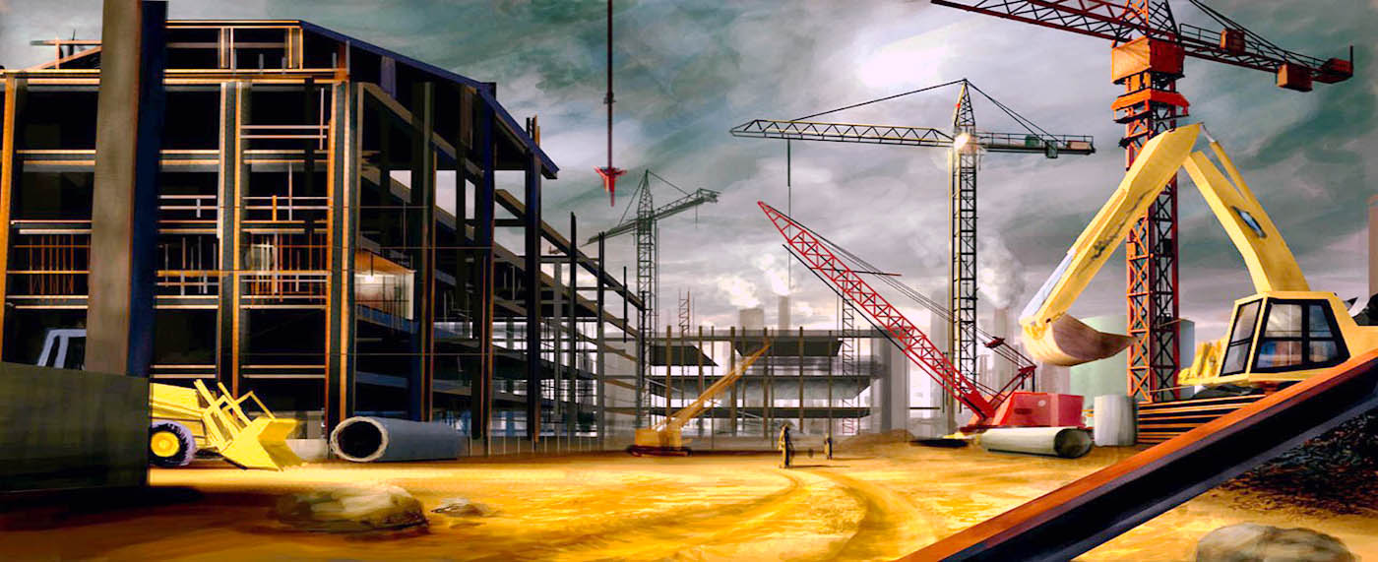
Remember –

The angle bisector for ABC will create a line of points that are equidistant (the same distance away) from the lines AB and BC

The perpendicular bisector for the line AB will create a line of points that are equidistant from the points A and B

Using this booklet
- AB (two letters) refers to a line

- ABC (three letters) refers to an angle created by going from A to B and finishing at C, in a clockwise direction (the angle we be around B)

- If a (P) is on the right of a question, a protractor may be used, it MUST NOT be used for any other questions

- Other materials you may use include a ruler, a pair of compasses and a sharp pencil

1. Bisect the angle ABC
A

C
B

2. Bisect the Line AB
B
A

3. Construct the triangle ABC where
AB = 10cm
BC = 8cm
AC = 6cm

4. Construct the line that is perpendicular to AB and passes through the point C

B

C

A
5. Bisect the angle CBA
A

B

C

6 Construct the triangle where (P)
AB = 7cm
ABC = 50ᵒ
CAB = 20ᵒ

7. Construct the locus of points 4 cm away from A

A

8. Construct the locus of points 2 cm away from the line AB

B

A

9. Construct the triangle where (P)
AB = 7 cm
BC = 8cm
ABC = 43ᵒ

10. Construct the perpendicular bisector for the line AB
A

B
11. Construct the locus of points which is equidistant from AB and BC
B

C

A

12. Construct the locus of points that is equidistant from B and C

A
B

C

13. Construct the line that is perpendicular to AB and passes through the point C
B

C

A

14. Construct a line that is parallel to AB and 3 cm away

A

B

15. Construct the triangle where (P)
ABC = 90ᵒ
AC = 7cm
BA = 4cm

16. By constructing an equilateral triangle, create and label a 60ᵒ angle

17. Using the method in the previous question, construct and label a 30ᵒ angle

18. Construct and label a 90ᵒ angle

19. Construct and label a 45ᵒ angle

20. Bisect the angle DEA
C
B

D
A

E
21. Create the locus of points 2cm away from the Line ABC

A
C

B

22. Create the locus of points 2cm away from the following shape

23. Create the locus of points that passes through D and is perpendicular to the line AB

C
D

B

A

24. Construct the triangle where (no protractor)
ABC = 90ᵒ
AC = 5cm
BC = 3cm

25. By constructing at least 2 angle bisectors, find the centre of a circle that touches each side of the triangle (the incircle).
Draw this circle.

26. By constructing at least 2 perpendicular bisectors, find the centre of a circle that touches each vertex of the triangle (the circumcircle).
Draw this circle.

27. Without using a protractor, construct a triangle where
AB = 10cm
ABC = 30ᵒ
CAB = 45ᵒ

