QQQ – Core Pure Yr1 - Chapter 2 – Complex Numbers & Argand Diagrams
Total Marks: 22
(22 = Platinum, 20 = Gold, 18 = Silver, 16 = Bronze)
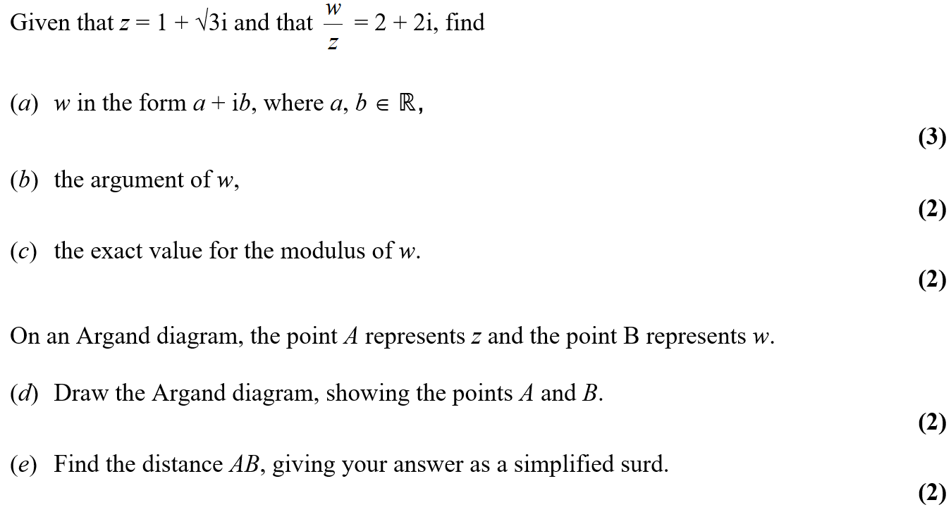
1.

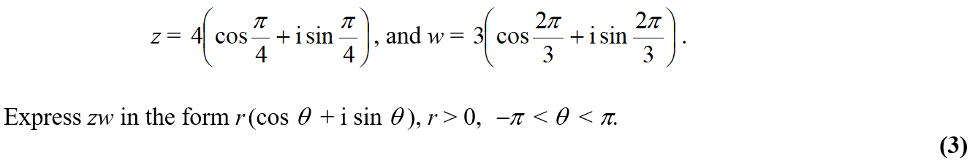
2.

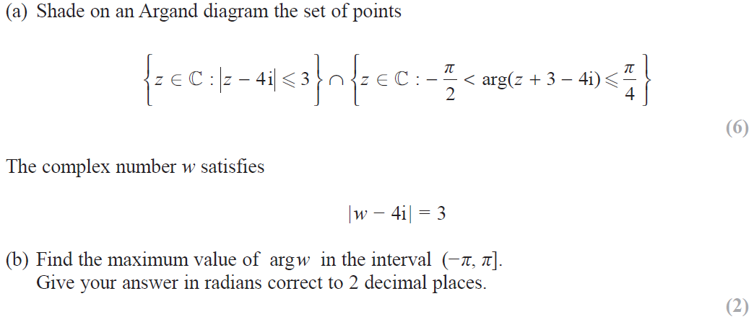
3.

Solutions (
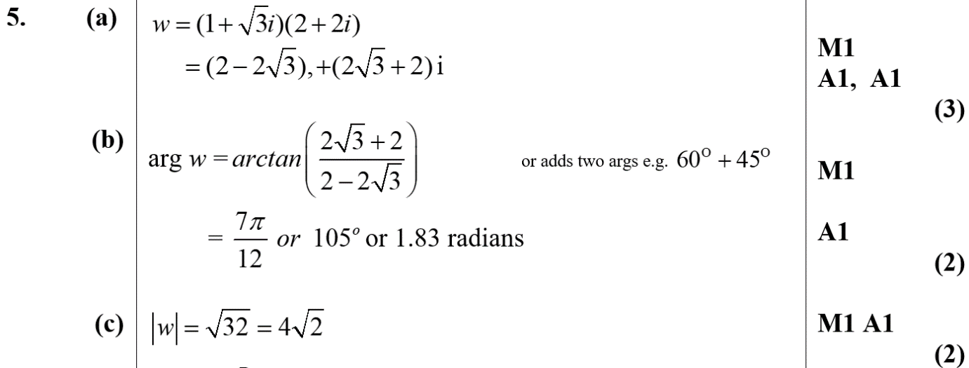
1.

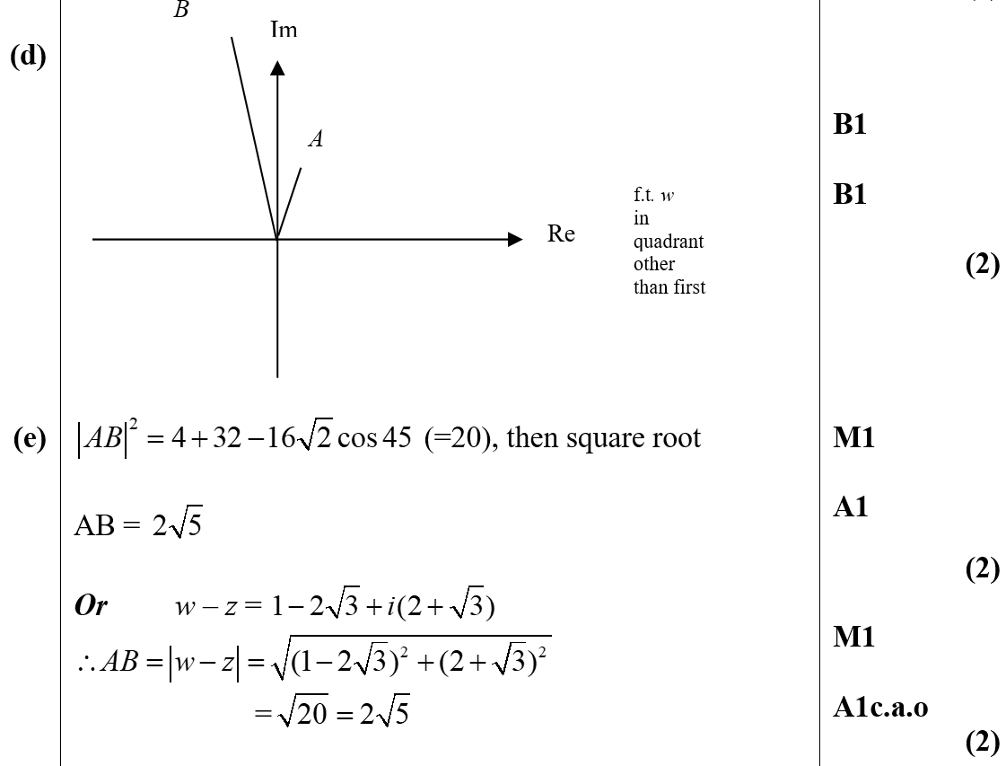

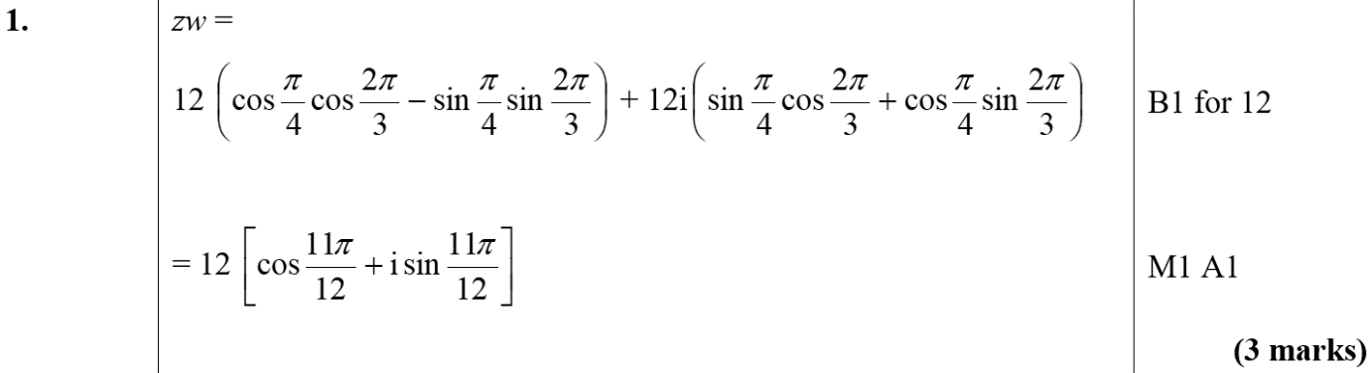
2.

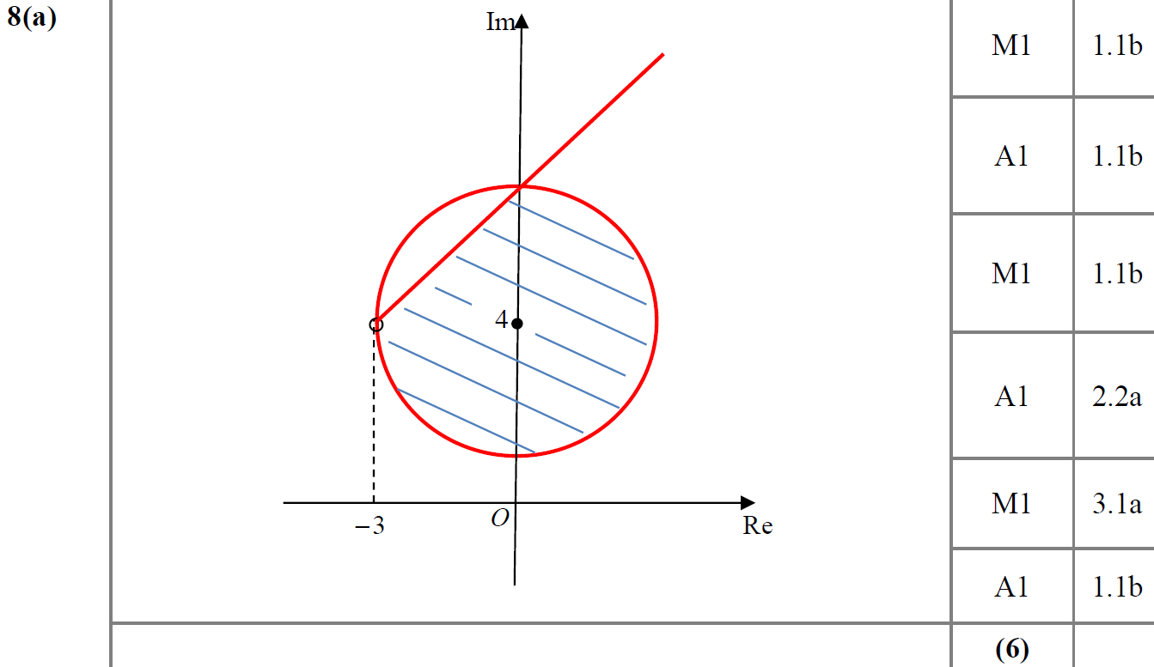
3.

