Coupled First-Order Linear Differential Equations

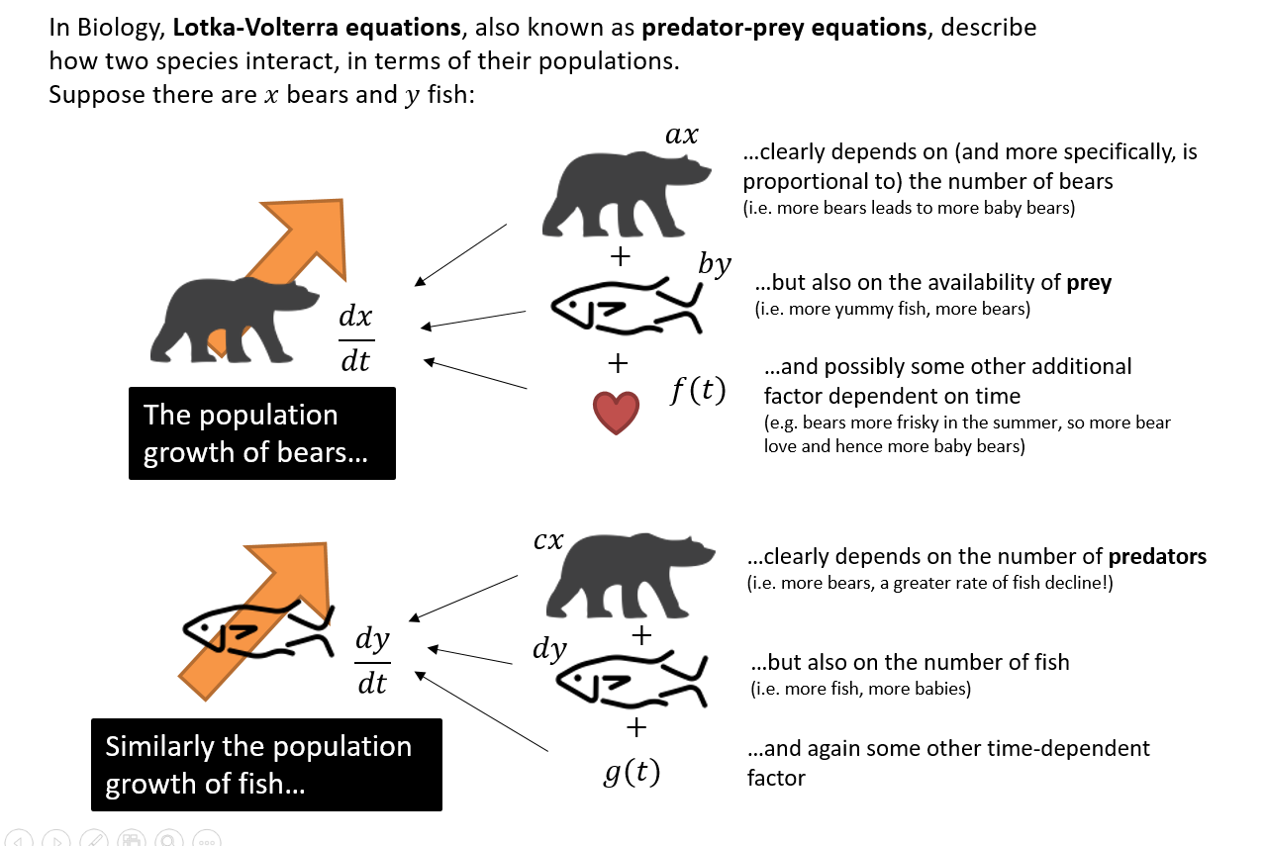

Coupled first-order linear differential equations:
$$\frac{dx}{dt}=ax+by+f\left(t\right)$$
$$\frac{dy}{dt}=cx+dy+g(t)$$

Homogeneous if $f\left(t\right)=g\left(t\right)=0$ for all $t$.

How can we solve a set of coupled DE’s?
Consider the equations $\frac{ dx}{dt}=ax+by+c (1)$
$$\frac{ dy}{dt}=dx+ey+f (2)$$

There are 2 possible strategies:
Strategy 1:
1. Make $y$ the subject of first equation then differentiate to find $\frac{dy}{dt}$.
2. Substitute into second equation to get single second-order differential equation just in terms of $x$, and solve.
3. To solve for $y$, no need to repeat whole process. Differentiate $x$ from Step 2 and sub $x$ and $\frac{dx}{dt}$ into $y$ from Step 1.

Strategy 2:
- Differentiate the first equation wrt t, to obtain a second order DE
- Use the second equation to substitute for $\frac{ dy}{dt}$. This gives an equation for $\frac{d^{2}x}{dt^{2}}$
- Rearrange the original equation to make y the subject and sub into the new equation. Rearrange the new equation to a give a second order DE in x.

Example
Find the particular solution of the equations:

$$\frac{ dx}{dt}=4x-2y$$
$$\frac{ dy}{dt}=3x-y$$

For which $x=2 and y=4 when t=0$

Example
At the start of the year 2010, a survey began on the numbers of bears and fish on a remote island in Northern Canada. After $t$ years the number of bears, $x$, and the number of fish, $y$, on the island are modelled by the differential equations
$$\frac{dx}{dt}=0.3x+0.1y (1)\frac{dy}{dt}=-0.1x+0.5y (2)$$
- Show that $\frac{d^{2}x}{dt^{2}}-0.8\frac{dx}{dt}+0.16x=0$
- Find the general solution for the number of bears on the island at time $t$.
- Find the general solution for the number of fish on the island at time $t$.
- At the start of 2010 there were 5 bears and 20 fish on the island.
Use this information to find the number of bears predicted to be on the island in 2020.
Comment on the suitability of the model.

Test Your Understanding
Two barrels contain contaminated water. At time $t$ seconds, the amount of contaminant in barrel $A$ is $x$ ml and the amount of contaminant in barrel $B$ is $y$ ml. Additional contaminated water flows into barrel $A$ at a rate of 5ml per second. Contaminated water flows from barrel $A$ to barrel $B$ and from barrel $B$ to barrel $A$ through two connecting hoses, and drains out of barrel $A$ to leave the system completely.
The system is modelled using the differential equations
$$\frac{dx}{dt}=5+\frac{4}{9}y-\frac{1}{7}x \left(1\right)\frac{dy}{dt}=\frac{3}{70}x-\frac{4}{9}y (2)$$
Show that $630\frac{d^{2}y}{dt^{2}}+370\frac{dy}{dt}+28y=135$

Congratulations
A Level Further Maths is Complete!

