8C Part 1 Damped Harmonic Motion
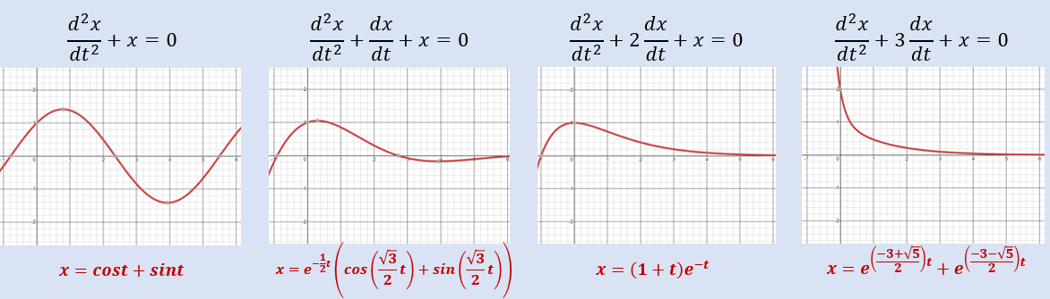

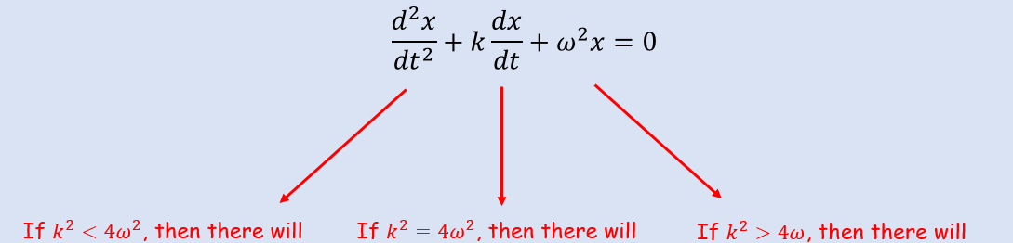

- A particle $P$ of mass 0.5kg moves in a horizontal straight line. At time $t$ seconds, the displacement of $P$ from a fixed point $O$, on the line is $x m$ and the velocity of $P$ is ${v ms}^{-1}$. A force of magnitude $8x N$ acts on $P$ in the direction $PO$. The particle is also subject to a resistance of magnitude $4v N$. When $t=0$, $x=1.5$ and $P$ is moving in the direction of $x$ increasing with speed $4 ms^{-1}$.
- Show that $\frac{d^{2}x}{{dt}^{2}}+8\frac{dx}{dt}+16x=0$

- Find the value of $x$ when $t=1$

- A particle $P$ hangs freely in equilibrium attached to one end of a light elastic string. The other end of the string is attached to a fixed point $A$. The particle is pulled down and held at rest in a container of liquid which exerts a resistance on the motion on $P$. $P$ is then released from rest. While the string remains taut and the particle in the liquid, the motion can be modelled using the equation:
$$\frac{d^{2}x}{{dt}^{2}}+6k\frac{dx}{dt}+{5k}^{2}x=0$$
Where $k$ is a positive real constant.
Find the general solution to the differential equation and state the type of damping the particle is subject to.

- One end of a light elastic spring is attached to a fixed point $A$. A particle $P$ is attached to the other end and hangs in equilibrium vertically below $A$. The particle is pulled vertically down from its equilibrium position and released from rest. A resistance proportional to the speed of $P$ acts on $P$.
$$\frac{d^{2}x}{{dt}^{2}}+2k\frac{dx}{dt}+{2k}^{2}x=0$$
The equation of motion of $P$ is given as:
Where $k$ is a positive real constant and $x$ is the displacement of $P$ from its equilibrium position.
- Find the general solution to the differential equation.

- Find the period of the motion

