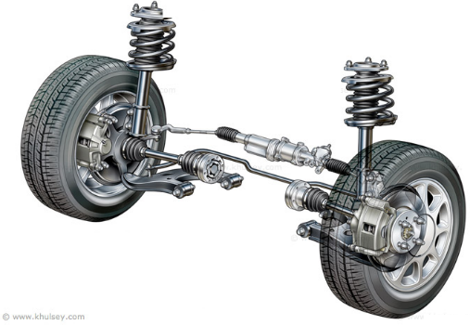
Damped and Force Harmonic Motion
SHM has constant amplitude and goes on forever.
In reality most systems will have oscillations which
gradually decrease with the motion eventually dying
away. This is called damped harmonic motion.

For particle moving with damped harmonic motion:

$$\frac{d^{2}x}{dt^{2}}=-k\frac{dx}{dt}-ω^{2}x$$

$$⇒ \frac{d^{2}x}{dt^{2}}+k\frac{dx}{dt}+ω^{2}x=0$$

The different possibilities for the roots of the auxiliary equation correspond to different types of damping.

Example
- A particle $P$ of mass 0.5 kg moves in a horizontal straight line. At time $t$ seconds, the displacement of $P$ from a fixed point, $O$, on the line is $x$ m and the velocity of $P$ is $v$ ms⁻¹. A force of magnitude $8x$ N acts on $P$ in the direction $PO$. The particle is also subject to a resistance of magnitude $4v$ N. When $t=0, x=1.5$ and $P$ is moving in the direction of increasing $x$ with speed $4$ ms⁻¹,
- Show that $\frac{d^{2}x}{dt^{2}}+8\frac{dx}{dt}+16x=0$
- Find the value of $x$ when $t=1$.

- A particle $P$ hangs freely in equilibrium attached to one end of a light elastic string. The other end of the string is attached to a fixed point $A$. The particle is now pulled down and held at rest in a container of liquid which exerts a resistance to motion on $P$. $P$ is then released from rest. While the string remains taut and the particle in the liquid, the motion can be modelled using the equation
$\frac{d^{2}x}{dt^{2}}+6k\frac{dx}{dt}+5k^{2}x=0,$ where $k$ is a positive real constant
Find the general solution to the differential equation and state the type of damping that the particle is subject to.

- One end of a light elastic spring is attached to a fixed point $A$. A particle $P$ is attached to the other end and hangs in equilibrium vertically below $A$. The particle is pulled vertically down from its equilibrium position and released from rest. A resistance proportional to the speed of $P$ acts on $P$. The equation of motion of $P$ is given as
$$\frac{d^{2}x}{dt^{2}}+2k\frac{dx}{dt}+2k^{2}x=0$$
where $k$ is a positive real constant and $x$ is the displacement of $P$ from its equilibrium position.
- Find the general solution to the differential equation.
- Write down the period of oscillation in terms of $k$.

