8B Simple Harmonic Motion
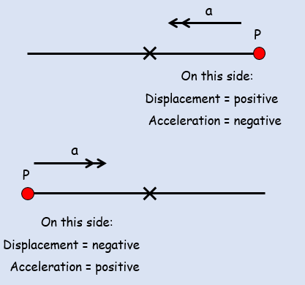
$\ddot{x}=-w^{2}x$

$$v^{2}=w^{2}\left(a^{2}-x^{2}\right)$$

$x=asin\left(wt+C \right)$
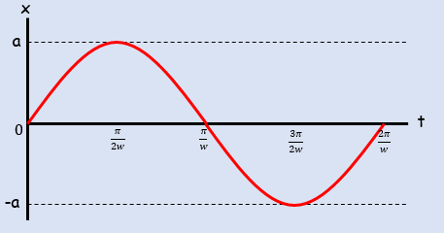
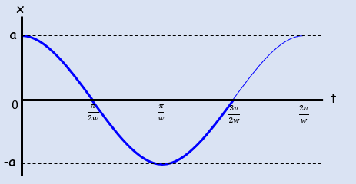
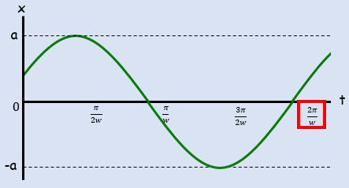
$$Period=\frac{2π}{w}$$
- A particle is moving along a straight line. At time $t$ seconds its displacement, $x m$ from a fixed point $O$ is such that:
$$\frac{d^{2}x}{{dt}^{2}}=-4x$$
Given that at $t=0$, $x=1$ and that the particle is moving with velocity $4 {ms}^{-1}$:
- Find an expression for the particle’s displacement after $t$ seconds

- Determine the maximum displacement of the particle from $O$.

- A particle $P$ is attached to the ends of two identical elastic springs. The free ends of the springs are attached to two points $A$ and $B$. The point $C$ lies between $A$ and $B$ such that $ABC$ is a straight line and $AB≠BC$. The particle is held at $C$ and then released from rest.
At time $t$ seconds, the displacement of the particle from $C$ is $x m$ and its velocity is $v {ms}^{-1}$. The subsequent motion can be described by the differential equation $\ddot{x}=-25x$.
- Describe the motion of the particle

- Given that when $t=0$, $x=0.4$and $v=0$, find $x$ as a function of $t$

- State the period of the motion and state the maximum speed of $P$.

