Simple Harmonic Motion
Simple Harmonic Motion (SHM) is motion in which the acceleration of a particle $P$ is always towards a fixed point $O$ on the line of motion of $P$. The acceleration is proportional to the displacement $x$ of $P$ from $O$.

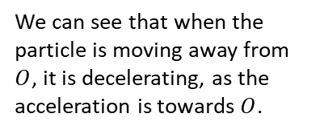
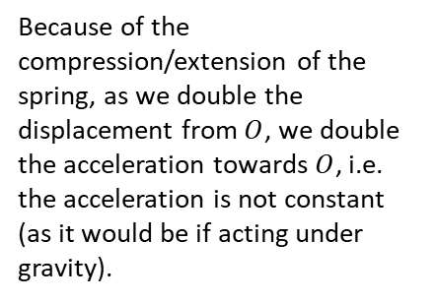

$$O$$

Simple Harmonic Motion:
General solution $x=Asinωt+Bcosωt$
Writing in harmonic form: $x=\operatorname{asin}\left(ωt+α\right)$
So, the general solution of SHM can be expressed as a sine function from which we can deduce:
- The solution varies between a and –a Amplitude
- The solution is periodic with Period $\frac{2π}{ω}$
- The velocity and acceleration can be found by differentiating the solution with respect to t.

Example
A particle is moving along a straight line. At time $t$ seconds its displacement, $x$ m from a fixed point $O$ is such that $\frac{d^{2}x}{dt^{2}}=-4x$.
Given that at $t=0, x=1$ and the particle is moving with velocity 4 ms⁻¹,
(a) find an expression for the displacement of the particle after $t$ seconds
(b) hence determine the maximum displacement of the particle from $O$.

Example
A particle $P$, is attached to the ends of two identical elastic springs. The free ends of the springs are attached to two points $A$ and $B$. The point $C$ lies between $A$ and $B$ such that $ABC$ is a straight line and $AC≠BC$. The particle is held at $C$ and then released from rest.
At time $t$ seconds, the displacement of the particle from $C$ is $x$ m and its velocity is $v$ ms⁻¹. The subsequent motion of the particle can be described by the differential equation $\ddot{x}=-25x$.
- Describe the motion of the particle.
Given that $x=0.4$ and $v=0$ when $t=0$,
(b) solve the differential equation to find $x$ as a function of $t$
(c) state the period of the motion and calculate the maximum speed of $P$.

Ex 8B

