CP2 Chapter 8
Modelling with Differential Equations

Course Structure
- Modelling with 1st order differential equations.
- Simple Harmonic Motion
- Damped and Force Harmonic Motion
- Coupled First-Order Differential Equations

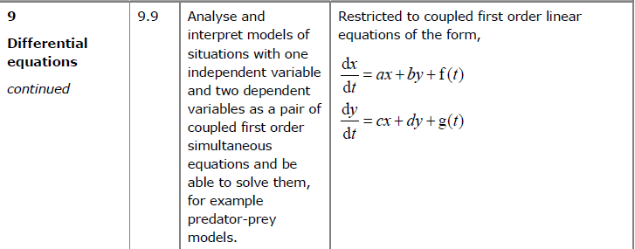
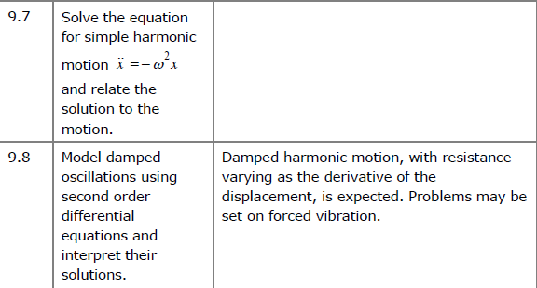

Modelling with 1st Order Differential Equations

Example
A particle $P$ is moving along a straight line. At time $t$ seconds, the acceleration of the particle is given by $a=t+\frac{3}{t}v, t≥0$
Given that $v=0$ when $t=2$, show that the velocity of the particle at time $t$ is given by the equation $v=ct^{3}-t^{2}$ where $c$ is a constant to be found.

Common Example Type:
A storage tank initially containers 1000 litres of pure water. Liquid is removed from the tank at a constant rate of 30 litres per hour and a chemical solution is added to the tank at a constant rate of 40 litres per hour. The chemical solution contains 4 grams of copper sulphate per litre of water. Given that there are $x$ grams of copper sulphate in the tank after $t$ hours and that the copper sulphate immediately disperses throughout the tank on entry,
- Show that the situation can be modelled by the differential equation
$$\frac{dx}{dt}=160-\frac{3x}{100+t}$$
- Hence find the number of grams of copper sulphate in the tank after 6 hours.
- Explain how the model could be refined.

Ex 8A

