8A Modelling with First Order Differentials
- A particle $P$ starts from rest at a given point $O$ and moves along a straight line. At time $t$ seconds, the acceleration, $a {ms}^{-2}$, of $P$ is given by:
$$a=\frac{6}{{\left(t-2\right)}^{2}},t≥0$$
- Find the velocity of $P$ at time $t$ seconds

- Show that the displacement of $P$ from $O$ when $t=6$ is given by $\left(18-12ln2\right) m$

- A particle $P$ is travelling along a straight line. At time t seconds, the acceleration of the particle is given by:
$$a=t+\frac{3}{t}v, t≥0$$
Given that $v=0$ when $t=2$, show that the velocity of the particle at time t is given by the equation:
$$v={ct}^{3}-t^{2}$$
where $c$ is a constant to be found.

- A storage tank initially contains 1000 litres of pure water. Liquid is removed from the tank at a constant rate of 30 litres per hour and a chemical solution is added at a constant rate of 40 litres per hour. The chemical solution contains 4 grams of copper sulphate per litre of water.
- Given that there are $x$ grams of copper sulphate in the tank after $t$ hours and that the copper sulphate immediately disperses throughout the tank upon entry, show that the situation can be modelled by the differential equation:
$$\frac{dx}{dt}=160-\frac{3x}{100+t}, t≥0$$

- Hence, find the number of grams of copper sulphate in the tank after 6 hours.

- Suggest a possible refinement for the model

8B Simple Harmonic Motion
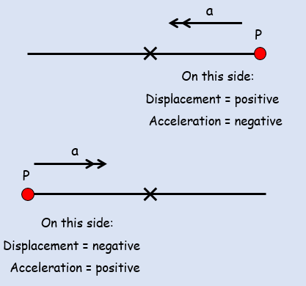
$\ddot{x}=-w^{2}x$

$$v^{2}=w^{2}\left(a^{2}-x^{2}\right)$$

$x=asin\left(wt+C \right)$
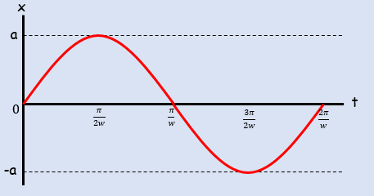
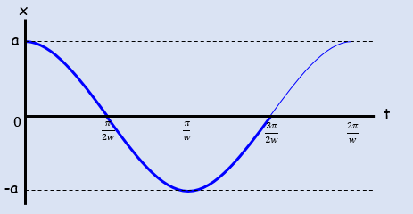
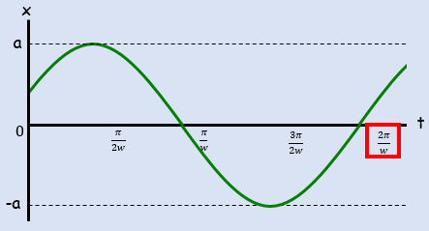
$$Period=\frac{2π}{w}$$
- A particle is moving along a straight line. At time $t$ seconds its displacement, $x m$ from a fixed point $O$ is such that:
$$\frac{d^{2}x}{{dt}^{2}}=-4x$$
Given that at $t=0$, $x=1$ and that the particle is moving with velocity $4 {ms}^{-1}$:
- Find an expression for the particle’s displacement after $t$ seconds

- Determine the maximum displacement of the particle from $O$.

- A particle $P$ is attached to the ends of two identical elastic springs. The free ends of the springs are attached to two points $A$ and $B$. The point $C$ lies between $A$ and $B$ such that $ABC$ is a straight line and $AB≠BC$. The particle is held at $C$ and then released from rest.
At time $t$ seconds, the displacement of the particle from $C$ is $x m$ and its velocity is $v {ms}^{-1}$. The subsequent motion can be described by the differential equation $\ddot{x}=-25x$.
- Describe the motion of the particle

- Given that when $t=0$, $x=0.4$and $v=0$, find $x$ as a function of $t$

- State the period of the motion and state the maximum speed of $P$.

8C Part 1 Damped Harmonic Motion
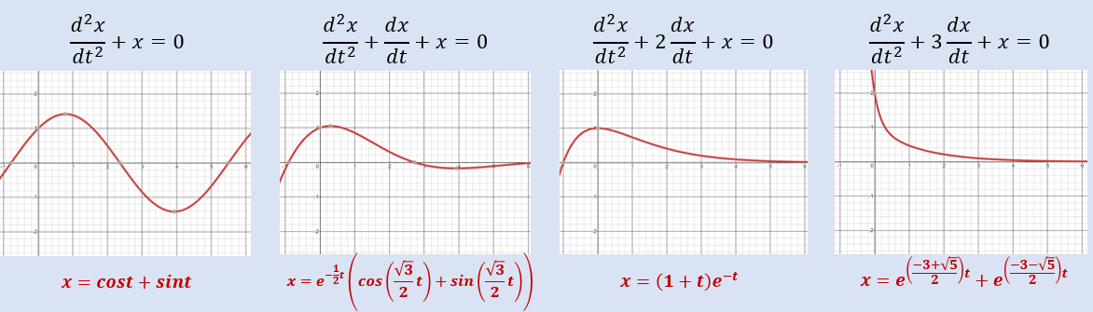

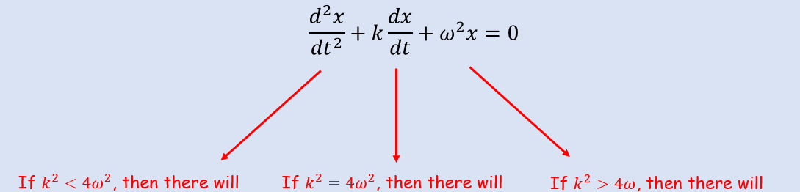

- A particle $P$ of mass 0.5kg moves in a horizontal straight line. At time $t$ seconds, the displacement of $P$ from a fixed point $O$, on the line is $x m$ and the velocity of $P$ is ${v ms}^{-1}$. A force of magnitude $8x N$ acts on $P$ in the direction $PO$. The particle is also subject to a resistance of magnitude $4v N$. When $t=0$, $x=1.5$ and $P$ is moving in the direction of $x$ increasing with speed $4 ms^{-1}$.
- Show that $\frac{d^{2}x}{{dt}^{2}}+8\frac{dx}{dt}+16x=0$

- Find the value of $x$ when $t=1$

- A particle $P$ hangs freely in equilibrium attached to one end of a light elastic string. The other end of the string is attached to a fixed point $A$. The particle is pulled down and held at rest in a container of liquid which exerts a resistance on the motion on $P$. $P$ is then released from rest. While the string remains taut and the particle in the liquid, the motion can be modelled using the equation:
$$\frac{d^{2}x}{{dt}^{2}}+6k\frac{dx}{dt}+{5k}^{2}x=0$$
Where $k$ is a positive real constant.
Find the general solution to the differential equation and state the type of damping the particle is subject to.

- One end of a light elastic spring is attached to a fixed point $A$. A particle $P$ is attached to the other end and hangs in equilibrium vertically below $A$. The particle is pulled vertically down from its equilibrium position and released from rest. A resistance proportional to the speed of $P$ acts on $P$.
$$\frac{d^{2}x}{{dt}^{2}}+2k\frac{dx}{dt}+{2k}^{2}x=0$$
The equation of motion of $P$ is given as:
Where $k$ is a positive real constant and $x$ is the displacement of $P$ from its equilibrium position.
- Find the general solution to the differential equation.

- Find the period of the motion

8C Part 2 Forced Harmonic Motion

- A particle $P$ of mass 1.5kg is moving along the x-axis. At time $t$ the displacement of $P$ from the origin $O$ is $x$ metres and the speed of $P$ is $v {ms}^{-1}$. Three forces act on $P$, namely a restoring force of $7.5x N$, a resistance to motion of $P$ of magnitude $6v N$ and a force of magnitude $12sint N$ acting in the direction $OP$. When $t=0$, $x=5$ and $\frac{dx}{dt}=2$.
- Show that $\frac{d^{2}x}{{dt}^{2}}+4\frac{dx}{dt}+5x=8sint$

- Find $x$ as a function of $t$

- Describe the motion when $t$ is large

$$x=e^{-2t}\left(6cost+13sint\right)+sint-cost$$

- A particle $P$ is attached to end $A$ of a light elastic string $AB$. Initially the particle and the string lie at rest on a smooth horizontal plane. At time $t=0$, the end $B$ of the string is set into motion and moves with constant speed $U$ in the direction $AB$, and the extension in the string is $x$. Air resistance acting on $P$ is proportional to its speed. The subsequent motion can be modelled by the differential equation:
$$\frac{d^{2}x}{{dt}^{2}}+2k\frac{dx}{dt}+k^{2}x=2kU$$
Find an expression for $x$ in terms of $U$, $k$ and $t$.

8D Coupled Differential Equations
$$\frac{dx}{dt}=ax+by+f(t)$$

$$\frac{dy}{dt}=cx+dy+g(t)$$

- At the start of 2010, a survey began on the number of bears and fish on a remote island in Northern Canada. After $t$ years the number of bears, $x$, and the number of fish, $y$, in the area are modelled by the differential equations:
$$\frac{dx}{dt}=0.3x+0.1y$$
$$\frac{dy}{dt}=-0.1x+0.5y$$
- Show that $\frac{d^{2}x}{{dt}^{2}}-0.8\frac{dx}{dt}+0.16x=0$

- Find the general solution for the number of bears on the island at time $t$

- Find the general solution for the number of fish on the island at time $t$

- At the start of 2010, there were 5 bears and 20 fish on the island. Use this information to predict the number of bears on the island in 2020.

- Comment on the suitability of the model

no other factors were taken into account as well – the f(t) and g(t) mentioned at the start
- Two barrels contain contaminated water. At time $t$ seconds, the amount of contaminant in barrel $A$ is $x$ ml and the amount in barrel $B$ is $y$ ml. Additional contaminated water flows into barrel $A$ at a rate of 5 ml per second. Contaminated water flows from barrel $A$ to barrel $B$ and then back to barrel $A$ through two connecting hoses, and then drains out of barrel $A$ to leave the system completely. The system is modelled using the following differential equations:
$$\frac{dx}{dt}=5+\frac{4}{9}y-\frac{1}{7}x$$
$$\frac{dy}{dt}=\frac{3}{70}x-\frac{4}{9}y$$
Show that $630\frac{d^{2}y}{{dt}^{2}}+370\frac{dy}{dt}+28y=135$

