Second Order Non-Homogenous DE’s

Non – homogeneous, second order DE’s have the form
$$a\frac{d^{2}y}{dx^{2}}+b\frac{dy}{dx}+cy=f(x)$$

Question: Start by considering the solution to the 1st order DE: $\frac{ dy}{dx}+2y=3x-1$

Consider another example with the same LHS: $\frac{ dy}{dx}+2y=e^{3x}$

Solving a Second Order, Non – Homogeneous DE

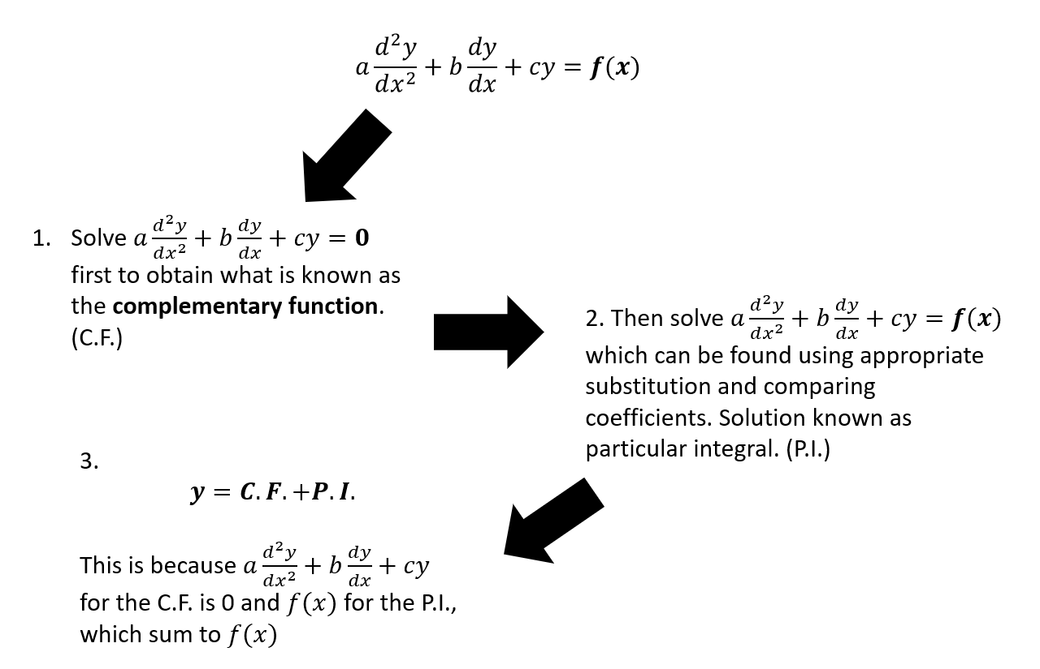

How do we find the Particular Integral?
To find a particular integral you need to establish a trial function whose form depends on the form of $f\left(x\right).$
Function ($f\left(x\right))$ | Form of Particular Integral
$$p$$ | $$λ$$
$$p+qx$$ | $$λ+µx$$
$$p+qx+rx^{2}$$ | $$λ+µx+vx^{2}$$
$$pe^{kx}$$ | $$λe^{kx}$$
$$pcosωx+qsinωx$$ | $$λcosωx+µsinωx$$
$$pcosωx$$ | $$λcosωx+µsinωx$$

The Particular Integral is a function which satisfies the original DE. We take our trial form and sub it back into the DE to find the value of the coefficients.

Example
Find the particular integral of the differential equation $\frac{d^{2}y}{dx^{2}}-5\frac{dy}{dx}+6y=3$

Example:
Find the general solution of the differential equation $\frac{d^{2}y}{dx^{2}}-5\frac{dy}{dx}+6y=2x$

Example:
Find the general solution of the differential equation $\frac{d^{2}y}{dx^{2}}-5\frac{dy}{dx}+6y=3x^{2}$

Example:
Find the general solution of the differential equation $\frac{d^{2}y}{dx^{2}}-5\frac{dy}{dx}+6y=e^{x}$

Interesting (and important) Example!
Find the general solution of the differential equation $\frac{d^{2}y}{dx^{2}}-5\frac{dy}{dx}+6y=e^{2x}$

Example:
Find the general solution of the differential equation $\frac{d^{2}y}{dx^{2}}-2\frac{dy}{dx}=3$

