7A Part 1 First Order Differential Equations 2.0

- Find the general solution of the differential equation, then sketch members of the family of solution curves represented by the general solution.

$$\frac{dy}{dx}=2$$
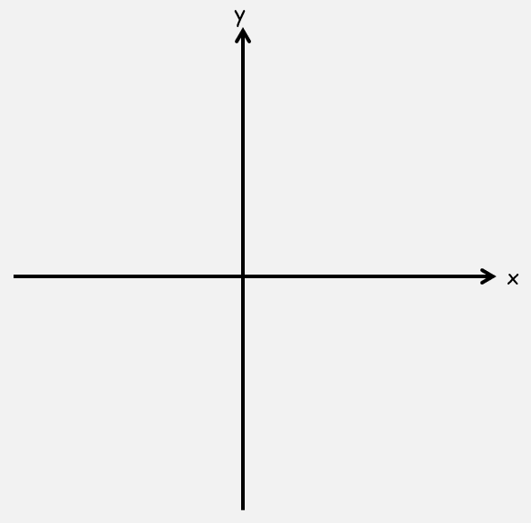

$$\frac{dy}{dx}=-\frac{x}{y}$$

$$\frac{dy}{dx}=-\frac{y}{x}$$

Product Rule Examples (The new stuff)

- Find the general solution of the following equation:

$$x^{3}\frac{dy}{dx}+{3x}^{2}y=sinx$$

$$6x^{2}y\frac{dy}{dx}+6xy^{2}=\sec^{2}x$$

$$\frac{dy}{dx}+\frac{2y}{x}=\frac{5}{{4x}^{2}}$$

