CP2 Chapter 7
Differential Equations

Course Structure
- First Order Differential Equations (Booklet 1)
- Second Order Differential Equations – Homogeneous (Booklet 2)
- Second Order Differentials – Non-homogeneous (Booklet 3)

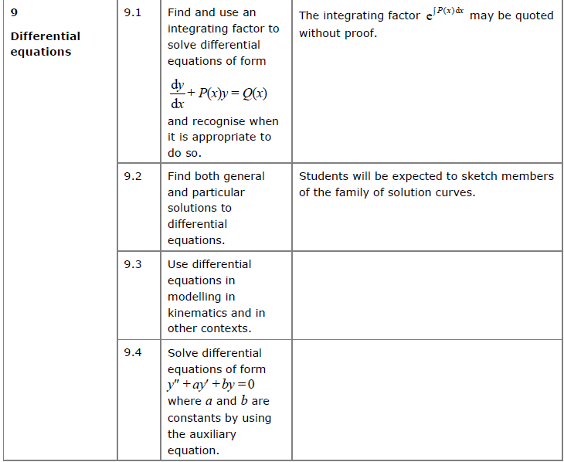
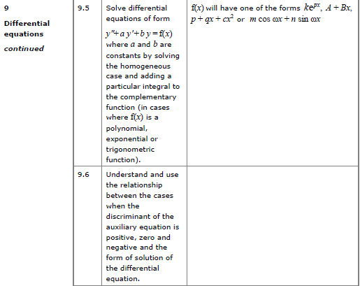

First order Differential Equations
A differential equation is an equation involving a derivative. A ‘first order’ differential equation means the equation contains the first derivative ($\frac{dy}{dx}$) but not the second derivative or beyond. D.E’s are used to model situations which involve rates of change and their solution gives the relationship between the variables themselves, not their derivatives.
- General Solution:

- Particular Solution:

Solving First Order DE’s

There are 3 methods to solve first order DE’s:
- Separating variables
- Reverse Product rule – perfect derivative
- Integrating Factor to produce a perfect derivative

- Separating Variables (Pure Year 2 Recap)

Examples:
- $\frac{dy}{dx}=2$

- Find general solutions to $\frac{dy}{dx}=-\frac{x}{y}$

- Find general solutions to $\frac{dy}{dx}=xy+x$

- Find general solutions to $\frac{dy}{dx}=-\frac{y}{x}$

- Reverse Product Rule
How could we find general solutions of the equation $x^{3}\frac{dy}{dx}+3x^{2}y=\sin{x}$
We can’t separate the variables. But do you notice anything about the LHS?

Examples
- $x\frac{dy}{dx}+y=cosx$

- $x^{2}e^{y}\frac{dy}{dx}+2{xe}^{y}=x$

Test Your Understanding
- Find general solutions of the equation $\frac{1}{x}\frac{dy}{dx}-\frac{1}{x^{2}}y=e^{x}$

- Find general solutions of the equation $4xy\frac{dy}{dx}+2y^{2}=x^{2}$

