7A Part 1 First Order Differential Equations 2.0

- Find the general solution of the differential equation, then sketch members of the family of solution curves represented by the general solution.

$$\frac{dy}{dx}=2$$
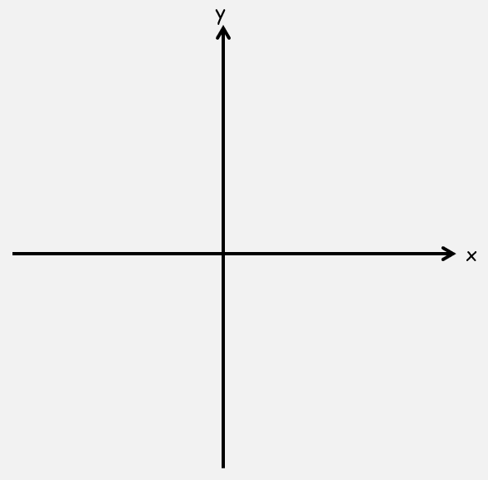

$$\frac{dy}{dx}=-\frac{x}{y}$$

$$\frac{dy}{dx}=-\frac{y}{x}$$

Product Rule Examples (The new stuff)

- Find the general solution of the following equation:

$$x^{3}\frac{dy}{dx}+{3x}^{2}y=sinx$$

$$6x^{2}y\frac{dy}{dx}+6xy^{2}=\sec^{2}x$$

$$\frac{dy}{dx}+\frac{2y}{x}=\frac{5}{{4x}^{2}}$$

7A Part 2 First Order Differential Equations and Integrating Factors
Notes:
Solve the general equation:
$$\frac{dy}{dx}+Py=Q$$
Where P and Q are functions of x.

- Find the general solution of the equation:
$$\frac{dy}{dx}-4y=e^{x}$$

- Find the general solution of the equation:
$$\cos{x}\frac{dy}{dx}+2y\sin{x}=\cos^{4}x$$

7B Homogeneous Second Order Differential Equations
$$a\frac{d^{2}y}{{dx}^{2}}+b\frac{dy}{dx}+cy=0$$
Solve the equation:
$$a\frac{dy}{dx}+by=0$$

Case 1: b² > 4ac
Find $\frac{dy}{dx}$ and $\frac{d^{2}y}{dx^{2}}$ when $$y=Ae^{mx}$$

Find the auxiliary equation for $$a\frac{d^{2}y}{{dx}^{2}}+b\frac{dy}{dx}+cy=0$$

Summary: when b² > 4ac then the solution will be in the form…

- Find the general solution of the equation:
$$\frac{d^{2}y}{{dx}^{2}}-7\frac{dy}{dx}+12y=0$$

Case 2: b² = 4ac
Show that
$$y=(A+Bx)e^{3x}$$
Satisfies the equation:
$$\frac{d^{2}y}{{dx}^{2}}-6\frac{dy}{dx}+9y=0$$

Summary: If b²=4ac then the solution will be in the form…

- Find the general solution of the equation:
$$\frac{d^{2}y}{{dx}^{2}}+8\frac{dy}{dx}+16y=0$$

Case 3: b² < 4ac
Find the general solution of the differential equation:
$$\frac{d^{2}y}{dx^{2}}+16y=0$$

- Find the general solution of the differential equation:
$$\frac{d^{2}y}{{dx}^{2}}-6\frac{dy}{dx}+34y=0$$

Summary: If b²=4ac then the solution will be in the form…

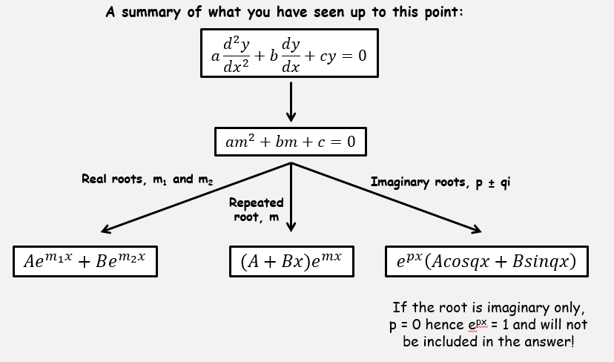

7C Particular Integrals of Second Order Differential Equations
$$a\frac{d^{2}y}{{dx}^{2}}+b\frac{dy}{dx}+cy=f(x)$$

- Find the solution of the differential equation:

$$\frac{d^{2}y}{{dx}^{2}}-5\frac{dy}{dx}+6y=3$$

$$\frac{d^{2}y}{{dx}^{2}}-5\frac{dy}{dx}+6y=2x$$

$$\frac{d^{2}y}{{dx}^{2}}-5\frac{dy}{dx}+6y=3x^{2}$$

$$\frac{d^{2}y}{{dx}^{2}}-5\frac{dy}{dx}+6y=e^{x}$$

$$\frac{d^{2}y}{{dx}^{2}}-5\frac{dy}{dx}+6y=13sin3x$$

- Find the general solution to the following differential equation:
$$\frac{d^{2}y}{{dx}^{2}}-2\frac{dy}{dx}=3$$

Summary:
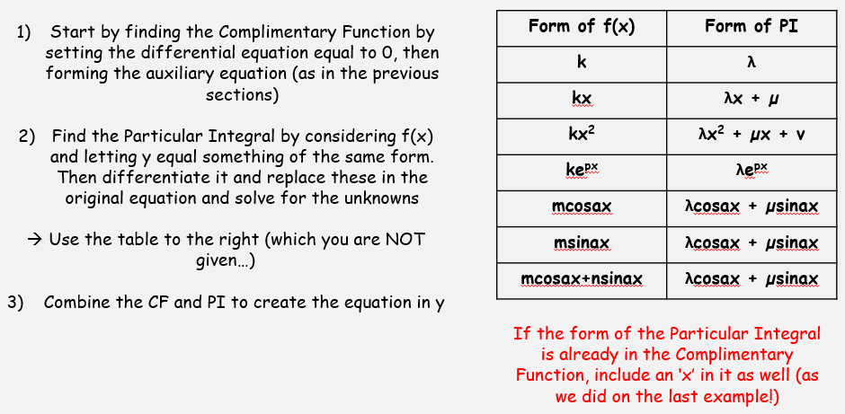
7D Finding Constants of Second Order Differential Equations

- Find y in terms of x, given that:
$$\frac{d^{2}y}{{dx}^{2}}-y=2e^{x}$$
And that when x = 0,
$$y=0 and \frac{dy}{dx}=0$$

- Given that the particular integral is of the form:
$$λsin2t$$
Find the solution of the differential equation:
$$\frac{d^{2}x}{{dt}^{2}}+x=3sin2t$$
When t = 0, x = 0 and ^{dx}/_{dt} = 1

