Standard Integrals

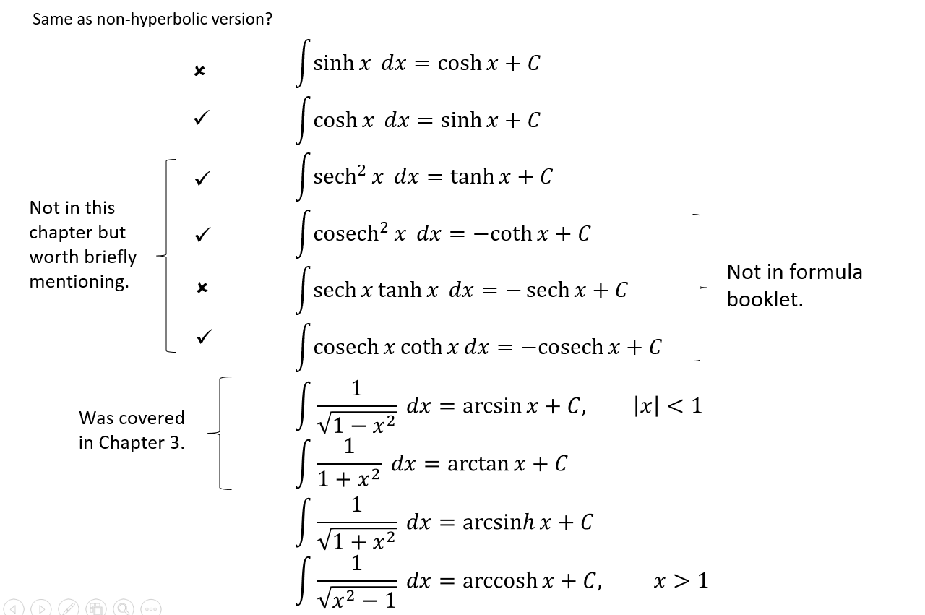

Standard Integral Examples
$$\int{\cosh\left(4x-1\right)dx}=$$
$$\int{sinh \left(\frac{2}{3}x\right)} dx=$$
$$\int{\frac{3}{\sqrt{1+x^{2}}}dx}=$$
$$\int{\frac{4}{\sqrt{x^{2}-1}}dx}=$$
$$\int{sinh \left(3x\right)} dx=$$
$$\int{\frac{10}{\sqrt{x^{2}-1}}dx}=$$
$$\int{\frac{2}{\sqrt{1+x^{2}}}dx}=$$

Not Quite so Standard Examples
- $\int{\frac{2+5x}{\sqrt{x^{2}+1}} dx}$

- $\int{\cosh^{5}{2x}\sinh{2x} dx}$

- $\int{\tanh{x} dx}$

Using Identities

- $\int{\cosh^{2}{3x} dx}$

- $\int{\sinh^{3}{x} dx}$

What now??
Sometimes there are techniques which work on non-hyperbolic trig functions but doesn’t work on hyperbolic ones. Just first replace any hyperbolic functions with their definition.

Examples
- Find $\int{e^{2x}\sinh{x} dx}$

- Find $\int{\operatorname{sech}{x} dx}$

Dealing with $1/\sqrt{a^{2}+x^{2}}$, $1/\sqrt{x^{2}-a^{2}}$, ….
We can use substitution to deal with this style of integration.

$$\sin^{2}{θ}+\cos^{2}{θ}=1$$
$$1+\tan^{2}{θ}=\sec^{2}{θ}$$
$$1+\sinh^{2}{u}=\cosh^{2}{u}$$

- Consider $\int{\frac{1}{\sqrt{a^{2}+x^{2}}}dx}$ . What substitution might we use?

- Consider$\int{\frac{1}{\sqrt{a^{2}+x^{2}}}dx}$. What substitution might we use?

$$\int{\frac{1}{\sqrt{a^{2}+x^{2}}}dx}=$$

$$\int{\frac{1}{\sqrt{x^{2}-a^{2}}}dx}=$$
Example
- Show that $\int{\frac{1}{\sqrt{x^{2}-a^{2}}}dx}=arcosh \left(\frac{x}{a}\right)+c$

- Show that $\int_{5}^{8}{\frac{1}{\sqrt{x^{2}-16}}dx}=\ln\left(\frac{2+\sqrt{3}}{2}\right)$

- Show that $\int{\sqrt{1+x^{2}} dx}=\frac{1}{2}arsinh x+\frac{1}{2}x\sqrt{1+x^{2}}+C$.

Test Your Understanding

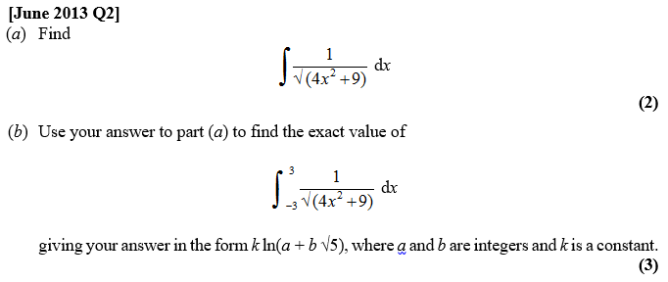

2)Using a hyperbolic substitution, evaluate $\int_{0}^{6}{\frac{x^{3}}{\sqrt{x^{2}+9}} dx}$

Integrating by Completing the Square
By completing the square, we can then use one of the standard results.
Examples
- Determine $\int{\frac{1}{x^{2}-8x+8}dx}$

- Determine $\int{\frac{1}{\sqrt{12x+2x^{2}}}dx}$

Test Your Understanding
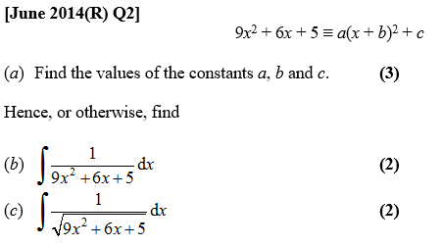

Ex 6E and Mixed Ex 6

