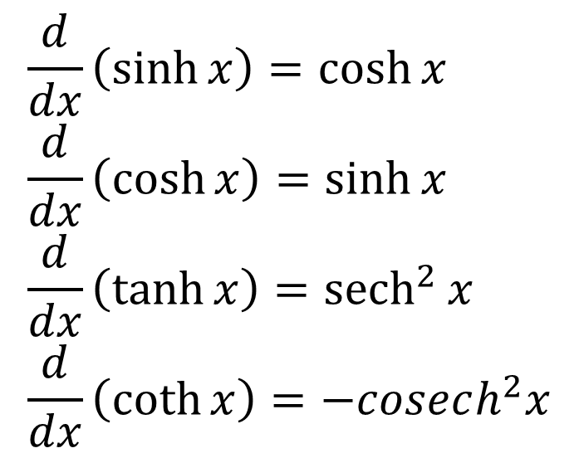
Differentiating hyperbolic functions

Example
Prove that $\frac{d}{dx}\left(\sinh{x}\right)=\cosh{x}$

Test Your Understanding
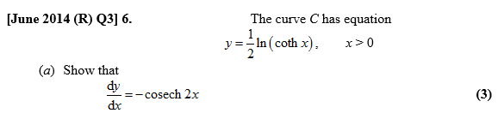

Inverse Hyperbolic Functions
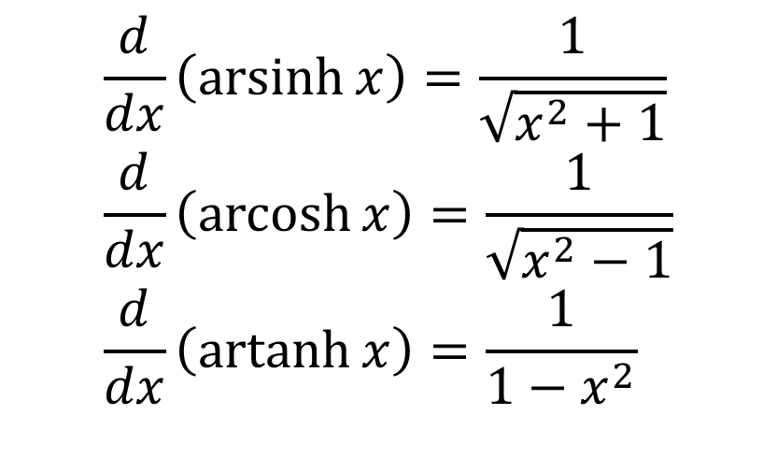

Proof of $\frac{d}{dx}\left(\operatorname{arsinh}{x}\right)=\frac{1}{\sqrt{x^{2}+1}}$

Examples
- Find $\frac{d}{dx}\left(artanh 3x\right)$

- Given that $y={\left(arcosh x\right)}^{2}$ prove that $\left(x^{2}-1\right){\left(\frac{dy}{dx}\right)}^{2}=4y$

Test Your Understanding
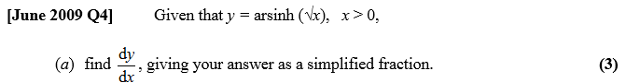

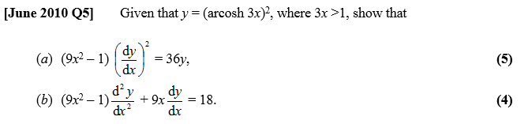

Using Maclaurin expansions for approximations

Textbook Example
(a) Show that $\frac{d}{dx}\left(arsinh x\right)=\frac{1}{\sqrt{1+x^{2}}}$ [We did this earlier]
(b) Find the first two non-zero terms of the series expansion of $arsinh x$.
The general form for the series expansion of $arsinh x$ is given by
$$arsinh x=\sum_{r=0}^{∞}{\left(\frac{{\left(-1\right)}^{n}\left(2n\right)!}{2^{2n}{\left(n!\right)}^{2}}\right)\frac{x^{2n+1}}{2n+1}}$$
(c) Find, in simplest terms, the coefficient of $x^{5}$.
(d) Use your approximation up to and including the term in $x^{5}$ to find an approximate value for $arsinh 0.5$.
(e) Calculate the percentage error in using this approximation.

Ex 6D pg 133

