Hyperbolic Identities
Use the definitions of $sinh$ and $cosh$ to find:

$\cosh^{2}{x}-\sinh^{2}{x}=$

$1-tanh^{2}x=$

$coth^{2}x-1=$

Also:
$$sinh \left(A±B\right)=sinh A cosh B±cosh A sinh B$$
$$cosh \left(A±B\right)=cosh A cosh B±sinh A sinh B$$

Hence:

$tanh \left(A±B\right)=$

Osborn’s Rule
We can get these identities from the normal sin/cos ones using Osborn’s rule:
Osborn’s Rule:
- Replace $sin→sinh$ and $cos→cosh$
- Negate any explicit or implied product of two sines.

$$\sin{A}\sin{B}=$$

$$\tan^{2}{A} =$$

$$cos2A=2\cos^{2}{A}-1 →$$

$$\tan\left(A-B\right)=\frac{\tan{A}-\tan{B}}{1+\tan{A}\tan{B}} →$$

Solving Equations
To solve equations either use hyperbolic identities or basic definitions of hyperbolic functions.

Examples
- Solve for all real $x, 6\sinh{x}-2\cosh{x}=7$

- Solve for all real $x, 2\cosh^{2}{x}-5sinh{x}=5$

Recap: If $\cos{x}=\frac{3}{5}$, find $\sin{x}$

- If $\sinh{x}=\frac{3}{4}$, find the exact value of:
a) $\cosh{x}$
b) $\tanh{x}$
c) $\sinh{2x}$

Test Your Understanding

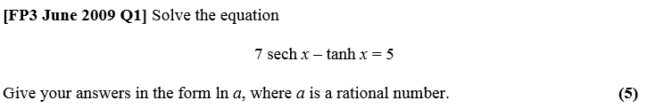

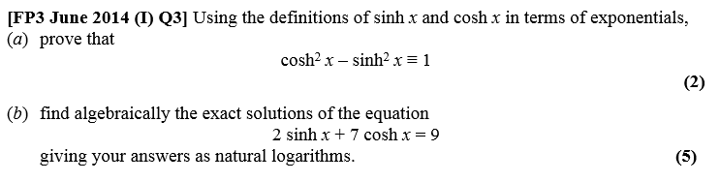

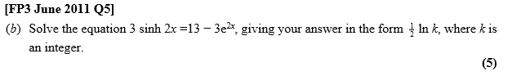
Ex 6C, pg 128

