6B Inverse Hyperbolic Functions
- Sketch hyperbolic function
- $y=arsinh x$
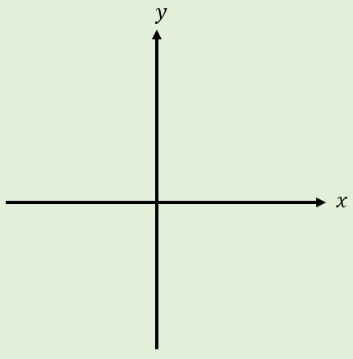
- $y=arcosh{x}$
- $y=\operatorname{artanh}{x}$
- Show that $arsinh x=ln\left(x+\sqrt{x^{2}+1}\right)$

- Show that $arcosh x=ln\left(x+\sqrt{x^{2}-1}\right)$

- Find an expression for $artanh x$ using logarithms

- Express using natural logarithms:
- $arsinh 1$

- $arcosh 2$

- $artanh \frac{1}{3}$

