Inverse Hyperbolic Functions
Each hyperbolic function has an inverse.

$y=arsinh x,$

$y=arcosh x,$

$y=artanh x$

$y=arsech x,$
$y=arcosech x,$
$y=arcoth x$
Expressing Inverse Hyperbolic Functions in terms of $ln$
Given that hyperbolic functions can be written in terms of $e$ inverse hyperbolic can be expressed in terms of $ln$.
Example:
Prove that $arsinh x=\ln\left(x+\sqrt{x^{2}+1}\right)$

Test Your Understanding
Prove that $arcosh x=\ln\left(x+\sqrt{x^{2}-1}\right), x≥1$

Summary so far:

$$arsinh x=\ln\left(x+\sqrt{x^{2}+1}\right)$$
$$arcosh x=\ln\left(x+\sqrt{x^{2}-1}\right), x≥1$$
$$artanh x=\frac{1}{2}\ln\left(\frac{1+x}{1-x}\right), \left|x\right|<1$$

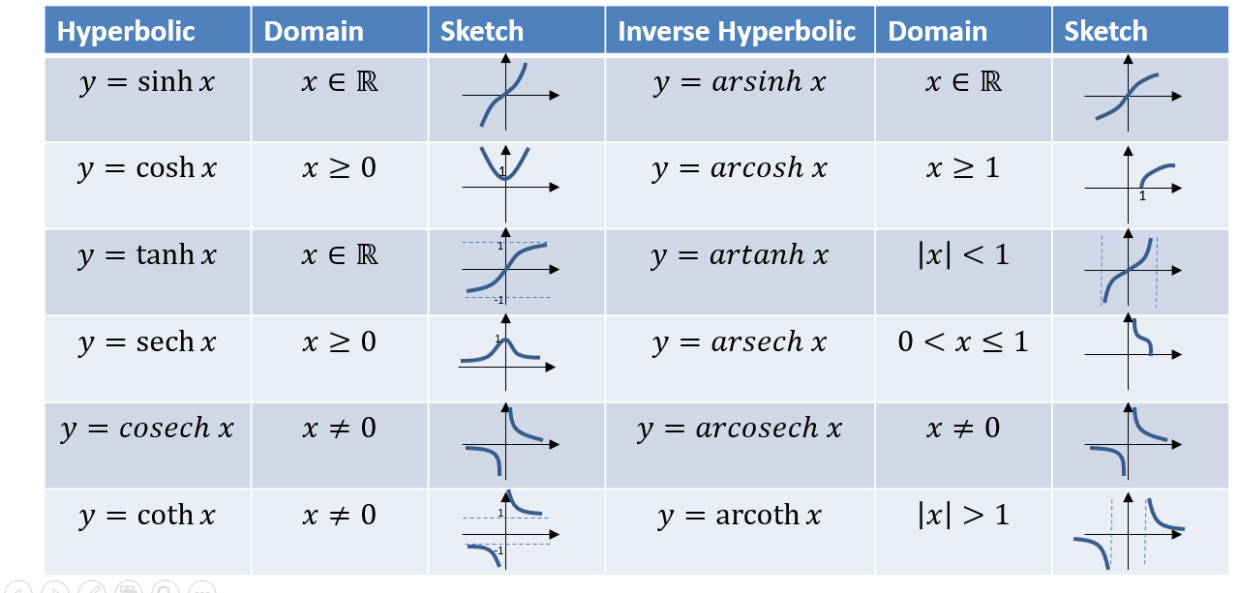

Ex 6B pg 125

