6A Introduction to Hyperbolic Functions

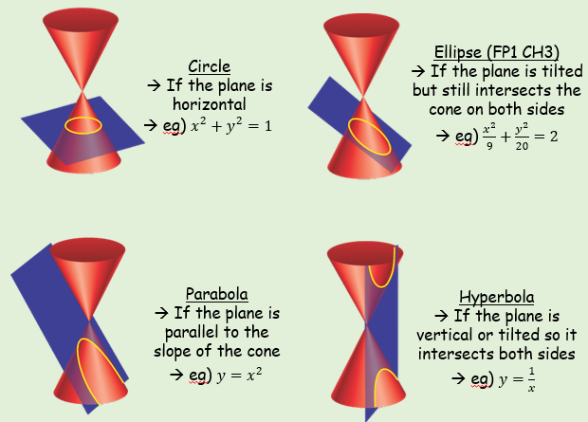
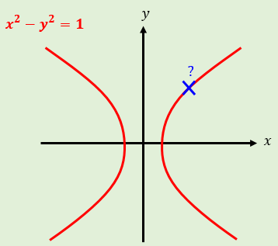

$sinhx$ $cosechx$

$coshx$ $sechx$

$tanhx$ $cothx$

- Find, to 2 decimal places, the value of:
- $\sinh{3}$

- $\cosh{1}$

- $\tanh{0.8}$

- Find the exact value of:
$$\tanh\left(ln4\right)$$

- Find the value of $x$ for which $\sinh{x}=5$. Give your answer to 2 decimal places.

- Sketch hyperbolic function
- $y=\sinh{x}$
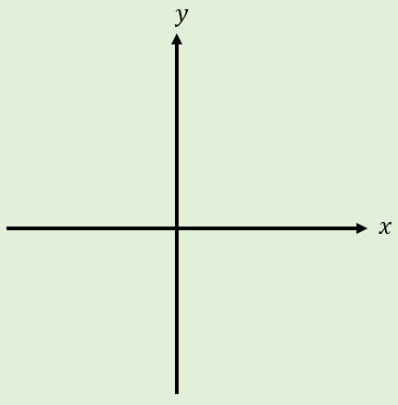
- $y=cosh{x}$
- $y=\tanh{x}$

