CP2 Chapter 6
Hyperbolic Functions

Course Structure
- Definition of hyperbolic functions and their sketches.
- Inverse hyperbolic functions.
- Hyperbolic Identities and Solving Equations
- Differentiation
- Integration
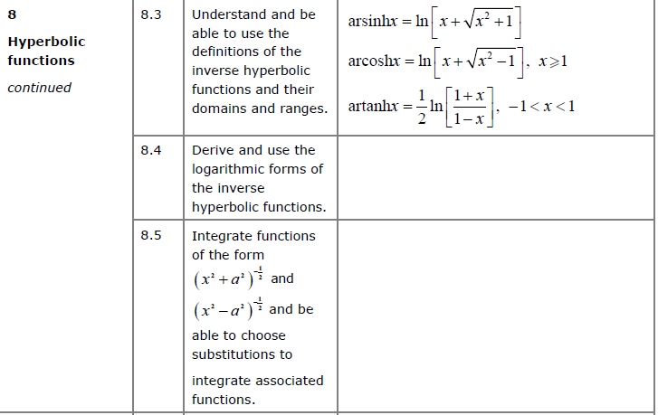
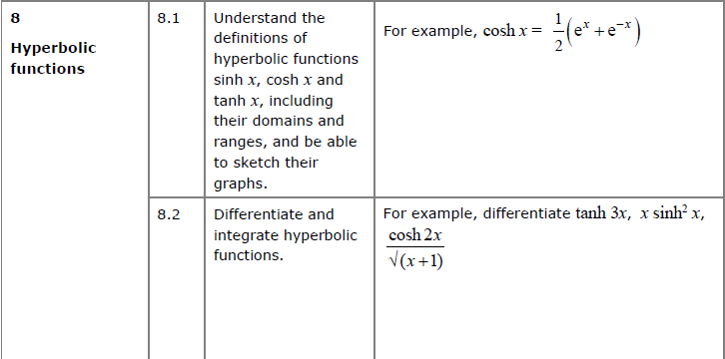

Conic Sections
In mathematics there are a number of different families of curves. Each of these have different properties and their equations have different forms.
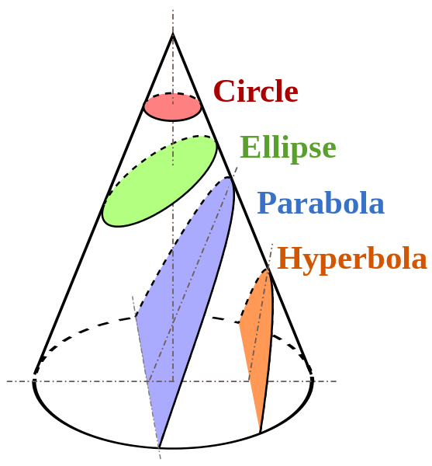
It is possible to obtain these different types of curves by slicing a cone, hence “conic sections”.
The axis of the parabola is parallel to the side of the cone.

For interest:
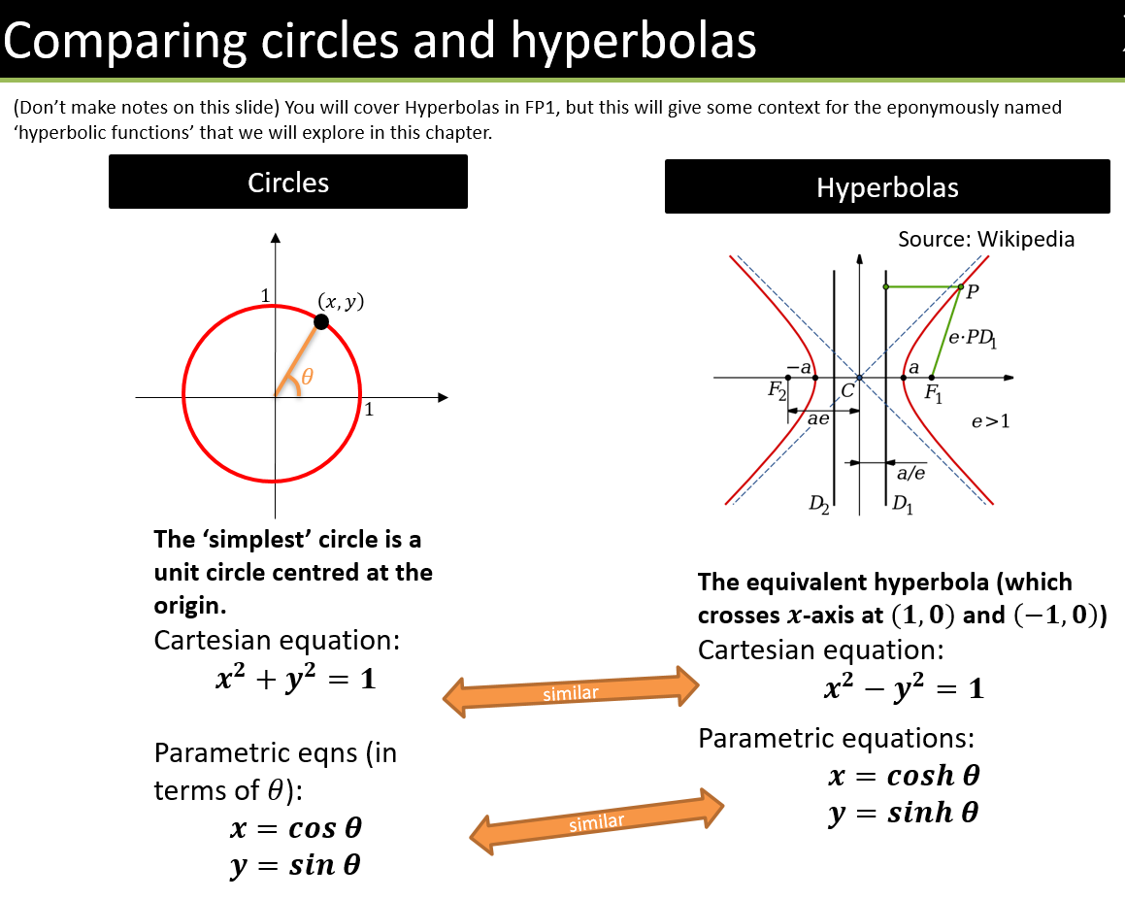

What’s the point of hyperbolic functions?
Hyperbolic functions often result from differential equations (e.g. in mechanics), and we’ll see later in this module how we can use these functions in calculus.
For example, we can consider forces acting on each point on a hanging piece of string.
Solving the relevant differential equations, we end up with coshx.

Equations for Hyperbolic Functions

Hyperbolic sine:
$$\sinh{x}=\frac{e^{x}-e^{-x}}{2} x∈R$$

Hyperbolic cosine:
$$\cosh{x}=\frac{e^{x}+e^{-x}}{2} x∈R$$

Hyperbolic tangent:
$$tanh x{=}\frac{\sinh{x}}{\cosh{x}}=\frac{e^{2x}-1}{e^{2x}+1} x∈R$$

Hyperbolic secant:
$$\operatorname{sech}{x}=\frac{1}{\cosh{x}}=\frac{2}{e^{x}+e^{-x}} x∈R$$

Hyperbolic cosecant:
$$\operatorname{cosech}{x}=\frac{1}{\sinh{x}}=\frac{2}{e^{x}-e^{-x}} x∈R, x≠0$$

Hyperbolic cotangent:
$$\coth{x}=\frac{1}{\tanh{x}}=\frac{e^{2x}+1}{e^{2x}-1} x∈R, x≠0$$

Examples:
- Calculate (using both your $sinh$ button and using the formula)
$$\sinh{3}=10.02$$

- Write in terms of $e$:$\operatorname{cosech}{3}$

- Find the exact value of:$tanh \left(ln 4\right)$

- Solve $sinh x=5$

Sketching Hyperbolic Functions

- $y=\sinh{x}$ is the average of $e^{x}$ and $-e^{-x}$:

- $y=\cosh{x}$ is the average of $e^{x}$ and $e^{-x}$:

- $\tanh{x}=\frac{\sinh{x}}{\cosh{x}}$

Test Your Understanding

Sketch the graph of $y=\operatorname{sech}{x}$

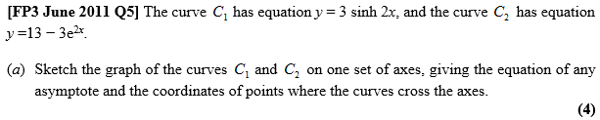

Ex 6A pg 122

