6A Introduction to Hyperbolic Functions

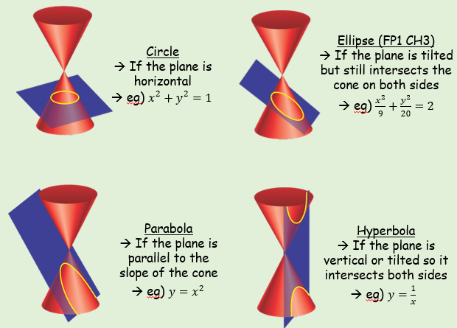
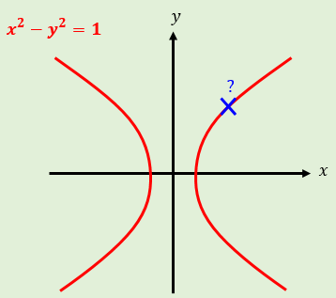

$sinhx$ $cosechx$

$coshx$ $sechx$

$tanhx$ $cothx$

- Find, to 2 decimal places, the value of:
- $\sinh{3}$

- $\cosh{1}$

- $\tanh{0.8}$

- Find the exact value of:
$$\tanh\left(ln4\right)$$

- Find the value of $x$ for which $\sinh{x}=5$. Give your answer to 2 decimal places.

- Sketch hyperbolic function
- $y=\sinh{x}$
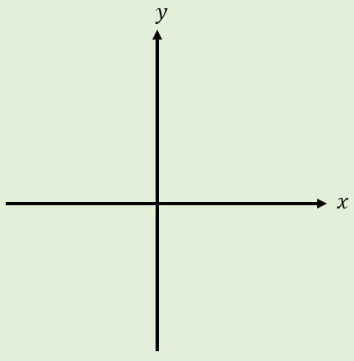
- $y=cosh{x}$
- $y=\tanh{x}$
6B Inverse Hyperbolic Functions
- Sketch hyperbolic function
- $y=arsinh x$
- $y=arcosh{x}$
- $y=\operatorname{artanh}{x}$
- Show that $arsinh x=ln\left(x+\sqrt{x^{2}+1}\right)$

- Show that $arcosh x=ln\left(x+\sqrt{x^{2}-1}\right)$

- Find an expression for $artanh x$ using logarithms

- Express using natural logarithms:
- $arsinh 1$

- $arcosh 2$

- $artanh \frac{1}{3}$

6C Hyperbolic Equations and Identities
- Prove that:

$$cosh^{2}A-\sinh^{2}A≡1$$

$$\sinh\left(A+B\right)≡\sinh{A}\cosh{B}+\cosh{A}\sinh{B}$$

$$\cosh{2A≡1+2si{nh}^{2}A}$$

Osborn’s Rule:

- Write down the hyperbolic identity corresponding to:

$$cos2A≡2\cos^{2}A-1$$

$$tan⁡(A-B)≡\frac{tanA-tanB}{1+tanAtanB}$$

- Given that $\sinh{x}=\frac{3}{4}$, find the exact value of:
- $\cosh{x}$

- $\tanh{x}$

- $\sinh{2x}$

- Solve the equation below for real values of $x$.
$$6\sinh{x}-2\cosh{x}=7$$

- Solve the equation below, giving answers as natural logarithms.
$$2cosh^{2}x-5\sinh{x}=5$$

- Solve the equation below, giving answers as natural logarithms where appropriate.
$$\cosh{2x}-5\cosh{x}+4=0$$

Some additions to Osborn’s rule

6D Differentiating Hyperbolics
- Show that $\frac{d}{dx}\left(\sinh{x}\right)=\cosh{x}$

- Show that $\frac{d}{dx}\left(\cosh{x}\right)=\sinh{x}$

- Show that $\frac{d}{dx}\left(\tanh{x}\right)=sech^{2} x$

- Differentiate $\cosh{3x}$ with respect to $x$

- Differentiate $x^{2}\cosh{4x}$ with respect to $x$

- Given that:
$$y=Acosh 3x+Bsinh 3x$$
Where $A$ and $B$ are constants, prove that $\frac{d^{2}y}{{dx}^{2}}=9y$

- Show that $\frac{d}{dx}\left(arcosh x\right)=\frac{1}{\sqrt{x^{2}-1}}, x>1$

- Given $y=xarcosh x$, find $\frac{dy}{dx}$

- Given $y={\left(arcosh x\right)}^{2}$, prove that:
$$\left(x^{2}-1\right){\left(\frac{dy}{dx}\right)}^{2}=4y$$

- Show that $\frac{d}{dx}\left(arsinh x\right)=\frac{1}{\sqrt{1+x^{2}}}$

- Find the first two non-zero terms in the series expansion of $arsinh x$

- The general term for the series expansion of $arsinh x$ is given by:
$$arsinh x=\sum_{r=0}^{∞}{\left(\frac{{(-1)}^{n}\left(2n\right)!}{2^{2n}{\left(n!\right)}^{2}}\right)\frac{x^{2n+1}}{2n+1}}$$

Find, in its simplest terms, the third term in the sequence

- Use your approximation, up to and including the term in $x^{5}$, to find an approximation for $arsinh 0.5$

- Calculate the percentage error by using this approximation

6E Integrating Hyperbolics
- Find

$$\int{\cosh\left(4x-1\right) dx}$$

$$\int{\left(\frac{2+5x}{\sqrt{x^{2}+1}}\right) dx}$$

$$\int{\cosh^{5}2x sinh2x dx}$$

$$\int{tanhx dx}$$

$$\int{\cosh^{2}3x dx}$$

$$\int{\sinh^{3}x dx}$$

$$\int{e^{2x}\sinh{x} dx}$$

- By using an appropriate substitution, find:
$$\int{\frac{1}{\sqrt{x^{2}-a^{2}}} dx}, x>a$$

Formula book reference:

- Show that

$$\int_{5}^{8}{\frac{1}{\sqrt{x^{2}-16}} dx=ln\left(\frac{2+\sqrt{3}}{2}\right)}$$

$$\int{\sqrt{1+x^{2}}} dx=\frac{1}{2}arsinhx+\frac{1}{2}x\sqrt{1+x^{2}}+c$$

- By using a hyperbolic substitution, evaluate:
$$\int_{0}^{6}{\frac{x^{3}}{\sqrt{x^{2}+9}} dx}$$

$$\int{\frac{1}{\sqrt{12x+{2x}^{2}}} dx}$$

- Use the substitution
$$x=\frac{1}{2}\left(3+4\cosh{u}\right)$$
to find:
$$\int{\frac{1}{\sqrt{{4x}^{2}-12x-7}} dx}$$

