5D Tangents to Polar Curves

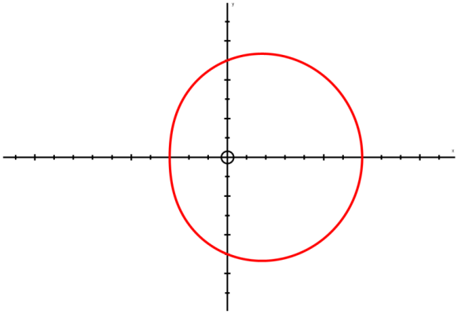

- Find the coordinates of the points on:
r = a(1 + cosθ)
Where the tangents are parallel to the initial line θ = 0.
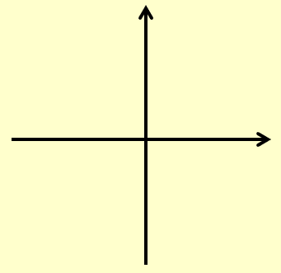

- Find the coordinates and the equations of the tangents to the curve:
r = asin2θ, 0 ≤ θ ≤ ^{π}/₂
Where the tangents are:
- Parallel to the initial line
Give answers to 3 s.f where appropriate:

- Perpendicular to the initial line
Give answers to 3 s.f where appropriate:

- Prove that for:
r = (p + qcosθ), p and q both > 0 and p ≥ q
to have a ‘dimple’, p < 2q and also
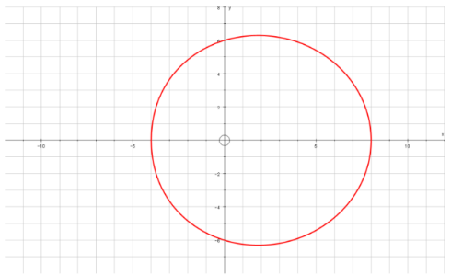
p ≥ q.

